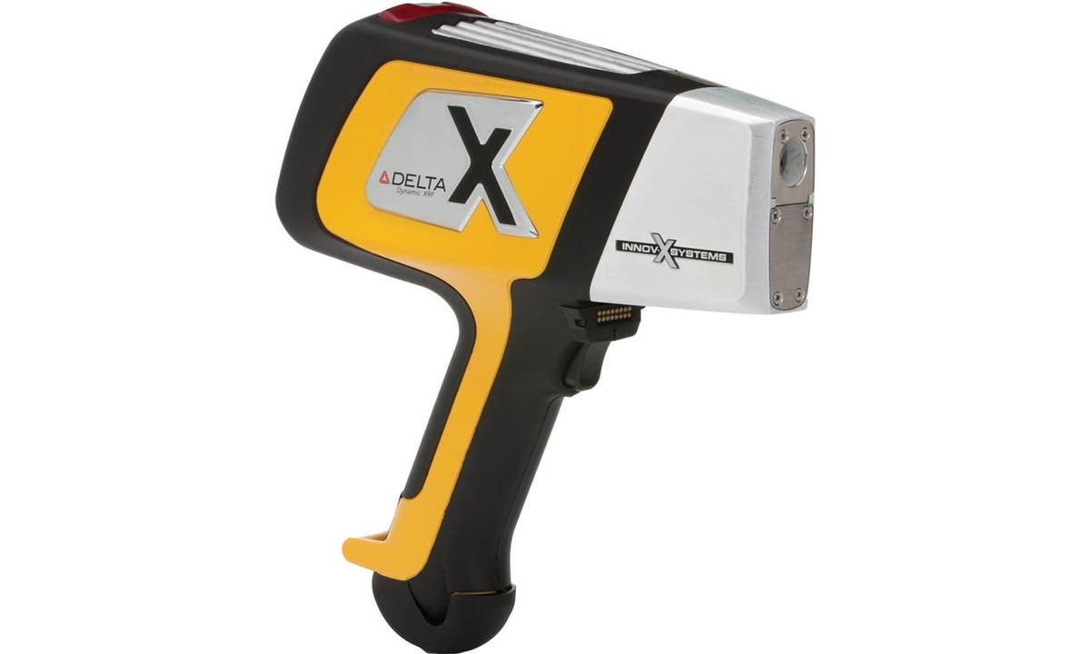

SCOPE
The scope of this Standard Operating Procedure outlines the safe use and operation of:
Name of machinery/equipment | Delta XRF Handheld Analyser

Campus | Parkville | Other:
Building | 200 – McCoy | Other:
Room No. | 111 – Petrophysics Lab | Other:
Offsite |  | Other:

This item has an inherent risk rating of
Risk rating | ☐ | Low | ☐ | Medium | ☒ | High

This Standard Operating Procedure considers the intended purpose and use as outlined by the manufacturer.

DESCRIPTION

INTENDED APPLICATION
The Delta X-ray fluorescence analyser is designed to measure the elemental concentrations, from magnesium to uranium, of discrete high-density samples.

MANUFACTURER’S SPECIFICATIONS
Security: The device must only be used by trained and authorised operators. Limit access only to those who have been trained and authorised.
Damage: Do not use if there is any evidence of damage as doing so could cause unintentional emission of stray radiation. Arrange for a qualified person to perform a radiation safety test. Do not install substitute parts or perform unauthorised modification. The device must be sent to an authorised repairer.
Shielding: Establish a no-admittance zone around the device to allow the beam to attenuate in the air. If possible, enclose the beam working area with protective steel panels (3mm).
Batteries: Only use batteries supplied by Olympus. Recharge batteries to between 40% and 80% before storing them.

TRAINING / LICENCING
Relevant local inductions that are required for operators of this machinery/equipment:

Petrophysics Laboratory Induction, XRF Analyser User Training

Relevant TrainME modules or external training required for operators of this machinery/equipment:

TrainME modules
☒ Health & Safety Roles & Responsibilities | ☐ Chemical Management | ☐ Hot Work
☐ Manual Handling | ☐ Compressed Gas Safety | ☐ Biorisk – Accredited Persons
☐ Computer Workstation Training | ☒ Safe Radiation Practices - Ionising | ☐ Animal Welfare & Ethics
☒ Personal Protective Equipment | ☐ Safe Radiation Practices - Laser | ☐ Other (please specify):
☒ Laboratory Safety | ☐ Biorisk – Biosafety Induction | ☐
☒ Plant Safety | ☐ Biorisk - Behavioural CF | ☐

Externally Provided Courses
☐Provide First Aid | ☐Working at Heights | ☐Four Wheel Drive
☐Remote First Aid | ☐Tower Rescue | ☐Chainsaw Safety
☐Diving Certificate | ☐Boat Licence | ☐Confined Spaces
☐Quad Bike | ☐Heavy Vehicle Licence | ☐Other (please specify):

This High-Risk SOP requires the following training by an authorised trainer:
- Complete Faculty of Science High-Risk Training Record
- Refresher training requirements: Refresher training should occur when the equipment procedure is updated significantly to change how the procedure is done, following an incident or near miss whereby the procedure was not followed, or if a significant amount of time has passed since last use.
- List Authorised Trainers (Subject Matter Experts):

Name | Position (Job Title) | Relevant Qualifications/Experience/Licensing (If Applicable)
Michelle Richards | Research Fellow | Radiation Use License; university training; experienced XRF user.
Jesse Ash | Laboratory Technician | University Training
Dan Sandiford | Research Fellow | University training

PERSONAL PROTECTIVE EQUIPMENT (PPE)
Personal protective equipment required that meets relevant Australian Standard.
- Standard PPE:

☐ Safety glasses/goggles (please specify type): | ☐ Face shield
☐ Gloves (please specify type): | ☐ Mask/ respirator (please specify type):
☐ Laboratory Coat/Gown (please specify type): | ☐ Apron (please specify type):
☒ Fully enclosed footwear (please specify type): fully enclosed shoes | ☐ Hat (please specify type):
☐ Long pants | ☐ Sunscreen
☐ Long sleeves | ☐ Wet suit
☐ Hearing Protection | ☐ Waders
☒ Other (Please Specify): Personal Dosimeter Badge. | ☐ Other (Please Specify):
☐ Other (Please Specify): | ☐ Other (Please Specify):
- Health Monitoring required (HHAQ complete form)
☐ Vaccination/s required | ☐ Spirometry testing
List here: | ☐ Hearing test
☐Other Monitoring (Please Specify): | ☐ Eye test for Laser work
 | ☐ Other (Please specify)

Warnings

SAFETY PRECAUTIONS
- Whilst in the lab the device must be used in the test stand and operated remotely
- Whilst in the field the device must be fitted with a shield that ensures complete contact with the sample
- Whilst operational a 1.5-meter exclusion zone must be created, and warning signs must be placed outside the laboratory or working area
- Samples permitted for use must have a minimum diameter (38mm) that covers the beam window
- The device must be stored in a locked cabinet separately from its batteries
- Operator must be trained and familiar with the safe operating procedure.
- Operator to wear PPE as listed.



DO’S AND DON’T:
ALWAYS – Isolate and tag out equipment requiring repairs and maintenance.
ALWAYS – Store the device in a locked cabinet separately from its batteries
ALWAYS – Use the test stand where possible, and a shield when it is not.
ALWAYS – Operate remotely where possible
ALWAYS – Ensure that there are no unauthorised or unnecessary personnel within 1.5 meters of the device while active
ALWAYS – Ensure that the sample is wide enough (38mm diameter) to completely cover the sensor window.
NEVER – Provide access to the device to unauthorised users.
NEVER – Point the device towards yourself or others.
NEVER – Activate the device whilst it is pointed towards an unshielded wall/ceiling/floor where people on the other side could be affected by the beam.
NEVER – Place or remove a sample from the window while it is active.
NEVER – Open the lid of the test stand while the XRF is active.

INSTRUMENT CONTROLS

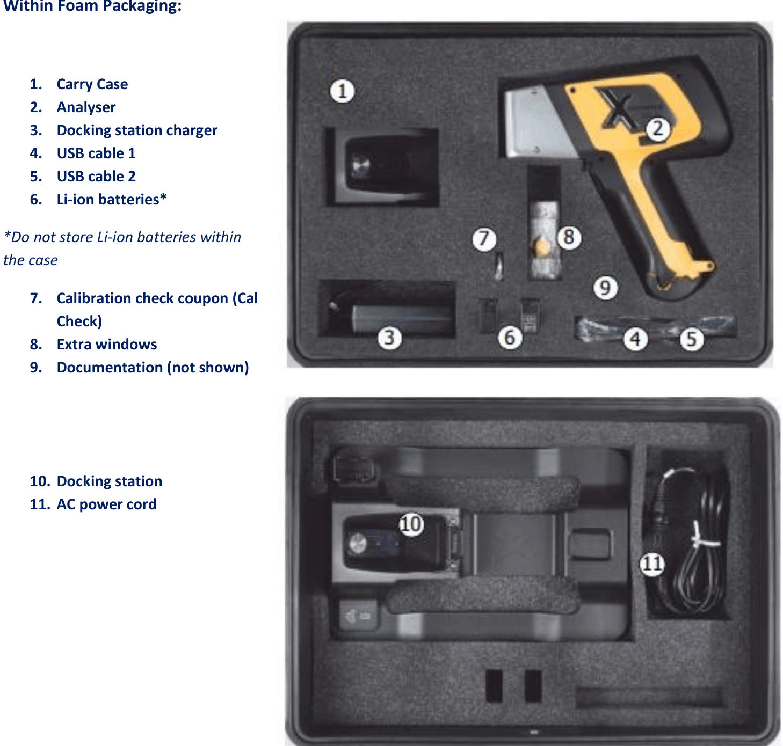

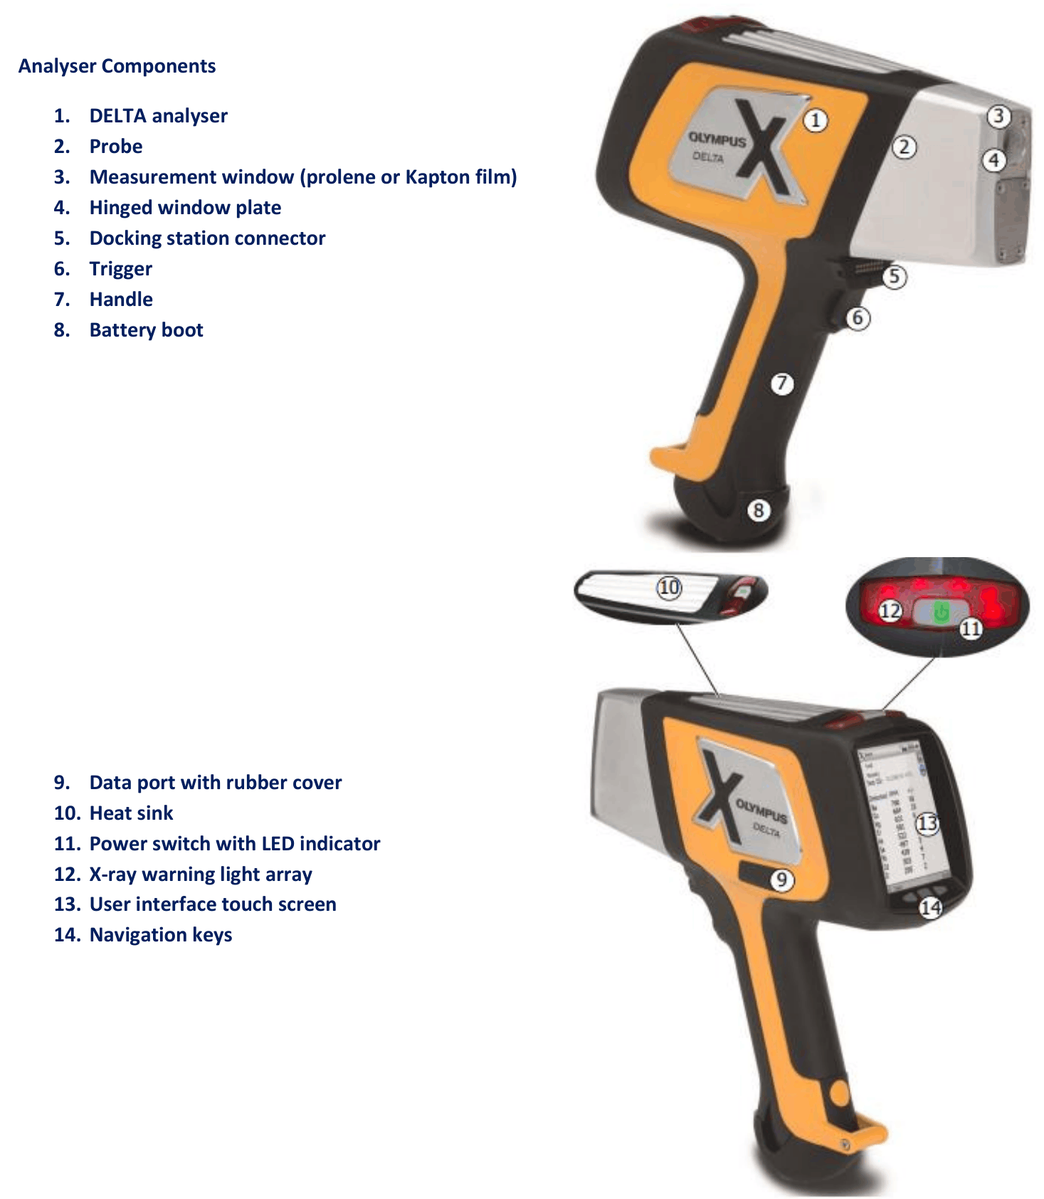

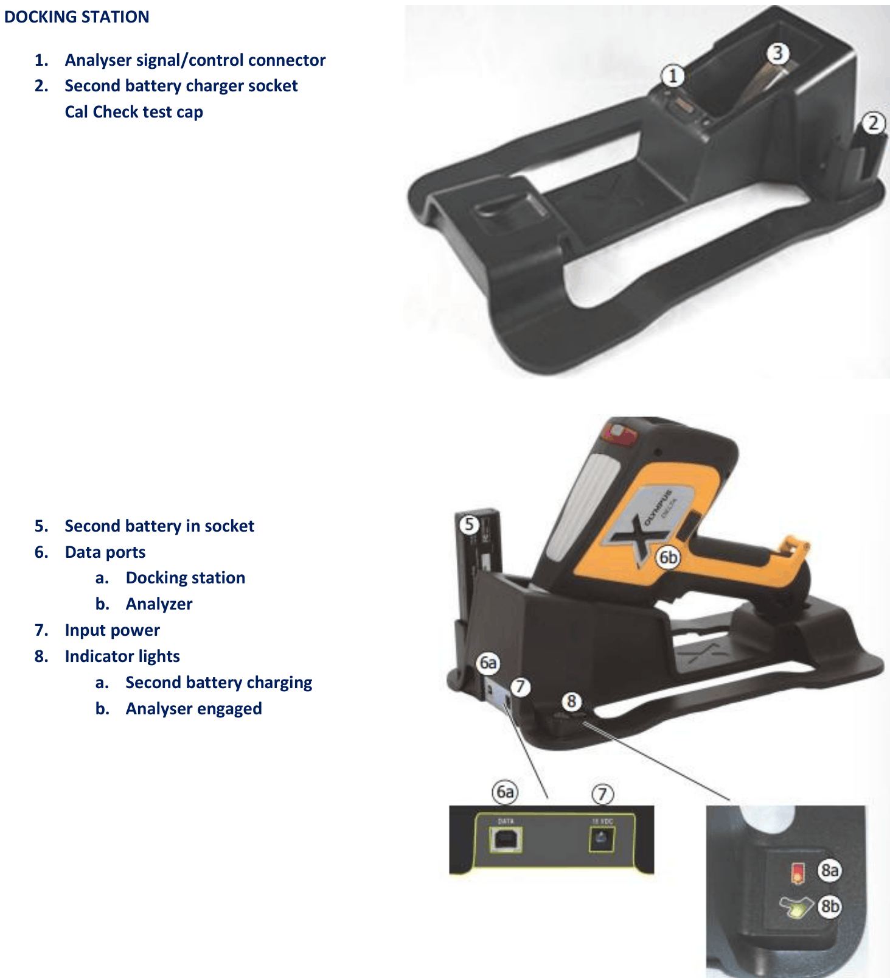
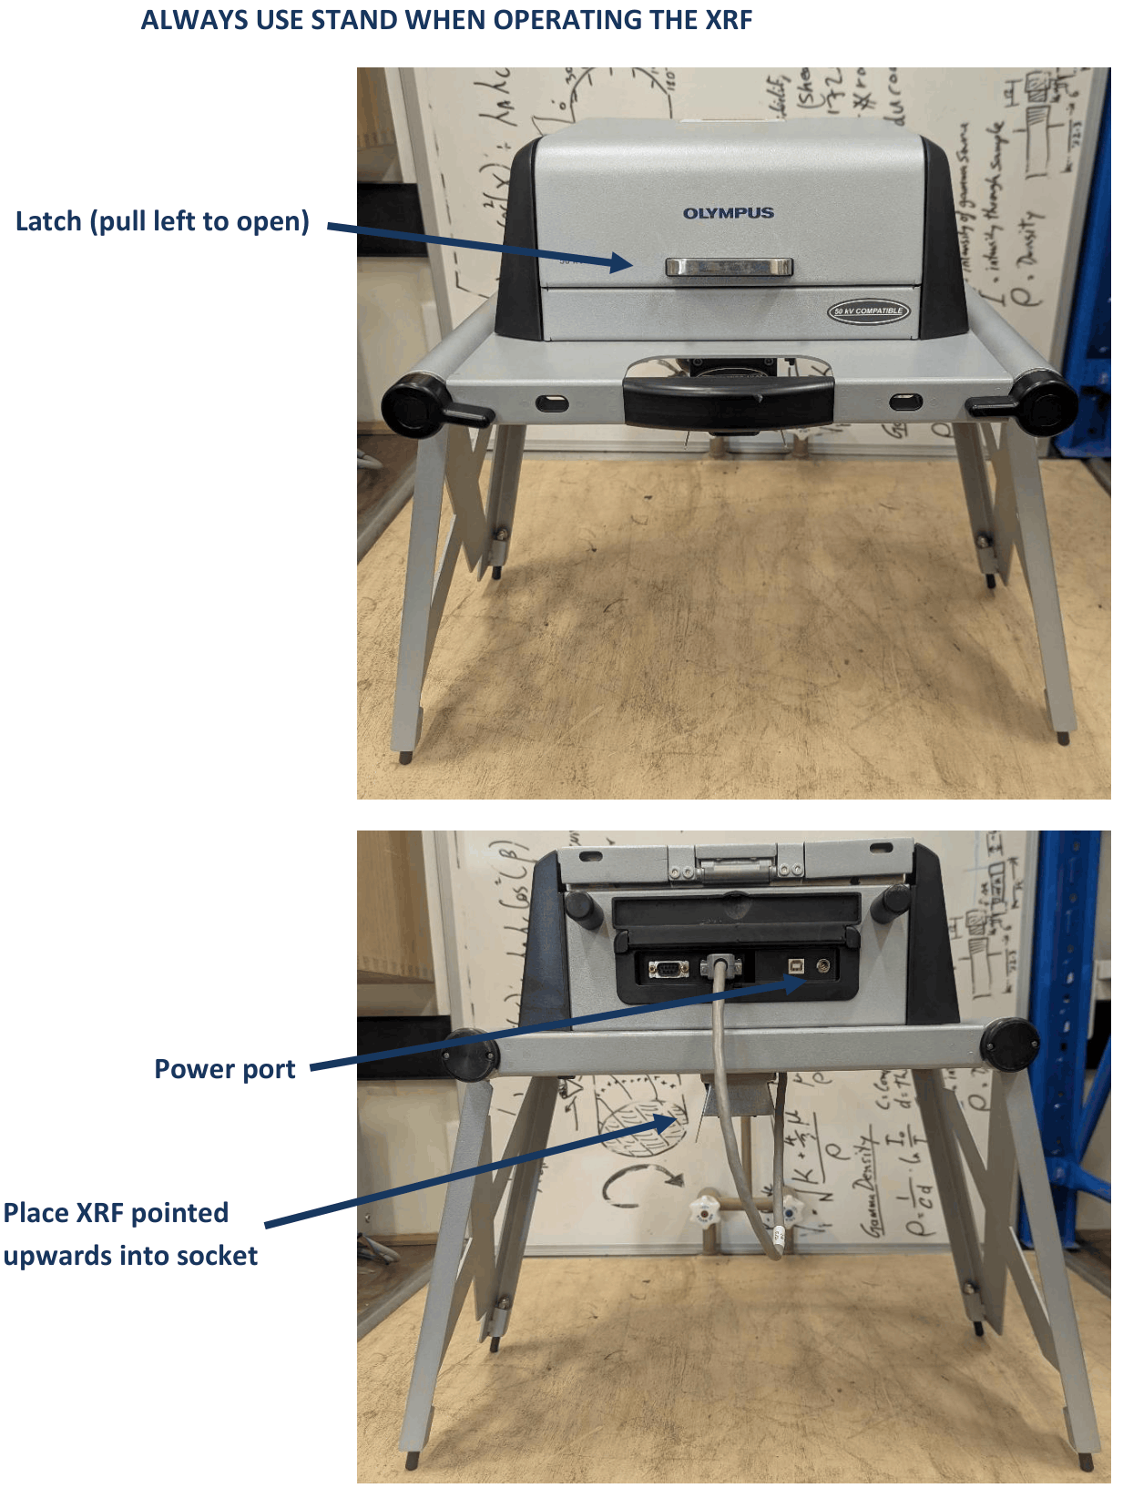

OPERATION

PRE-START UP
- Insert a charged battery into the analyser handle and turn it on.
- Place the analyser into the underside of the stand so that the analyser window is pointing upwards.
- Connect the charging cable to the stand and the analyser to the ‘XRF’ PC with a USB cable.
- Windows mobile centre will try to set up a new device. Select ‘connect without setting up your device’.
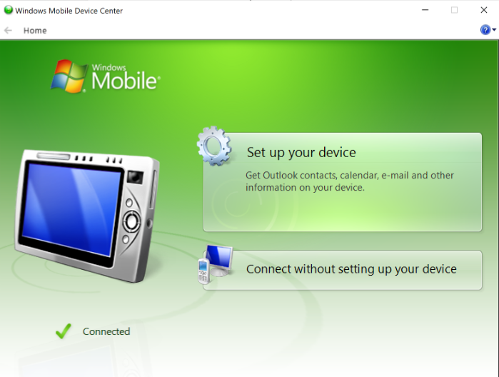

START UP
- Click on the Innov-X app.

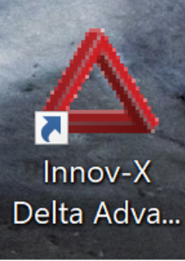
- The program takes a few seconds to boot. Once it has, click on ‘Close Device App’ to remove control from the instrument. Then click Start to connect the instrument to the desktop app.
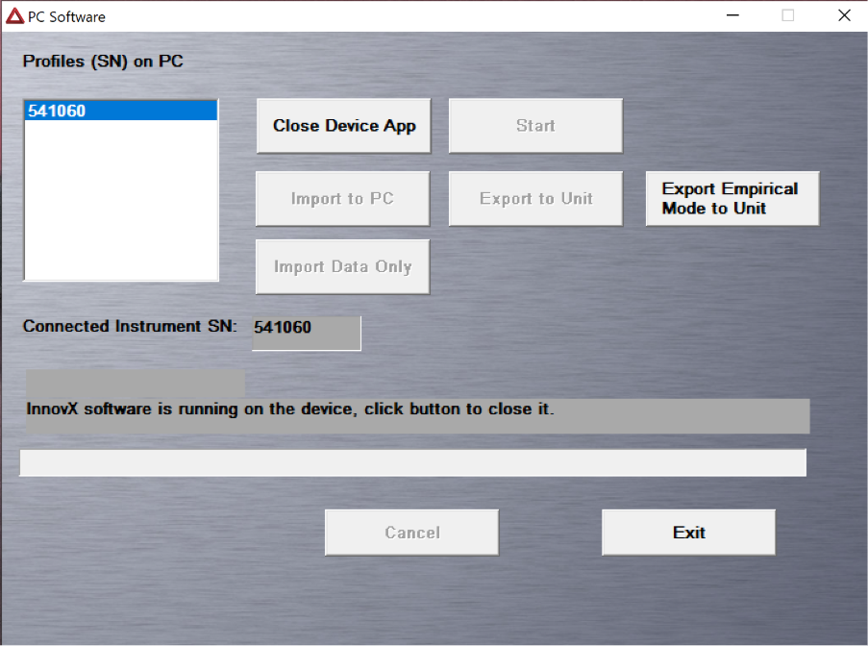
- A new window will open. Log in using:
User: innovx
Password: 1776
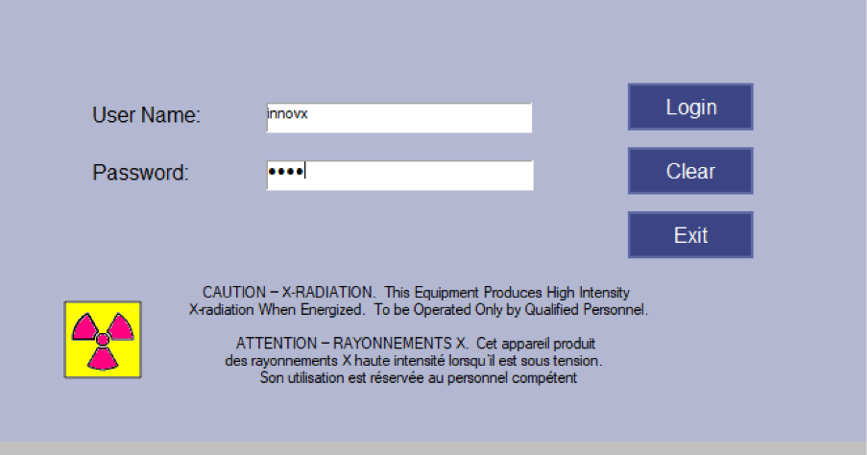
- Place the 316-stainless steel disc (Cal Check) onto the analyser window. Close the lid of the stand and run a calibration check. This needs to be done every 10 hours.
- Go to the mode tab and select between Geochem and Soil. Soil is good for heavy elements in a light matrix and uses three beams. Geochem is better for bulk elements, only uses two beams.
- Go to Setup Test Condition. Set analysis time and which beams to use. Leave as default if unsure.
- Open the lid of the stand an d place the sample directly in contact with the analyser window. Close the lid.
- Click start test from on the PC screen. The analysis takes 60 seconds. Only once the analysis has ended can you open the lid and swap out the sample.
- Readings are stored as a single file for each day. If you select multiple ‘Results’ files they will be collated into a single exported file (with the current date as a default filename). If you select multiple ‘Spectra’ files, then only the readings from the most recent date will be exported but with the current date (not the date of the readings) as the default filename.

SHUT DOWN
- Close the application on the PC and shut down.
- Remove the device from the stand and unplug all cords.
- Hold down the power button for 3 seconds to shut off.
- Remove the battery from the device and store separately.
- Pack the device back into its box and lock in the petrophysics cupboard.

EMERGENCY SHUT DOWN

If the user realises the beam is activated whilst certain safety precautions are not in place they should immediately abort the test from the PC.

MAINTENANCE
To ensure reliable and trouble-free operation, it is the user’s responsibility to maintain the machine in the best possible condition. Such a machine will produce accurate consistent results; problems will be less frequent and less severe.

CLEANING
Gently wipe the window clean with a dry nonabrasive cloth after each analysis to remove any dirt from the analyser window. Make sure that the window is not ripped or punctured. The rest of the body can be wiped down with a damp (not wet) cloth.

MAINTENANCE
The delta does not contain any user-serviceable parts. Any maintenance must be performed by an Olympus authorized service provider.

EMERGENCY
Commence emergency procedures in accordance with the local emergency requirements.
UNIVERSITY SECURITY (Parkville 24hr) 834 46666

FIRST AID KITS
The Petrophysics Laboratory first aid kit can be found on the shelf directly above the vacuum chamber.

PORTABLE DEFIBRILLATORS
Portable Defibrillator located at the entrance to Thomas Cherry Building level 2, walk through McCoy foyer. A second Portable Defibrillator is in the Physics podium over the walkway/bridge across Swanston St.

LISTINGS OF FIRST AIDERS
Listings of First Aiders located at First Aid Kits, as well as emergency contact posters on safety notice board.

INCIDENT REPORTING
- Report any incident to your Supervisor immediately.
- Report the incident on ERMS and local OHS contact https://unimelbcloud.sharepoint.com/teams/ScienceOHSResources as soon as possible.
- In the event of a major incident the following reporting steps will also occur:
  - Notify the relevant emergency response department e.g. Fire, Ambulance, Police (000).
  - Notify Security (834 46666) 24/7 support.
  - Notify your supervisor and the local OHS contact as soon as reasonably practicable. https://unimelbcloud.sharepoint.com/teams/ScienceOHSResources

REFERENCES

Reference Material | Location (if physical) or Link (if electronic)
University of Melbourne risk register | https://safety.unimelb.edu.au/__data/assets/pdf_file/0009/4859235/UoM-Health-and-Safety-Risk-Register-v4.pdf
School/Department risk register | https://unimelbcloud.sharepoint.com/teams/SGEASHealthandSafetyResources
Equipment Risk Assessment | The risk assessment can be found in the laboratory manual, on the subsurface observatory webpage or via a QR code attached to the device.
 | https://sgeas.unimelb.edu.au/research/auscope-subsurface-observatory.
Manufacturer’s / Supplier’s operating manual | The quick start guide and user manual can be found in the laboratory manual, on the subsurface observatory webpage or via a QR code attached to the device.
 | https://sgeas.unimelb.edu.au/research/auscope-subsurface-observatory.
Research Group Safety Manual (If applicable) | The safety manual can be found in the laboratory manual or on the subsurface observatory webpage.
 | https://sgeas.unimelb.edu.au/research/auscope-subsurface-observatory.
University safety website guidelines and requirements | https://safety.unimelb.edu.au/

Relevant Legislation References | Location (web link or physical copy location))
OHS Act, Vic. | https://www.legislation.vic.gov.au/in-force/acts/occupational-health-and-safety-act-2004/043
OHS Regulations, Vic | https://www.legislation.vic.gov.au/in-force/statutory-rules/occupational-health-and-safety-regulations-2017/014
Other relevant Acts and Regulations:  ☒ Australian Radiation Protection and Nuclear Safety Act 1998  ☒ Australian Radiation Protection and Nuclear Safety Regulations 1999  ☒ Radiation Act 2005  ☒ Radiation Regulation 2007 | https://www.legislation.gov.au/C2004A00383/asmade/text  https://www.legislation.vic.gov.au/in-force/acts/radiation-act-2005/034  https://www.legislation.vic.gov.au/as-made/statutory-rules/radiation-regulations-2007
Compliance codes and Codes of Practice  ☒ Code of practice for protection against ionising radiation emitted from x-ray analysis equipment, Radiation Health Series No. 9 (NHMRC, 1985)  ☒ X-ray analysis equipment (1984) Code of Practice | https://www.worksafe.vic.gov.au/laws-and-regulations  https://www.arpansa.gov.au/sites/default/files/legacy/pubs/rhs/rhs9.pdf
Australian Standards: source SAI Global.  ☒ Australian Standard – AS 2243.4. Safety in laboratories. Part 4. Ionising radiations (Standards Association of Australia, 1998). | https://research.ebsco.com/c/xppotz/search/details/f7kyfyxrkz  https://www.intertekinform.com/preview/825397153026.pdf?sku=125007_SAIG_AS_AS_263093&srsltid=AfmBOoqOrj5NrcbAWcebxRY_BROBifO5fLgDNEr73NwrZdkQJWRIqgNG

