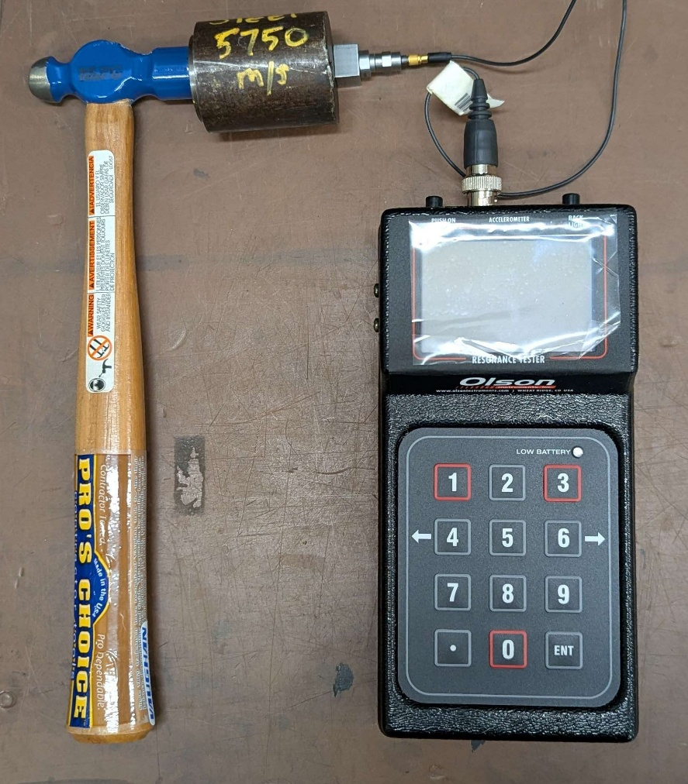

SCOPE
The scope of this Standard Operating Procedure outlines the safe use and operation of:
Name of machinery/equipment | Resonant Frequency Test (RT)

Campus | Parkville | Other:
Building | 200 – McCoy | Other:
Room No. | 111 – Petrophysics Lab | Other:
Offsite |  | Other:

This item has an inherent risk rating of:
Risk rating | ☒ | Low | ☐ | Medium | ☐ | High

This Standard Operating Procedure considers the intended purpose and use as outlined by the manufacturer.

DESCRIPTION

INTENDED APPLICATION
The RT-1 resonant frequency tester is intended to be used to measure the transverse, longitudinal and torsional resonant frequencies of concrete, rock and core samples.

MANUFACTURER’S SPECIFICATIONS
If the RT-1 batteries are replaced with non-rechargeable batteries the unit can no longer be charged.

TRAINING / LICENCING
Relevant local inductions that are required for operators of this machinery/equipment

Petrophysics Laboratory

Relevant TrainME modules or external training required for operators of this machinery/equipment

TrainME modules
☒ Health & Safety Roles & Responsibilities | ☐ Chemical Management | ☐ Hot Work
☐ Manual Handling | ☐ Compressed Gas Safety | ☐ Biorisk – Accredited Persons
☐ Computer Workstation Training | ☐ Safe Radiation Practices - Ionising | ☐ Animal Welfare & Ethics
☒ Personal Protective Equipment | ☐ Safe Radiation Practices - Laser | ☐ Other (please specify):
☒ Laboratory Safety | ☐ Biorisk – Biosafety Induction | ☐
☐ Plant Safety | ☐ Biorisk - Behavioural CF | ☐

Externally Provided Courses
☐Provide First Aid | ☐Working at Heights | ☐Four Wheel Drive
☐Remote First Aid | ☐Tower Rescue | ☐Chainsaw Safety
☐Diving Certificate | ☐Boat Licence | ☐Confined Spaces
☐Quad Bike | ☒Heavy Vehicle Licence | ☐Other (please specify):

PERSONAL PROTECTIVE EQUIPMENT (PPE)
Personal protective equipment required that meets relevant Australian Standard.
- Standard PPE:

☐ Safety glasses/goggles (please specify type): | ☐ Face shield
☐ Gloves (please specify type): | ☐ Mask/ respirator (please specify type):
☐ Laboratory Coat/Gown (please specify type): | ☐ Apron (please specify type):
☒ Fully enclosed boots | ☐ Hat (please specify type):
☐ Long pants | ☐ Sunscreen
☐ Long sleeves | ☐ Wet suit
☐ Hearing Protection | ☐ Waders
☐ Other (Please Specify): | ☐ Other (Please Specify):
☐ Other (Please Specify): | ☐ Other (Please Specify):
- Health Monitoring required (HHAQ complete form)
☐ Vaccination/s required | ☐ Spirometry testing
List here: | ☐ Hearing test
☐Other Monitoring (Please Specify): | ☐ Eye test for Laser work
 | ☐ Other (Please specify)

Warnings

SAFETY PRECAUTIONS
- Operator must be trained and familiar with the safe operating procedure.
- Always check any electrics cords for damage before using the device
- Do not replace batteries with non-rechargeable batteries.
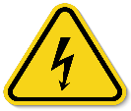

DO’S AND DON’T:
ALWAYS – Isolate and tag out equipment requiring repairs and maintenance.
ALWAYS – Check cords for damage before use
NEVER – Replace batteries with non-rechargeable batteries

INSTRUMENT CONTROLS
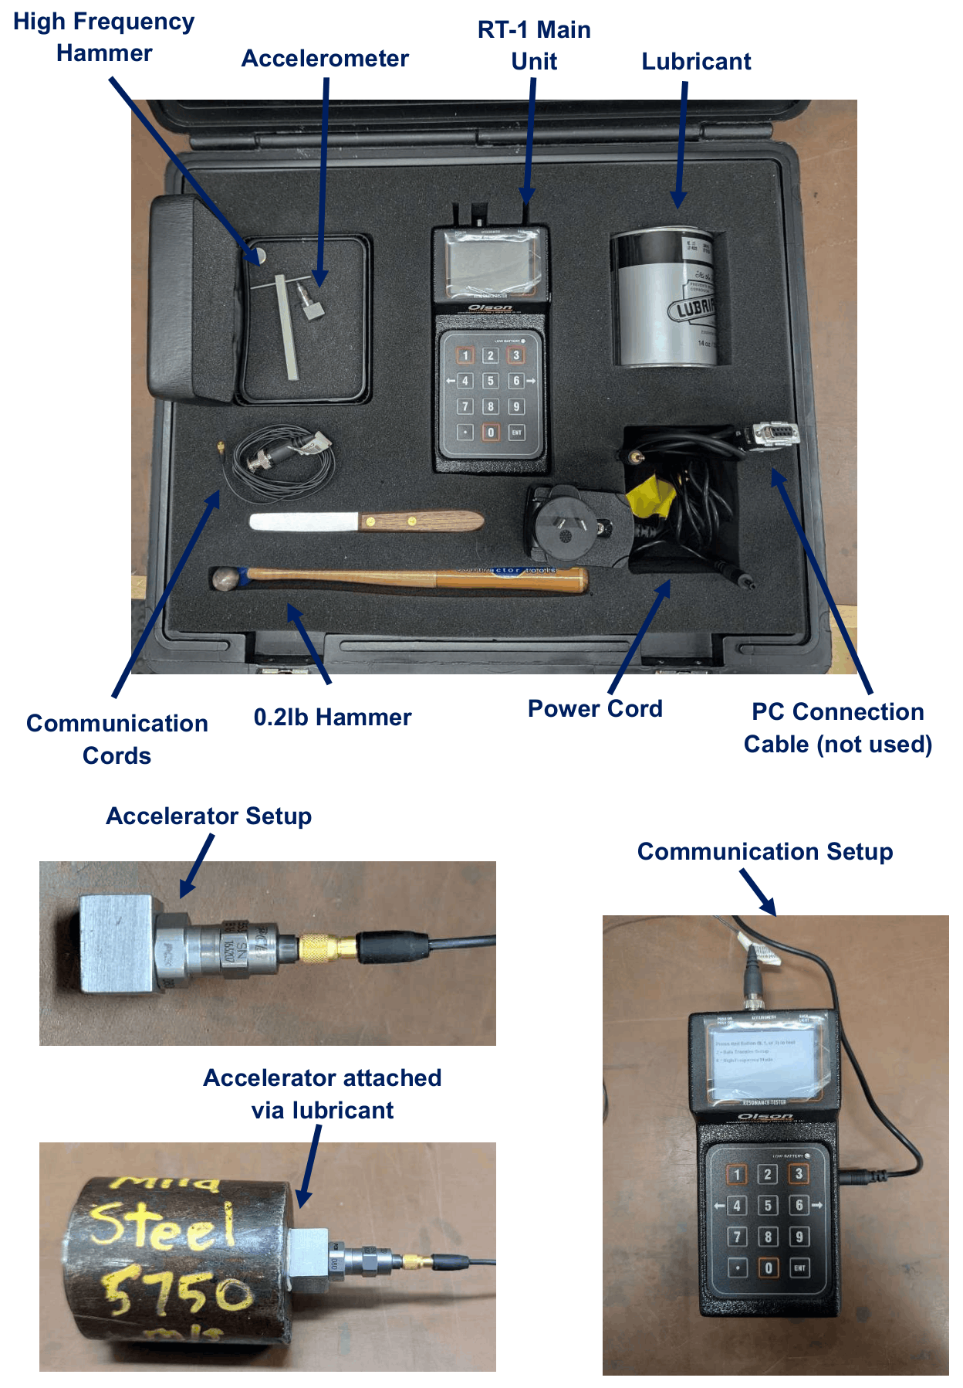

OPERATION

PRE-START UP
- Connect the communication and power cords to the device (the device will not start up unless powered at the wall).
- Attach the magnetic block to the accelerator and connect to the communications cord
- Apply a small amount of lubricant to the sample surface to adhere the magnetic block. Placement of the block should be dictated by the desired direction of measurement:
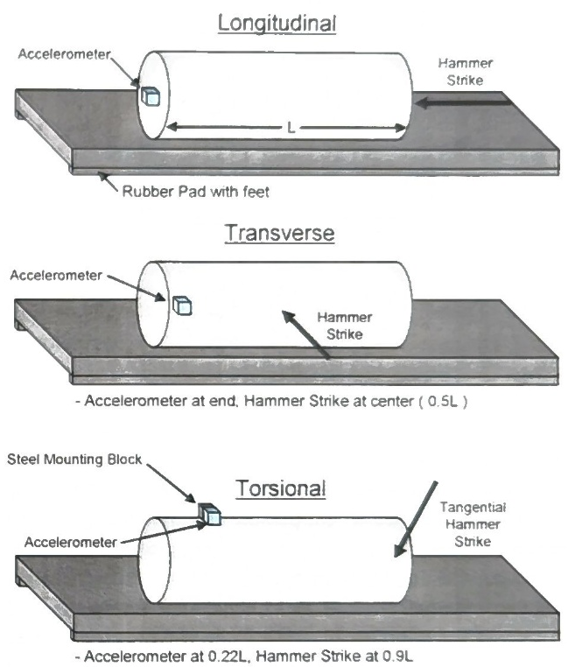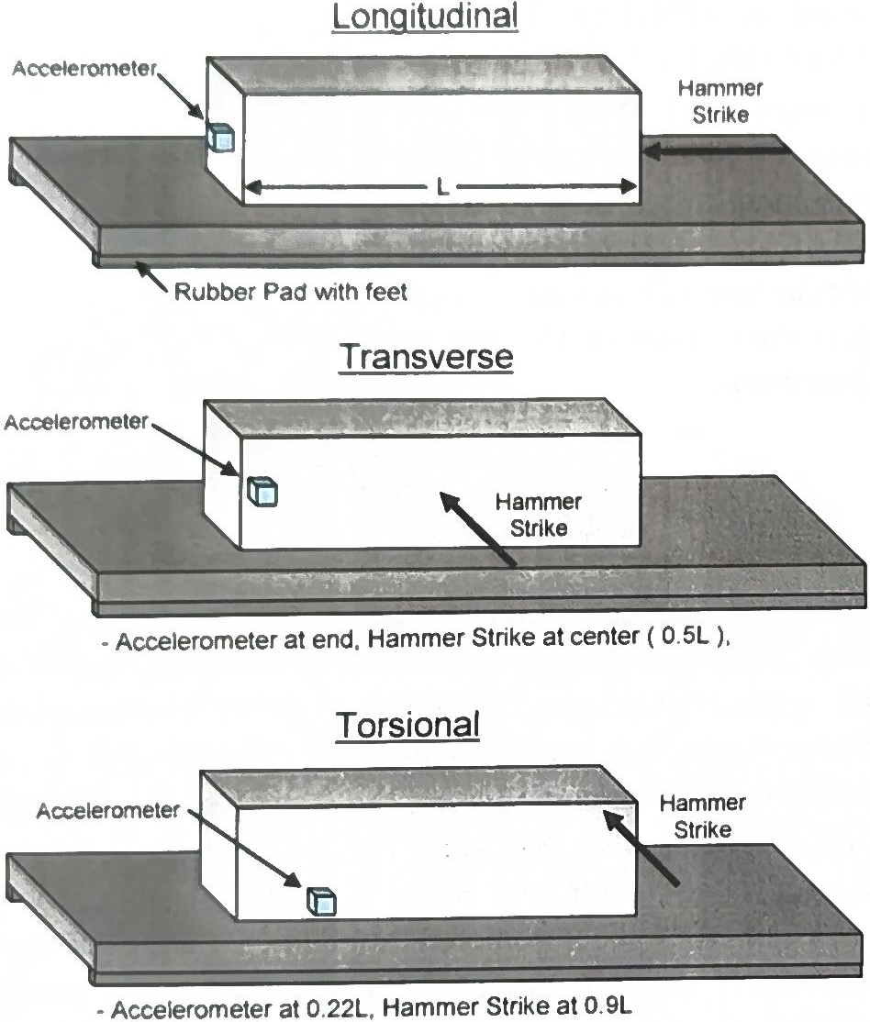

START UP
- Press the top left-hand button to turn on
- Follow on screen prompts. Pressing a red button (1, 3, 0) should activate measurement mode. Pressing 6 will alternate between high frequency and regular modes.
- After striking the sample wait for results to appear. Record and save or exit.
Data transfer is not available because the software is no longer supported.

SHUT DOWN
To shut down press the top-left hand button again. Detach cords and pack away.

MAINTENANCE
To ensure reliable and trouble-free operation, it is the user’s responsibility to maintain the machine in the best possible condition. Such a machine will produce accurate consistent results; problems will be less frequent and less severe.

CLEANING
Do not get the device wet. Wipe down with a damp towel to clean.

MAINTENANCE
Ensure that the ports and cables remain undamaged and free from obtrusions through regular inspection.

EMERGENCY
Commence emergency procedures in accordance with the local emergency requirements.
UNIVERSITY SECURITY (Parkville 24hr) 834 46666

FIRST AID KITS
There is a first aid kit on the shelf directly above the vacuum chamber.

PORTABLE DEFIBRILLATORS
Portable Defibrillator located at the entrance to Thomas Cherry Building level 2, walk through McCoy foyer. A second Portable Defibrillator is in the Physics podium over the walkway/bridge across Swanston St.

LISTINGS OF FIRST AIDERS
Listings of First Aiders located at First Aid Kits, as well as emergency contact posters on safety notice board.

INCIDENT REPORTING
- Report any incident to your Supervisor immediately.
- Report the incident on ERMS and local OHS contact https://unimelbcloud.sharepoint.com/teams/ScienceOHSResources as soon as possible.
- In the event of a major incident the following reporting steps will also occur:
  - Notify the relevant emergency response department e.g. Fire, Ambulance, Police (000).
  - Notify Security (834 46666) 24/7 support.
  - Notify your supervisor and the local OHS contact as soon as reasonably practicable. https://unimelbcloud.sharepoint.com/teams/ScienceOHSResources

REFERENCES

Reference Material | Location (if physical) or Link (if electronic)
University of Melbourne risk register | https://safety.unimelb.edu.au/__data/assets/pdf_file/0009/4859235/UoM-Health-and-Safety-Risk-Register-v4.pdf
School/Department risk register | https://unimelbcloud.sharepoint.com/teams/SGEASHealthandSafetyResources
Equipment Risk Assessment | N/A
Manufacturer’s / Supplier’s operating manual | https://sgeas.unimelb.edu.au/research/auscope-subsurface-observatory. Physical copy stored with device.
Research Group Safety Manual (If applicable) | https://sgeas.unimelb.edu.au/research/auscope-subsurface-observatory. Alternatively scan QR code attached to lid.
University safety website guidelines and requirements | https://safety.unimelb.edu.au/

Relevant Legislation References | Location (web link or physical copy location))
OHS Act, Vic. | https://www.legislation.vic.gov.au/in-force/acts/occupational-health-and-safety-act-2004/043
OHS Regulations, Vic | https://www.legislation.vic.gov.au/in-force/statutory-rules/occupational-health-and-safety-regulations-2017/014
Other relevant Acts and Regulations:
☐ ________________________
☐ ________________________
☐ ________________________
☐ ________________________

Compliance codes and Codes of Practice  ☐ ________________________  ☐ ________________________  ☐ ________________________  ☐ ________________________ | https://www.worksafe.vic.gov.au/laws-and-regulations
Australian Standards: source SAI Global.  ☐ ________________________  ☐ ________________________  ☐ ________________________  ☐ ________________________ | https://research.ebsco.com/c/xppotz/search/details/f7kyfyxrkz

