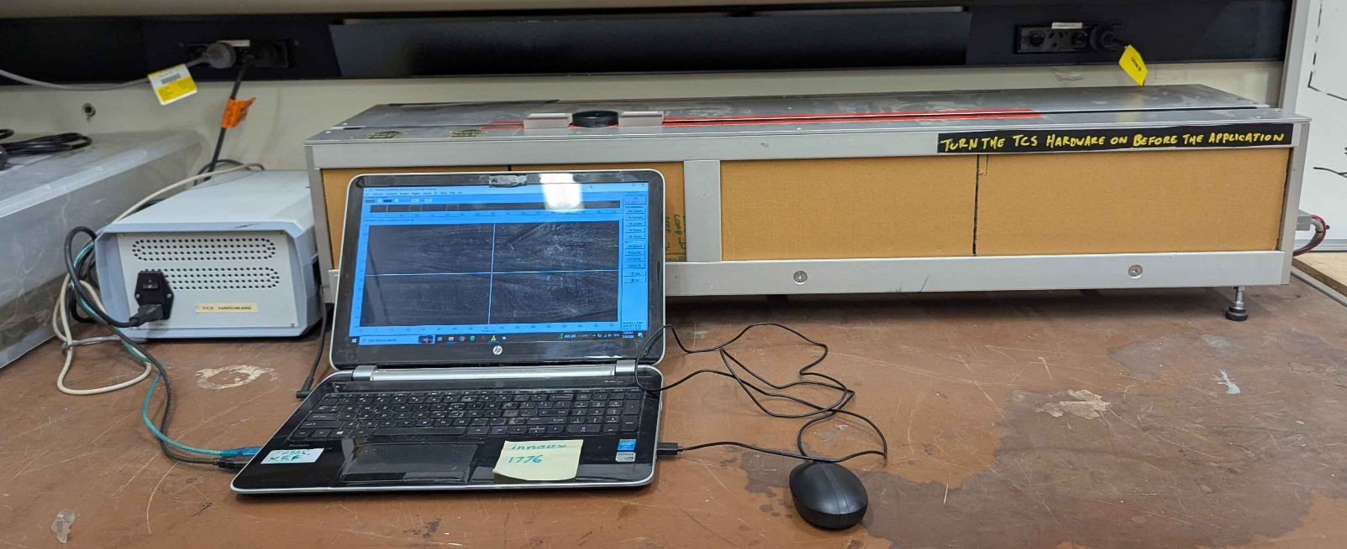

SCOPE
The scope of this Standard Operating Procedure outlines the safe use and operation of:
Name of machinery/equipment | Thermal Conductivity Scanner

Campus | Parkville | Other:
Building | 200 – McCoy | Other:
Room No. | 111 – Petrophysics Lab | Other:
Offsite |  | Other:

This item has an inherent risk rating of:
Risk rating | ☐ | Low | ☒ | Medium | ☐ | High

This Standard Operating Procedure considers the intended purpose and use as outlined by the manufacturer.

DESCRIPTION

INTENDED APPLICATION
The TCS (thermal conductivity scanner) is intended to be used to measure the thermal conductivity and diffusivity of natural materials. It can scan up to a meter length of material in a single measurement making it ideal for measuring core.

MANUFACTURER’S SPECIFICATIONS
The measurement equipment makes use of an infrared emitting heat source (electrical lamp) that is strong enough to burn paper and other materials. Therefore, never cover the optical head with combustible material whilst switched on, never look directly into the lamp beam, do not to touch the lamp or move your hand into its beam.
There are moving parts in the machine that pose a crushing hazard. Therefore, never put your hands or any other parts of your body inside the TCS whilst it is in operation.
Ensure the scanner and standards are always kept at a constant room temperature, out of direct sunlight
away from heaters, ventilators, flowing air and open windows

TRAINING / LICENCING
Relevant local inductions that are required for operators of this machinery/equipment

Petrophysics Laboratory Induction

Relevant TrainME modules or external training required for operators of this machinery/equipment

TrainME modules
☒ Health & Safety Roles & Responsibilities | ☐ Chemical Management | ☐ Hot Work
☐ Manual Handling | ☐ Compressed Gas Safety | ☐ Biorisk – Accredited Persons
☐ Computer Workstation Training | ☐ Safe Radiation Practices - Ionising | ☐ Animal Welfare & Ethics
☒ Personal Protective Equipment | ☐ Safe Radiation Practices - Laser | ☐ Other (please specify):
☒ Laboratory Safety | ☐ Biorisk – Biosafety Induction | ☐
☒ Plant Safety | ☐ Biorisk - Behavioural CF | ☐

Externally Provided Courses
☐Provide First Aid | ☐Working at Heights | ☐Four Wheel Drive
☐Remote First Aid | ☐Tower Rescue | ☐Chainsaw Safety
☐Diving Certificate | ☐Boat Licence | ☐Confined Spaces
☐Quad Bike | ☐Heavy Vehicle Licence | ☐Other (please specify):

List of authorised trainers:

Name | Position (Job Title) | Relevant Qualifications/Experience/Licensing (If Applicable)
Dan Sandiford | Research Fellow
Jesse Ash | Laboratory Support Staff

PERSONAL PROTECTIVE EQUIPMENT (PPE)
Personal protective equipment required that meets relevant Australian Standard.
- Standard PPE:

☐ Safety glasses/goggles (please specify type): | ☐ Face shield
☐ Gloves (please specify type): | ☐ Mask/ respirator (please specify type):
☐ Laboratory Coat/Gown (please specify type): | ☐ Apron (please specify type):
☒ Fully enclosed footwear (please specify type): fully enclosed boots | ☐ Hat (please specify type):
☐ Long pants | ☐ Sunscreen
☐ Long sleeves | ☐ Wet suit
☐ Hearing Protection | ☐ Waders
☐ Other (Please Specify): | ☐ Other (Please Specify):
☐ Other (Please Specify): | ☐ Other (Please Specify):
- Health Monitoring required (HHAQ complete form)
☐ Vaccination/s required | ☐ Spirometry testing
List here: | ☐ Hearing test
☐Other Monitoring (Please Specify): | ☐ Eye test for Laser work
 | ☐ Other (Please specify)

Warnings

SAFETY PRECAUTIONS
- Be careful of moving parts. Do not place hands near the machine whilst it is in motion.
- The infrared laser produces heat, do not touch it or place hands within beam path whilst it is on. Additionally, do not place combustible materials onto or near it.
- Do not look directly into the lamp whilst it is on
- Operator must be trained and familiar with the safe operating procedure.
- Operator to wear PPE as listed.
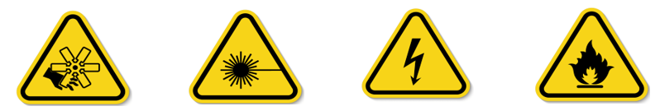

DO’S AND DON’T:
ALWAYS – Isolate and tag out equipment requiring repairs and maintenance.
ALWAYS – Check power cords and other cables for damage before use
ALWAYS – Check moving parts for obstructions before powering on the device
ALWAYS – Keep combustible materials away from the device before turning it on

NEVER – Look directly into the lamp whilst it is switched on
NEVER – Touch the lamp whilst it is switched on
NEVER – Place your hands into the device whilst it is on operation
NEVER – Cover the lamp with paper or other combustible materials

INSTRUMENT CONTROLS
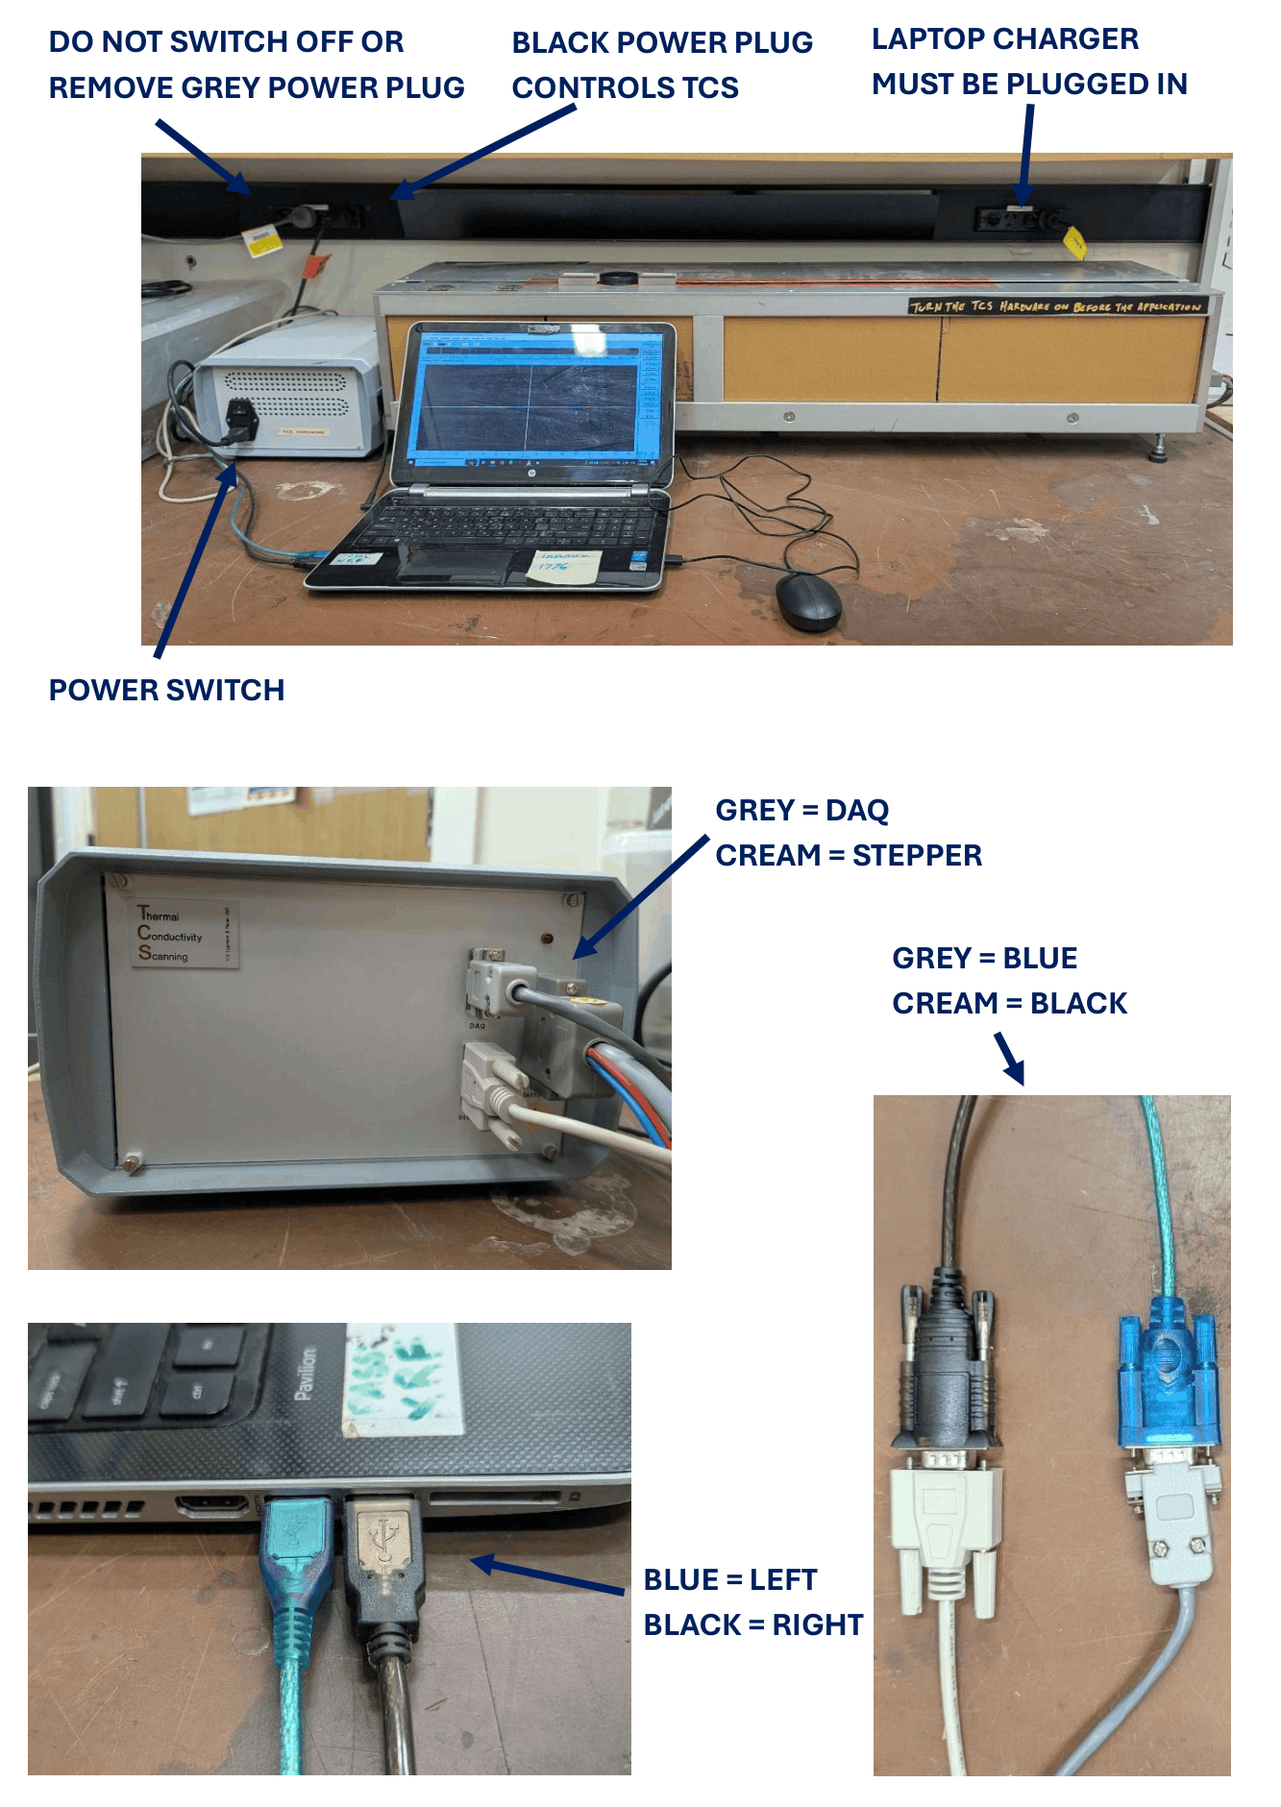
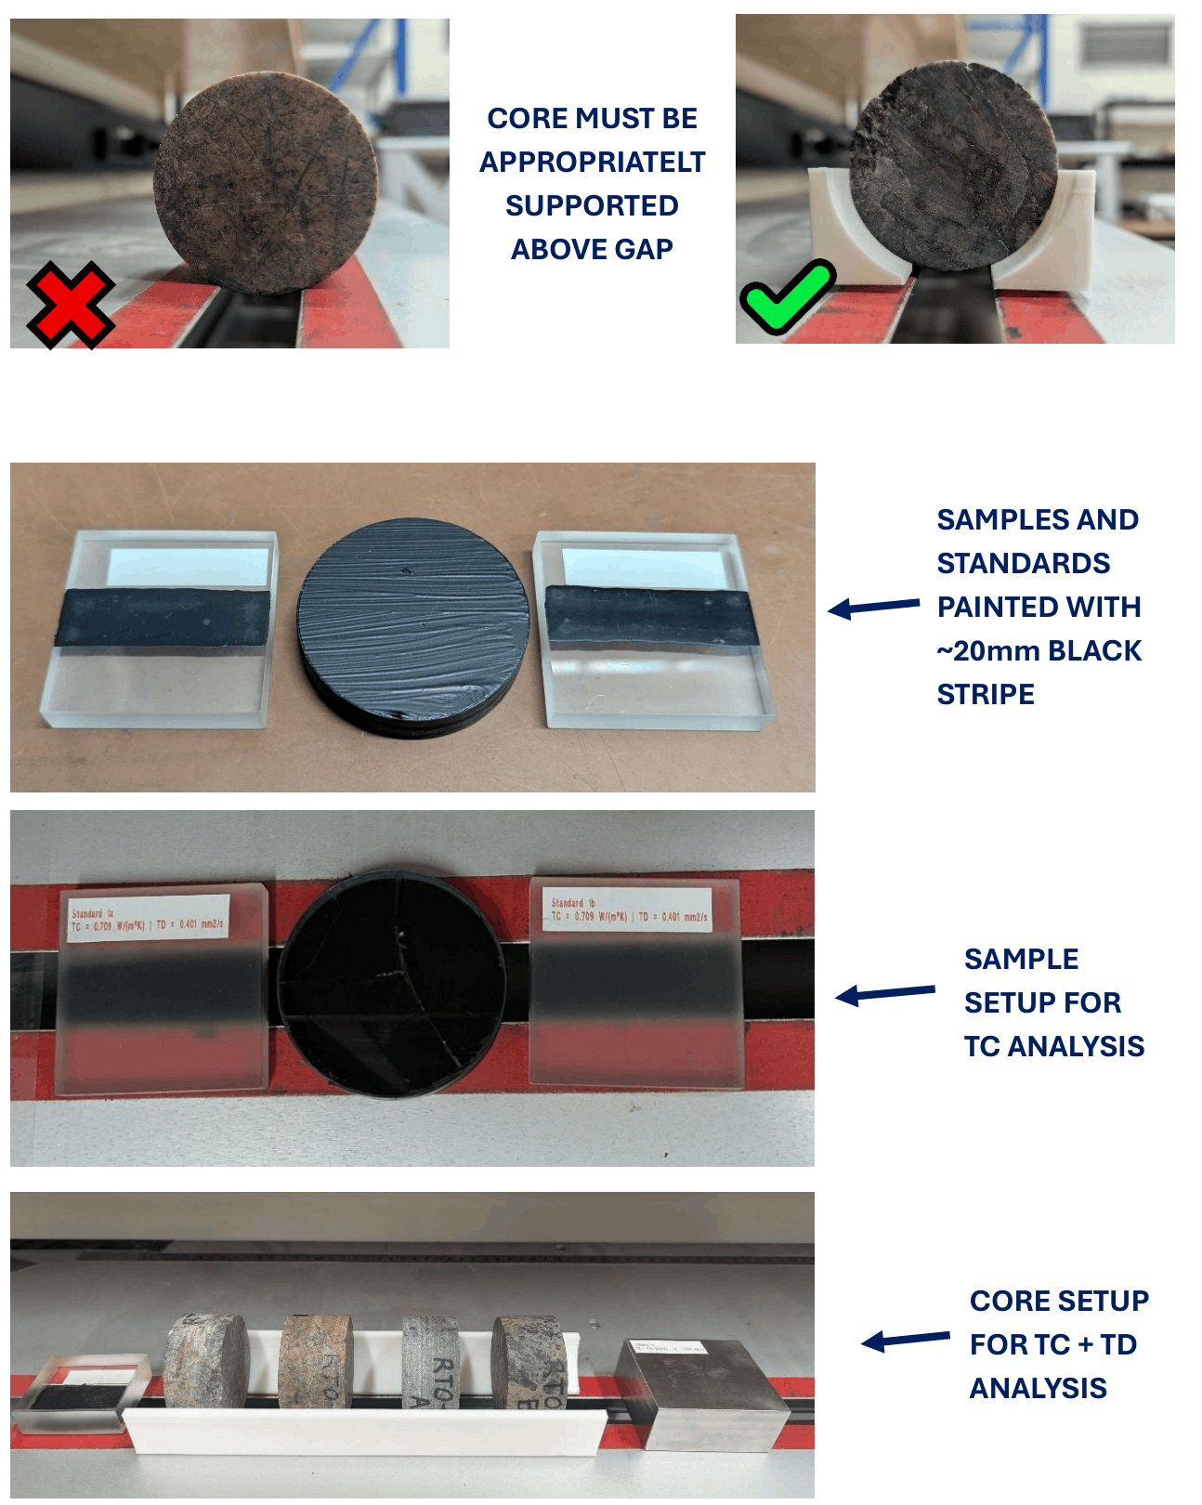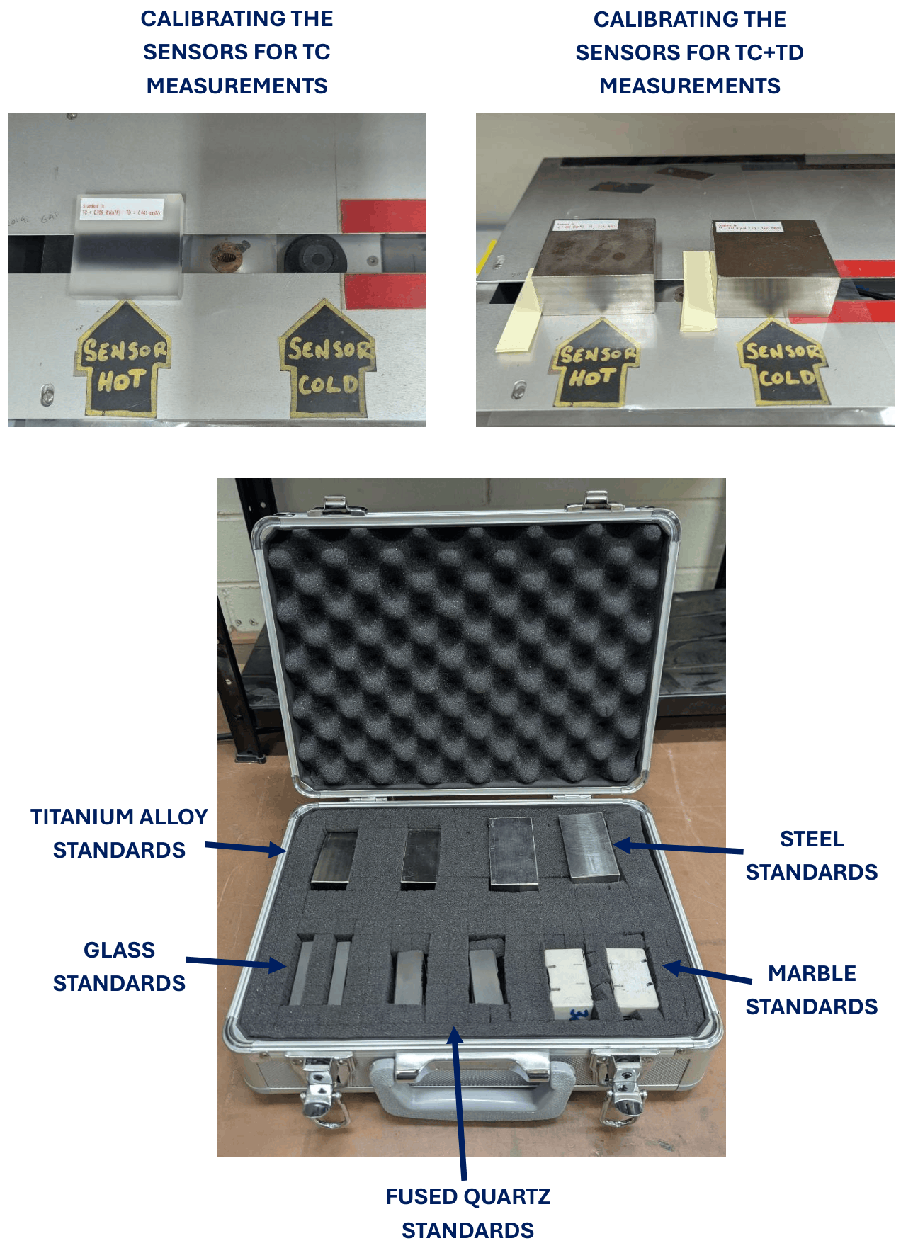

OPERATION

PRE-START UP
- Ensure the standards and samples are appropriately prepared.
  - The standards should already be prepared with a black line of paint ~20mm thick. This paint should not be reapplied unless necessary (because it has worn out)
  - The samples should all be painted with a black line ~20mm thick. Try to match the colour as close as possibly to the standards.
- Ensure all the cables are attached as shown in the pictures above.
  - DO NOT UNPLUG THE GREY CORD NEXT TO THE TCS BLACK POWER CORD
- Ensure that the standards are removed from the case and allowed to equilibrise to the same temperature as the device (~1 hour).

START UP
- Turn on the TCS hardware FIRST
- Open the TCS application
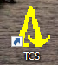
- You will be presented with the following screen. In order to measure a sample you will work through the buttons on the right side of the screen. First, ensure that the TCS is setup properly:
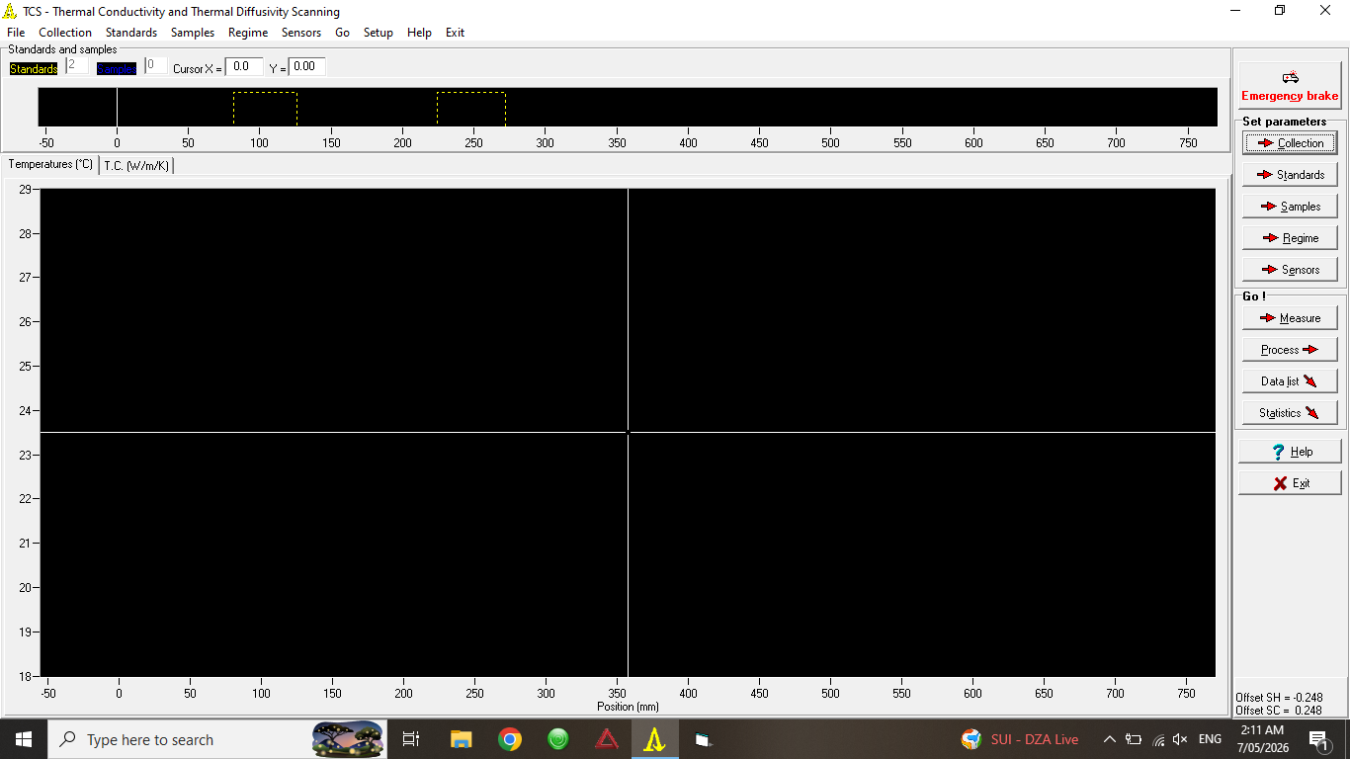
  - Setup Device. Ensure the settings match:
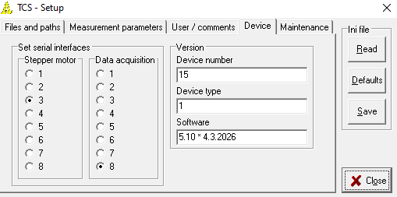
  - Setup Test Stepper Motor. Ensure that the stepper motor moves right, left and stops. Return it to the reference position.
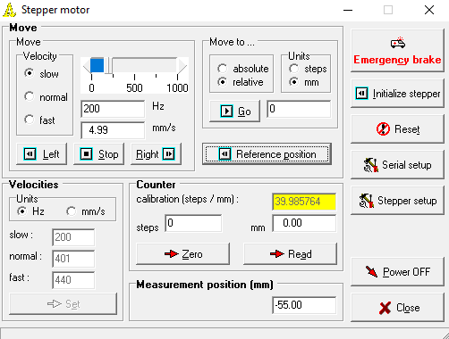

  - Setup Test DAQ. Test that the hot (diff. input channels 0-1) and cold (channels 2-3) sensors are working by pressing start (continuous reading) and waving your hand over the respective sensor. It should detect a change. Afterwards slide 0% slider to 50 to test the luminosity of the lamp. DO NOT LOOK DIRECTLY INTO IT.
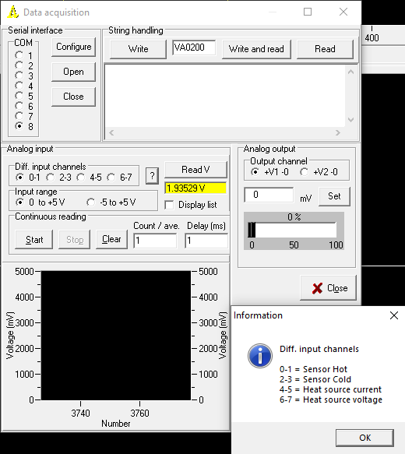
  - Setup TC mode OR TC+TD mode. Note that the first portion of this SOP will focus on the TC only mode as the TC+TD mode has special requirements.
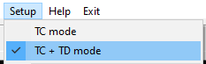

- Place your sample(s) onto the track. Place a standard on either side of the sample(s). Ensure that there is a gap between each material. Align the black stripe on the underside of the standards and materials along the gap. See photos for reference.
  - For TC mode the two standards used must be the of the same material. Choose a material with a TC as close to the sample TC as possible.
  - For TC+TD mode the standard pair must be different. A standard with a lower conductivity than the sample should be at the front and a standard with a higher conductivity must be at the back. For natural materials it is recommended to use fused quartz (low) and titanium alloy (high).
# | Material | TC (W/(m*K)) | TD (mm²/s)
1 | Glass | 0.709 | 0.401
2 | Fused Quartz | 1.35 | 0.827
3a | Marble | 3.91 | 1.608
3b | Marble | 3.81 | 1.580
4 | Titanium Alloy | 5.94 | 2.685
5 | Steel | 13.3 | 3.619

- Collection
Select TCS and create a new folder. Double click on that folder and the name should appear under ‘sample collection name’. Select use. A popup will appear asking whether you would like to read the statistics file. If this is a new project you are saving into, there will not be a statistics file yet. Therefore, select cancel and then close.
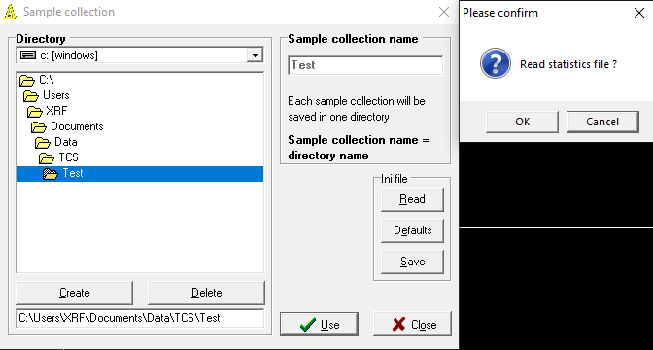
- Standards
Select the appropriate standards. Do not change the start and end positions (they will be determined later). Select close. A popup will appear. Select OK.
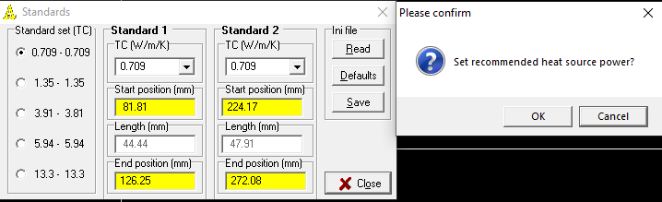
Above: TC mode; Below: TC+TD mode
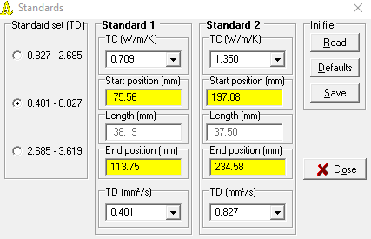
- Samples
Label your sample(s). Cycle through the sample numbers with the arrows. Do not change the start and end positions (they will be determined later).
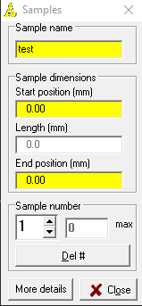
- Regime
This default values should be used unless you know why you are changing them. Also note that the temperature difference produced by the infrared lamp should be ~3-4C. It should never exceed 4C.
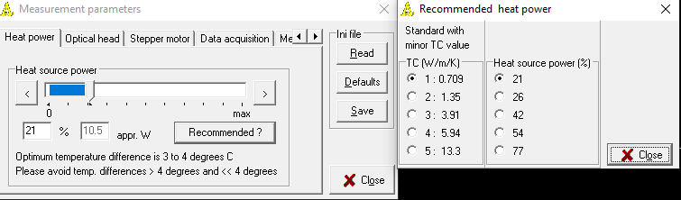

- Sensors
The sensors should be calibrated before every measurement. Select 2 runs then start. Follow the directions as prompted. Take a standard (it must be at the same temperature as the TCS) and place it over the hot sensor. Select OK. Repeat for the cold sensor.
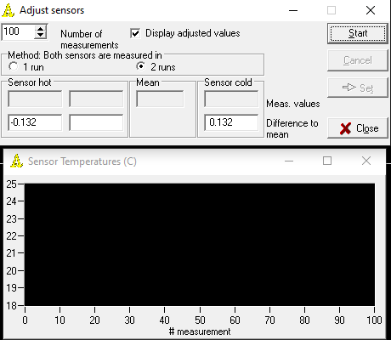
9.5 TC+TD Calibration
The TC+TD calibration does not need to be done frequently. It should only be done if changes have been made to the sensor setup. TC+TD mode must be active.
- Take the two titanium alloy standards and place one into a refrigerator (~10C) and the other into an oven (~40C) both for ~1 hour.
- Setup Sensor calibration
- Select start. Follow the prompts. The cold sample should be placed onto the warm sensor and the warm sample onto the cold sensor. Select ok. Swap the samples. Select ok. Swap the samples. Select ok.
- Repeat at least 10 times. Once the results are statistically sound select set.
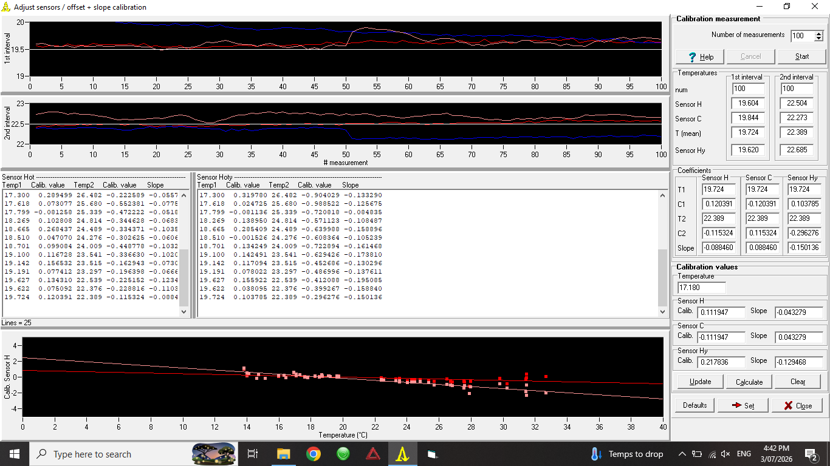

- Measure
The sensor heads will begin to move and record. Once both sensor heads have travelled down the entire length of samples and standards select stop. You will be prompted to save the scan file.
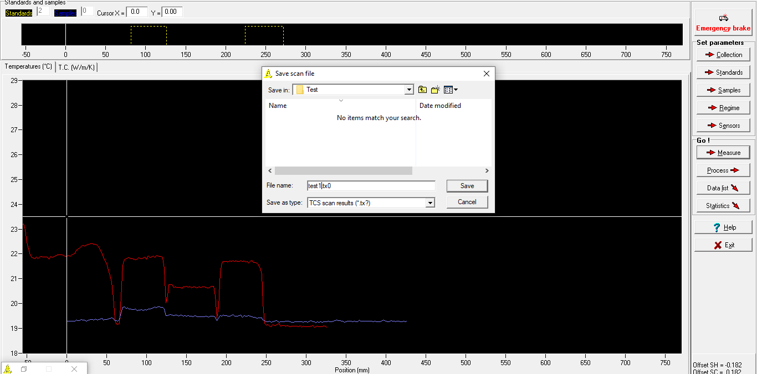
- Process
A popup will appear asking you to set the start and end points of the standards and sample(s). Drag the centre of the crosshairs over each location and double click the yellow box to set the location. Ensure that any boundary effects (erroneously high/low temperatures at the edges of the measurements) are not selected. Select calculate TC before calculate TD (if relevant)
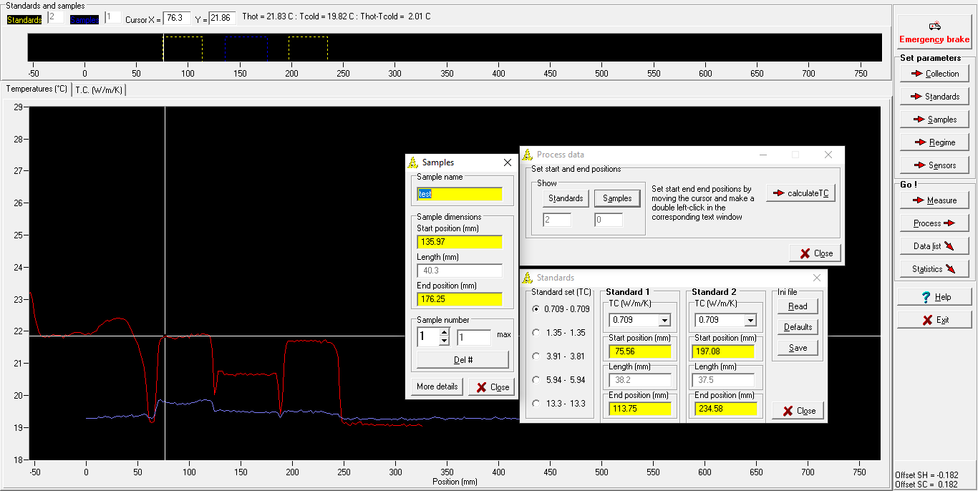
- Statistics
A statistics window will appear that presents the mean values of the test. Save the scan file.
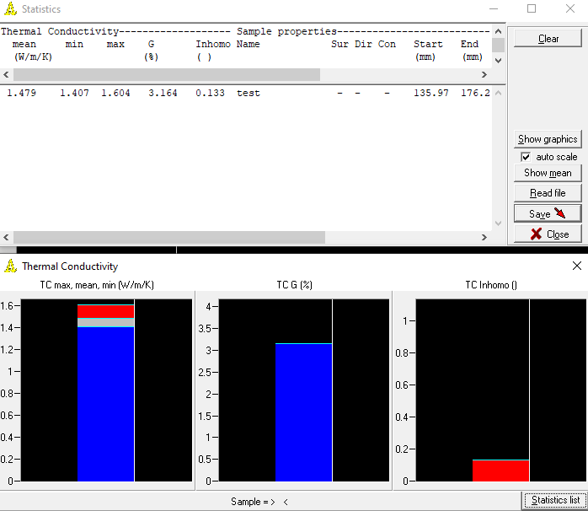
- Data List
You can import data back into the instrument by selecting read file and selecting the saved scan file (.tx0). Each measurement will also have a .dat which contains only the means.
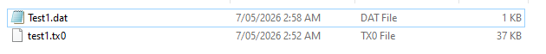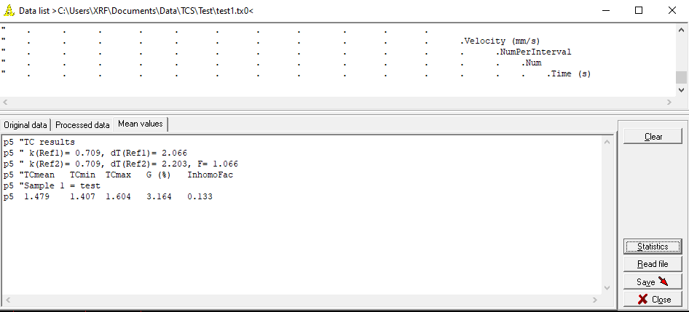
- Other
You can also select the T.C. tab (or T.D. tab if relevant) to see the change in TC over the length of the sample. Moving the white line will show the value at the location (top box).
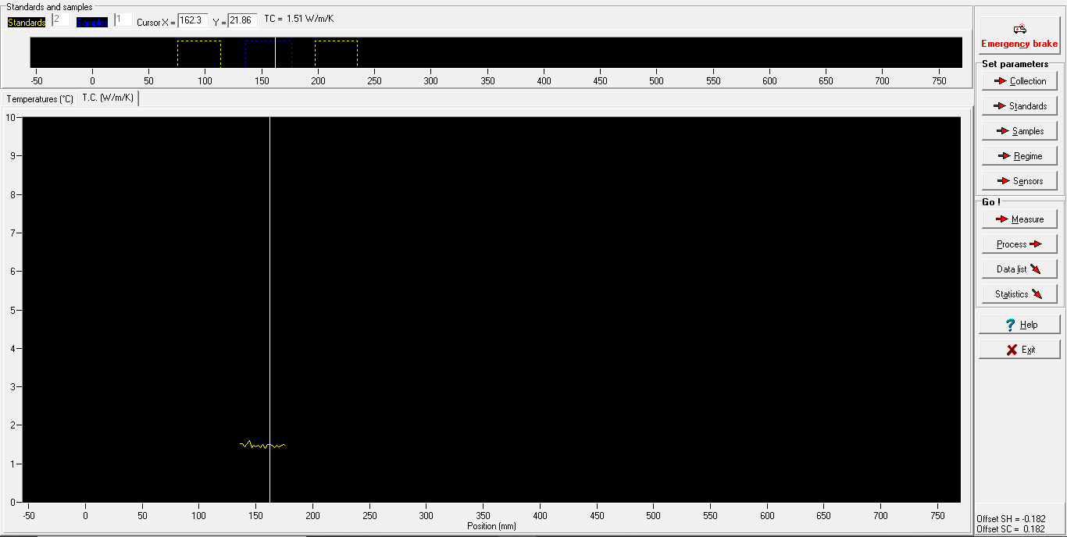
TC+TD Measurement:
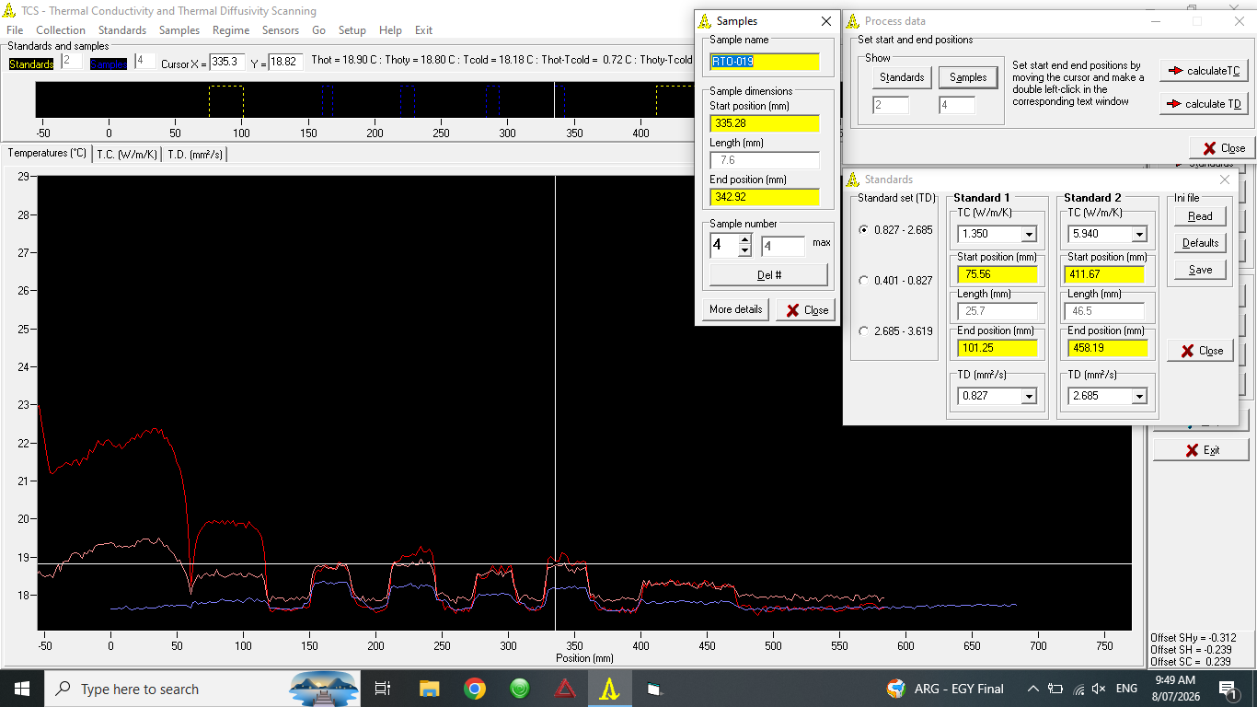

Core samples can show a lot of variation along length. Double click either axis to change the range
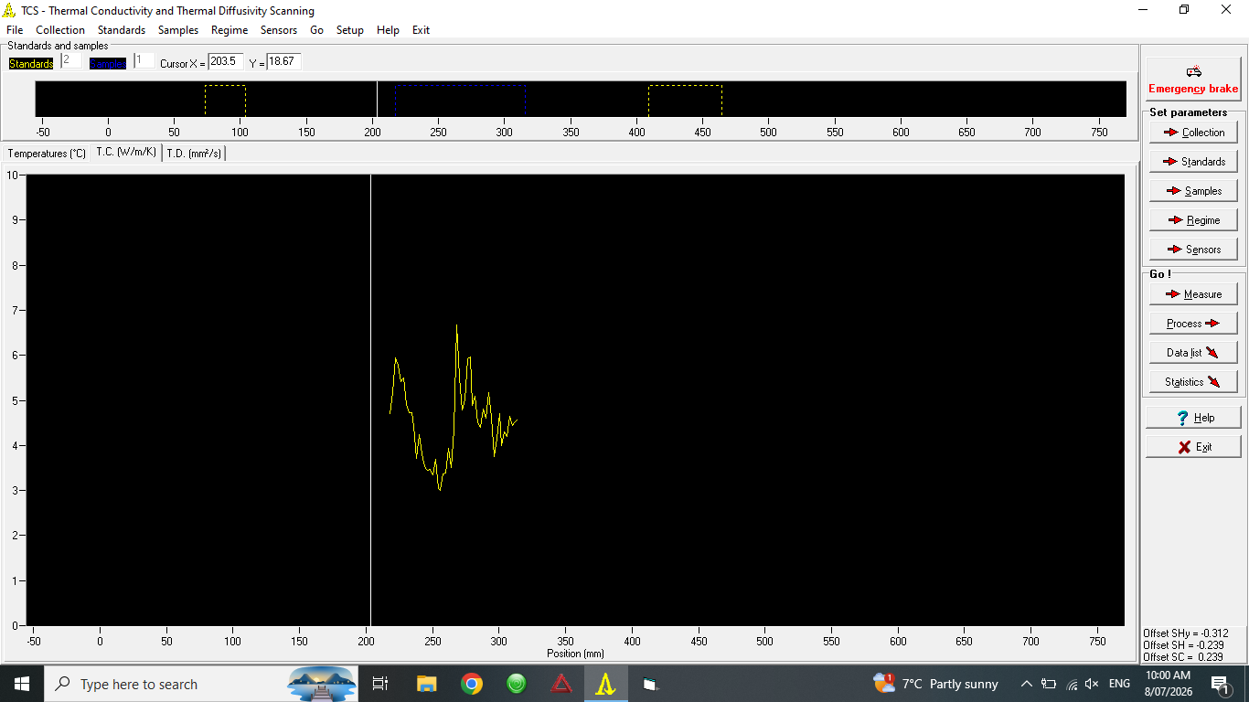

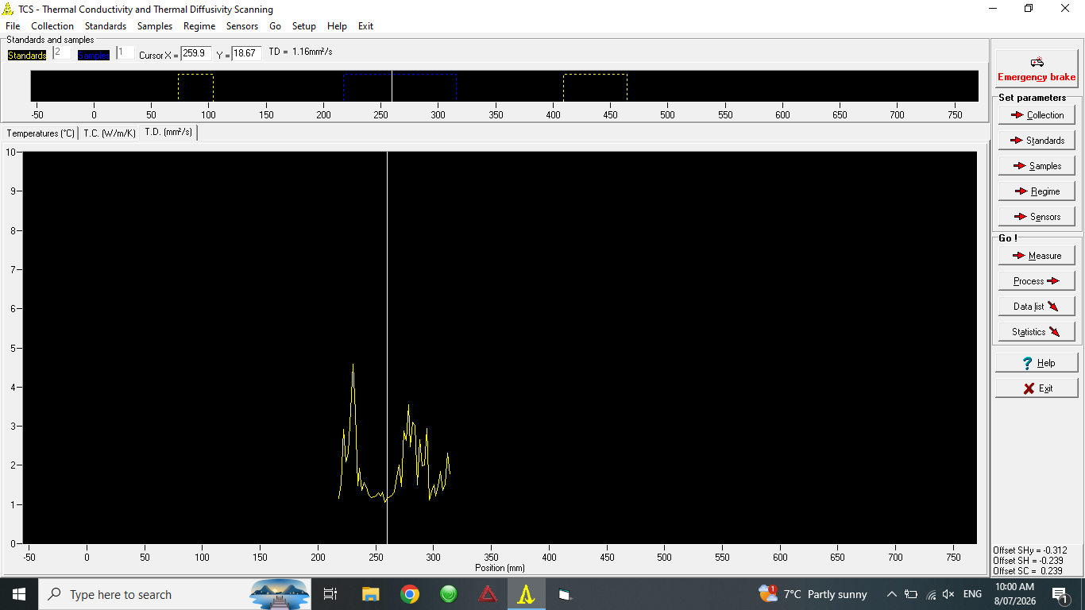

SHUT DOWN
To close the program, select Exit. Close the program before switching off the TCS.

EMERGENCY SHUT DOWN

If it is not possible to switch off the TCS, unplug at the wall.

TROUBLESHOOTING

If you are having issues with erroneous results, make sure that the samples, standards and TCS are all at the same temperature. This might take 1-2 hours if they were stored separately. Also ensure that the TCS has been setup in an appropriate location and has been recently calibrated.

MAINTENANCE
To ensure reliable and trouble-free operation, it is the user’s responsibility to maintain the machine in the best possible condition. Such a machine will produce accurate consistent results; problems will be less frequent and less severe.

CLEANING
Many components on the TCS are not waterproof, therefore it should not be cleaned with water. Instead, use a damp cloth to wipe it down.

MAINTENANCE
Paint may need to be periodically reapplied to the standards. The belt should be oiled when it begins to make an irregular noise or no longer moves smoothly. Check all cords for damage before use.

EMERGENCY
Commence emergency procedures in accordance with the local emergency requirements.
UNIVERSITY SECURITY (Parkville 24hr) 834 46666

FIRST AID KITS
There is a first aid kit on the shelf directly above the vacuum chamber.

PORTABLE DEFIBRILLATORS
Portable Defibrillator located at the entrance to Thomas Cherry Building level 2, walk through McCoy foyer. A second Portable Defibrillator is in the Physics podium over the walkway/bridge across Swanston St.

LISTINGS OF FIRST AIDERS
Listings of First Aiders located at First Aid Kits, as well as emergency contact posters on safety notice board.

INCIDENT REPORTING
- Report any incident to your Supervisor immediately.
- Report the incident on ERMS and local OHS contact https://unimelbcloud.sharepoint.com/teams/ScienceOHSResources as soon as possible.
- In the event of a major incident the following reporting steps will also occur:
  - Notify the relevant emergency response department e.g. Fire, Ambulance, Police (000).
  - Notify Security (834 46666) 24/7 support.
  - Notify your supervisor and the local OHS contact as soon as reasonably practicable. https://unimelbcloud.sharepoint.com/teams/ScienceOHSResources

REFERENCES

Reference Material | Location (if physical) or Link (if electronic)
University of Melbourne risk register | https://safety.unimelb.edu.au/__data/assets/pdf_file/0009/4859235/UoM-Health-and-Safety-Risk-Register-v4.pdf
School/Department risk register | https://unimelbcloud.sharepoint.com/teams/SGEASHealthandSafetyResources
Equipment Risk Assessment | https://sgeas.unimelb.edu.au/research/auscope-subsurface-observatory. Alternatively scan QR code attached to device.
Manufacturer’s / Supplier’s operating manual | https://sgeas.unimelb.edu.au/research/auscope-subsurface-observatory. Alternatively scan QR code attached to device.
Research Group Safety Manual (If applicable) | https://sgeas.unimelb.edu.au/research/auscope-subsurface-observatory. Alternatively scan QR code attached to device.
University safety website guidelines and requirements | https://safety.unimelb.edu.au/

Relevant Legislation References | Location (web link or physical copy location))
OHS Act, Vic. | https://www.legislation.vic.gov.au/in-force/acts/occupational-health-and-safety-act-2004/043
OHS Regulations, Vic | https://www.legislation.vic.gov.au/in-force/statutory-rules/occupational-health-and-safety-regulations-2017/014
Other relevant Acts and Regulations:
☐ ________________________
☐ ________________________
☐ ________________________
☐ ________________________

Compliance codes and Codes of Practice  ☐ ________________________  ☐ ________________________  ☐ ________________________  ☐ ________________________ | https://www.worksafe.vic.gov.au/laws-and-regulations
Australian Standards: source SAI Global.  ☐ ________________________  ☐ ________________________  ☐ ________________________  ☐ ________________________ | https://research.ebsco.com/c/xppotz/search/details/f7kyfyxrkz

