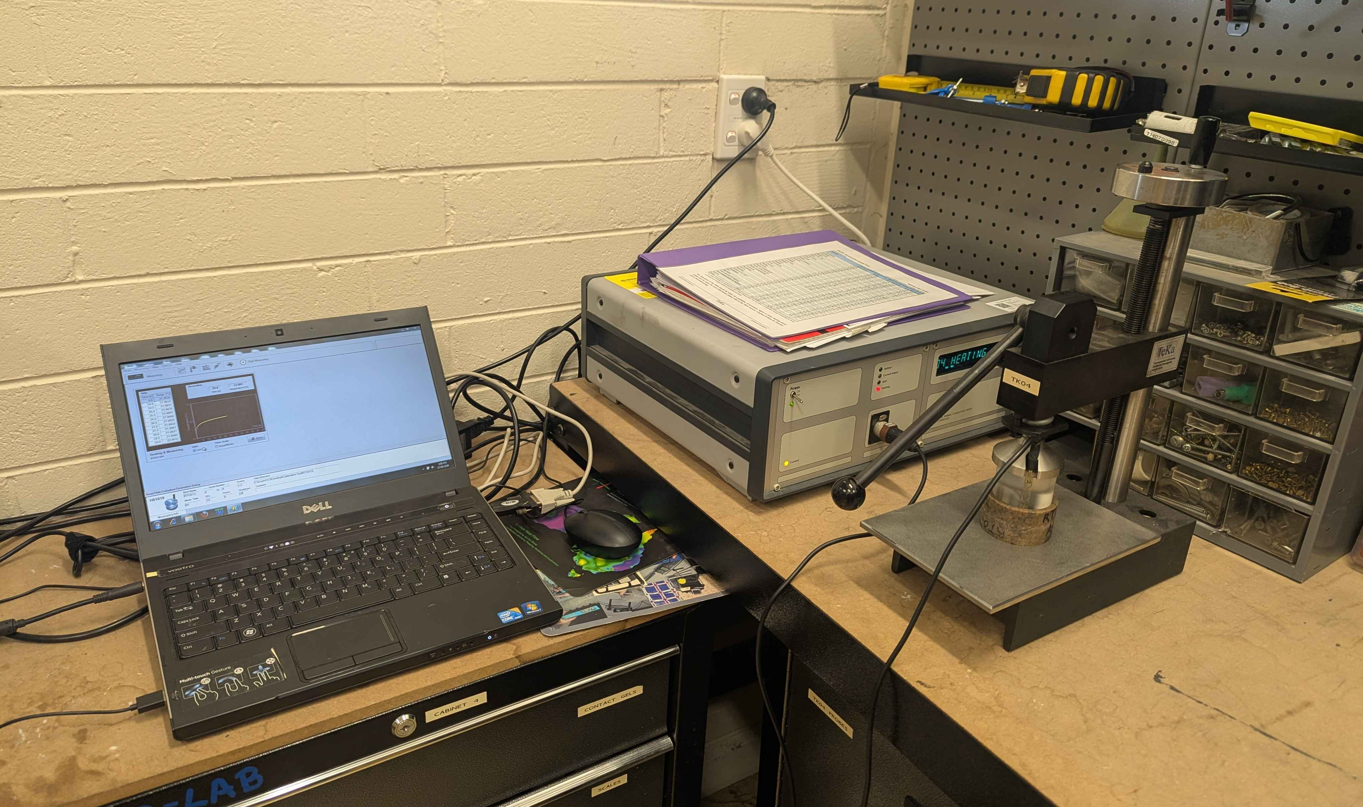

SCOPE
The scope of this Standard Operating Procedure outlines the safe use and operation of:
Name of machinery/equipment | TK04 Thermal Conductivity Scanner

Campus | Parkville | Other:
Building | 200 – McCoy | Other:
Room No. | 111 – Petrophysics Lab | Other:
Offsite |  | Other:

This item has an inherent risk rating of:
Risk rating | ☒ | Low | ☐ | Medium | ☐ | High

This Standard Operating Procedure considers the intended purpose and use as outlined by the manufacturer.

DESCRIPTION

INTENDED APPLICATION
The TK04 Thermal Conductivity Meter by TeKa is intended to be used to measure the thermal conductivity of rock samples using a fast and high precision transient line source method. The standard (88mm diameter) and mini (50mm diameter) HLQ probes are only to be used to measure core samples with two smooth, parallel surfaces. The needle probe is only to be used to measure loose sediments, or rock samples have been precisely drilled to accommodate the needle (2mm diameter, 70mm depth). The TK04 can also be used to measure plastics, glass, ceramics, building materials and wood with an appropriate setup.

MANUFACTURER’S SPECIFICATIONS
Always use the provided pressure-limited device to clamp the HLQ probe to the sample. To ensure that the maximum pressure (10 bar) is not exceeded, do not continue to use the handwheel after the lever it closed. The sample must have two parallel surfaces that have been grinded and smoothed.

Do not apply any force when inserting the VLQ (needle) probe into the sample to avoid bending the needle.

All probes are protected against water, but they should never be submerged completely. The VLQ handle should always remain dry.

TRAINING / LICENCING
Relevant local inductions that are required for operators of this machinery/equipment

Petrophysics Laboratory Induction

Relevant TrainME modules or external training required for operators of this machinery/equipment

TrainME modules
☒ Health & Safety Roles & Responsibilities | ☐ Chemical Management | ☐ Hot Work
☐ Manual Handling | ☐ Compressed Gas Safety | ☐ Biorisk – Accredited Persons
☐ Computer Workstation Training | ☐ Safe Radiation Practices - Ionising | ☐ Animal Welfare & Ethics
☒ Personal Protective Equipment | ☐ Safe Radiation Practices - Laser | ☐ Other (please specify):
☒ Laboratory Safety | ☐ Biorisk – Biosafety Induction | ☐
☐ Plant Safety | ☐ Biorisk - Behavioural CF | ☐

Externally Provided Courses
☐Provide First Aid | ☐Working at Heights | ☐Four Wheel Drive
☐Remote First Aid | ☐Tower Rescue | ☐Chainsaw Safety
☐Diving Certificate | ☐Boat Licence | ☐Confined Spaces
☐Quad Bike | ☐Heavy Vehicle Licence | ☐Other (please specify):

PERSONAL PROTECTIVE EQUIPMENT (PPE)
Personal protective equipment required that meets relevant Australian Standard.
☐ Safety glasses/goggles (please specify type): | ☐ Face shield
☐ Gloves (please specify type): | ☐ Mask/ respirator (please specify type):
☐ Laboratory Coat/Gown (please specify type): | ☐ Apron (please specify type):
☒ Fully enclosed footwear: Fully enclosed boots | ☐ Hat (please specify type):
☐ Long pants | ☐ Sunscreen
☐ Long sleeves | ☐ Wet suit
☐ Hearing Protection | ☐ Waders
☐ Other (Please Specify): | ☐ Other (Please Specify):
☐ Other (Please Specify): | ☐ Other (Please Specify):
- Health Monitoring required (HHAQ complete form)
☐ Vaccination/s required | ☐ Spirometry testing
List here: | ☐ Hearing test
☐Other Monitoring (Please Specify): | ☐ Eye test for Laser work
 | ☐ Other (Please specify)

Warnings

SAFETY PRECAUTIONS
- Ensure that all power and PC cables are free from damage before use.
- Operator must be trained and familiar with the safe operating procedure.
- Operator to wear PPE as listed.


DO’S AND DON’T:
ALWAYS – Inspect all cables for damage before plugging them in
ALWAYS – Ensure the material you are testing has been approved for use
ALWAYS – Ensure the sample has two parallel faces that are level and smooth
NEVER – Connect, disconnect or swap a cord whilst the device is powered on
NEVER – Allow the device to get wet or subject it to non-atmospheric heat and temperature conditions
NEVER – Place chemically aggressive materials onto the probe surfaces

INSTRUMENT CONTROLS
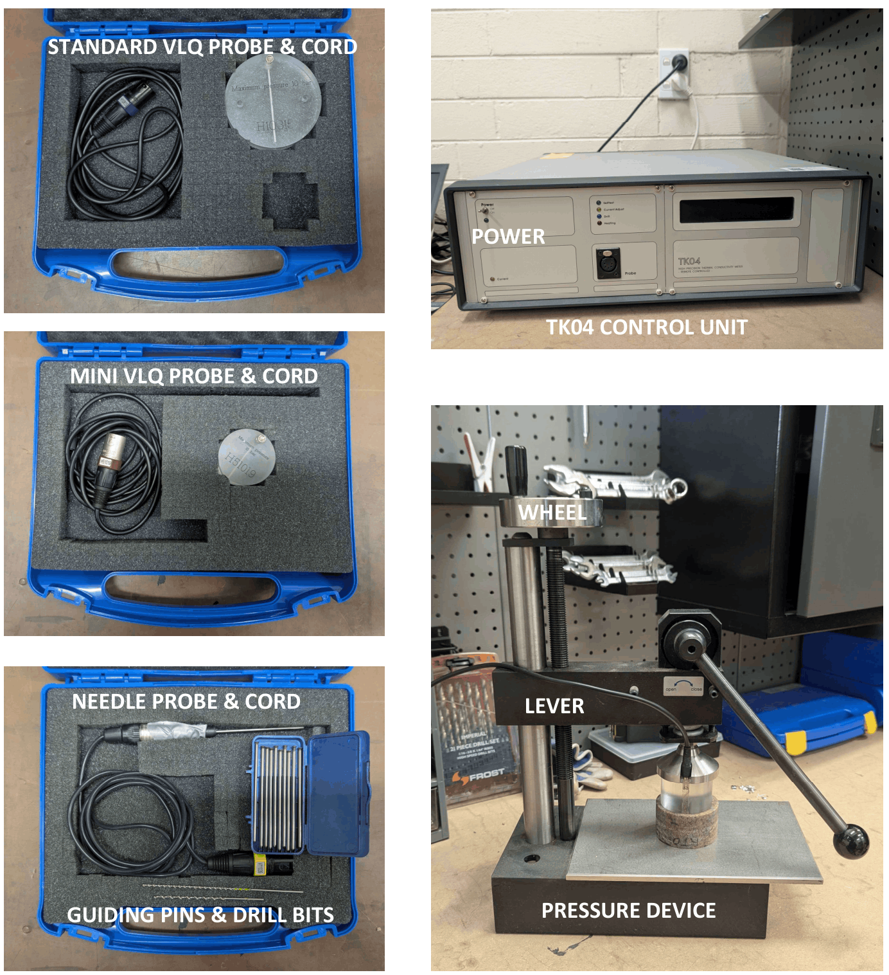

OPERATION

PRE-START UP
GENERAL
- Connect the TK04 power cord and laptop connection via a serial to USB converter
- Connect the probe to the TK04 control unit using the cord supplied in the same box as the probe.
VLQ:
- The sample must have two, smooth parallel surfaces. If the sample has a diameter: greater than 88mm use the standard VLQ; between 88mm and 50mm use the mini VLQ; less than 50mm it is inappropriate for measurement.
- Apply a contact gel (e.g. petroleum jelly) to the sample surface that will be in contact with the probe.
- Clamp the probe and sample together in the pressure device. Ensure that the lever is in the open position when winding the wheel. Once the wheel hits its pressure limit, close the lever.
Needle Probe
- Apply a contact gel (e.g. petroleum jelly) to the length of the probe.
- The sample must have a straight 2x70mm hole drilled into it (preferably using the drill bits supplied with the probe. The probe must fall freely into the hole, without pressure applied by the user. Alternatively, if the sample is soft or viscous in nature (sand, soil, etc.) the probe can be inserted directly into sample but ensure not to apply excessive pressure.

START UP
- Switch on the TK04 unit and wait 10 minutes for it to warm up.
- Start the TK04 software (desktop or taskbar)


- Open the measurement configuration tab:
- Probe number: choose the correct probe (the number labelled on the cord and probe)
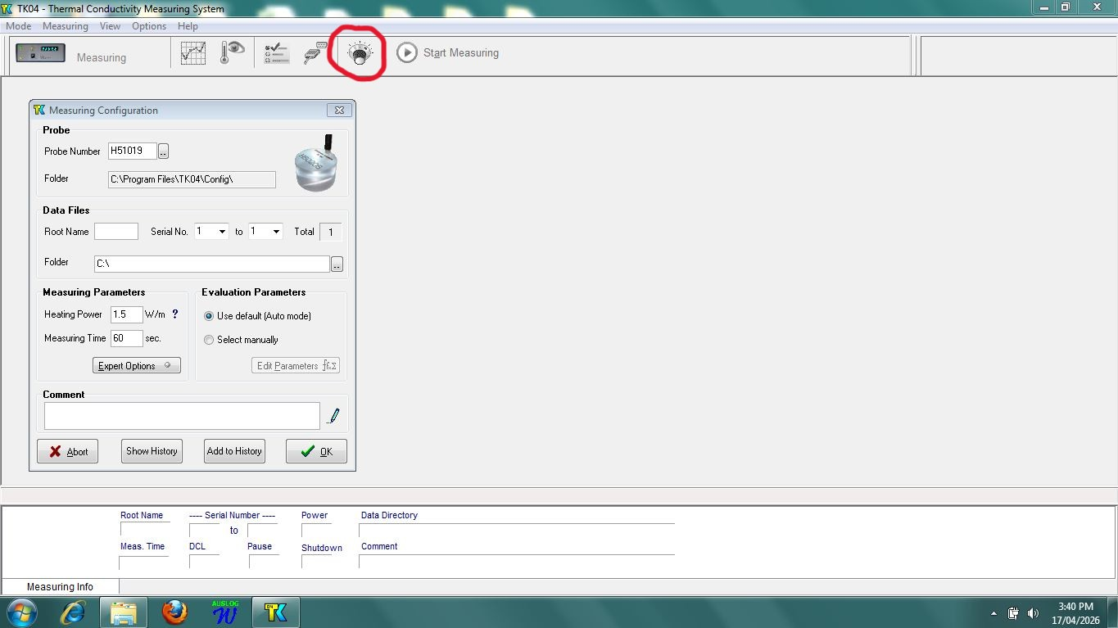
- Root Name: Choose a label based on the sample ID
- Serial No.: Each measurement needs a unique serial number. If you are adding to an existing folder an error will appear. If you choose to append, ensure the new serial number is unique otherwise it will overwrite the last entry with this serial number and root name combination.
- Folder: Choose an appropriate save directory
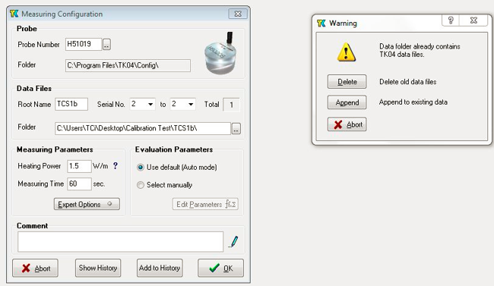
- Measurement and Evaluation parameters: For the first measurement either use the default parameters (listed below) or select parameters based on the material type, visible via the ‘?’ icon. Adjust based on experience and software recommendations for subsequent measurements
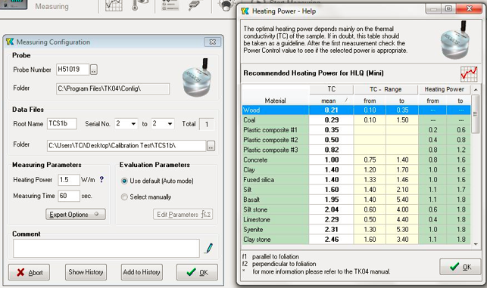
- VLQ Standard:
  - Heating power: 3 W m⁻¹
  - Measuring time: 80s
  - Expert options: default (DCL = 10, Pause = 0, Start Delay =0)
  - Evaluation Parameters
    - Start time minimum: 20s
    - Start time maximum: 40s
    - End time: 80s
    - Interval length minimum: 25s
    - LET minimum: 4
- VLQ Mini:
  - Heating power: 1 W m⁻¹
  - Measuring time: 60s
  - Expert options: default (DCL = 10, Pause = 0, Start Delay =0)
  - Evaluation Parameters
    - Start time minimum: 10s
    - Start time maximum: 30s
    - End time: 60s
    - Interval length minimum: 20s
    - LET minimum: 4
- Needle Probe:
  - Heating power: 5 W m⁻¹
  - Measuring time: 80s
  - Expert options: default (DCL = 10, Pause = 0, Start Delay =0)
  - Evaluation Parameters
    - Start time minimum: 20s
    - Start time maximum: 40s
    - End time: 80s
    - Interval length minimum: 25s
    - LET minimum: 4
- Click OK to start measurement. Wait for the interface to check ports.
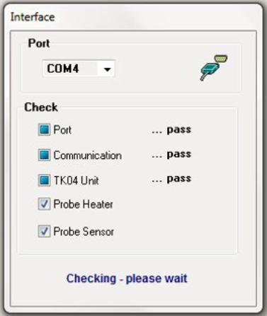
- A window will appear to ask you to adjust the heating power. Control using the up and down arrows. Find the smallest deviation then select OK.
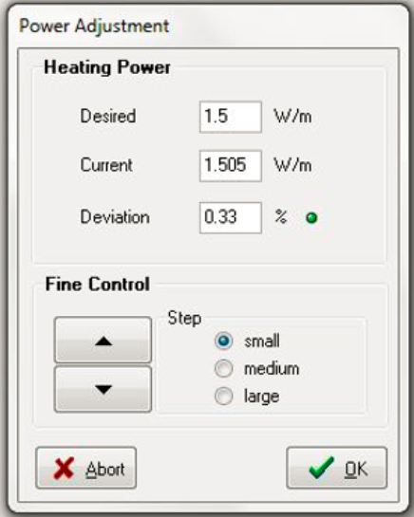

The TK04 will automatically begin to measure. Once the measurement has completed it will display the results along with any previous measurements in the same root folder.
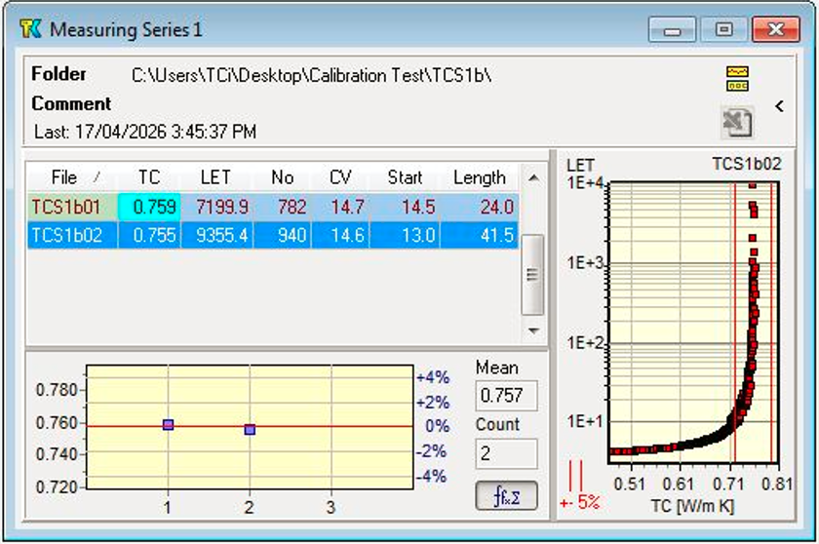

SHUT DOWN
Shut down the software, turn off at the switch and then turn off at the wall. Only once the device has been fully powered down should you attempt to disconnect or switch out the probe.

EMERGENCY SHUT DOWN
If it is not possible to shut the TK04 down at the switch, immediately turn it off at the wall.

MAINTENANCE
To ensure reliable and trouble-free operation, it is the user’s responsibility to maintain the machine in the best possible condition. Such a machine will produce accurate consistent results; problems will be less frequent and less severe.

CLEANING
The device and probes should never be submerged in water. To clean, gently wipe down with a damp cloth.

MAINTENANCE
Meter: Only replace fuses with appropriate type and size as indicated on the instruments rear-panel
Pressure Device: If the lever ceases to move smoothly the sliding surface at the lever’s base should be lubricated with molybdenum sulphide paste ONLY.

EMERGENCY
Commence emergency procedures in accordance with the local emergency requirements.
UNIVERSITY SECURITY (Parkville 24hr) 834 46666

FIRST AID KITS
There is a first aid kit on the shelf directly above the vacuum chamber.

PORTABLE DEFIBRILLATORS
Portable Defibrillator located at the entrance to Thomas Cherry Building level 2, walk through McCoy foyer. A second Portable Defibrillator is in the Physics podium over the walkway/bridge across Swanston St.

LISTINGS OF FIRST AIDERS
Listings of First Aiders located at First Aid Kits, as well as emergency contact posters on safety notice board.

INCIDENT REPORTING
- Report any incident to your Supervisor immediately.
- Report the incident on ERMS and local OHS contact https://unimelbcloud.sharepoint.com/teams/ScienceOHSResources as soon as possible.
- In the event of a major incident the following reporting steps will also occur:
  - Notify the relevant emergency response department e.g. Fire, Ambulance, Police (000).
  - Notify Security (834 46666) 24/7 support.
  - Notify your supervisor and the local OHS contact as soon as reasonably practicable. https://unimelbcloud.sharepoint.com/teams/ScienceOHSResources

REFERENCES

Reference Material | Location (if physical) or Link (if electronic)
University of Melbourne risk register | https://safety.unimelb.edu.au/__data/assets/pdf_file/0009/4859235/UoM-Health-and-Safety-Risk-Register-v4.pdf
School/Department risk register | https://unimelbcloud.sharepoint.com/teams/SGEASHealthandSafetyResources
Equipment Risk Assessment | N/A
Manufacturer’s / Supplier’s operating manual | https://sgeas.unimelb.edu.au/research/auscope-subsurface-observatory. Alternatively scan QR code attached to device.
Research Group Safety Manual (If applicable) | https://sgeas.unimelb.edu.au/research/auscope-subsurface-observatory. Alternatively scan QR code attached to device.
University safety website guidelines and requirements | https://safety.unimelb.edu.au/
Other (please specify)

Relevant Legislation References | Location (web link or physical copy location))
OHS Act, Vic. | https://www.legislation.vic.gov.au/in-force/acts/occupational-health-and-safety-act-2004/043
OHS Regulations, Vic | https://www.legislation.vic.gov.au/in-force/statutory-rules/occupational-health-and-safety-regulations-2017/014
Other relevant Acts and Regulations:
☐ ________________________
☐ ________________________
☐ ________________________
☐ ________________________

Compliance codes and Codes of Practice  ☐ ________________________  ☐ ________________________  ☐ ________________________  ☐ ________________________ | https://www.worksafe.vic.gov.au/laws-and-regulations
Australian Standards: source SAI Global.  ☐ ________________________  ☐ ________________________  ☐ ________________________  ☐ ________________________ | https://research.ebsco.com/c/xppotz/search/details/f7kyfyxrkz

