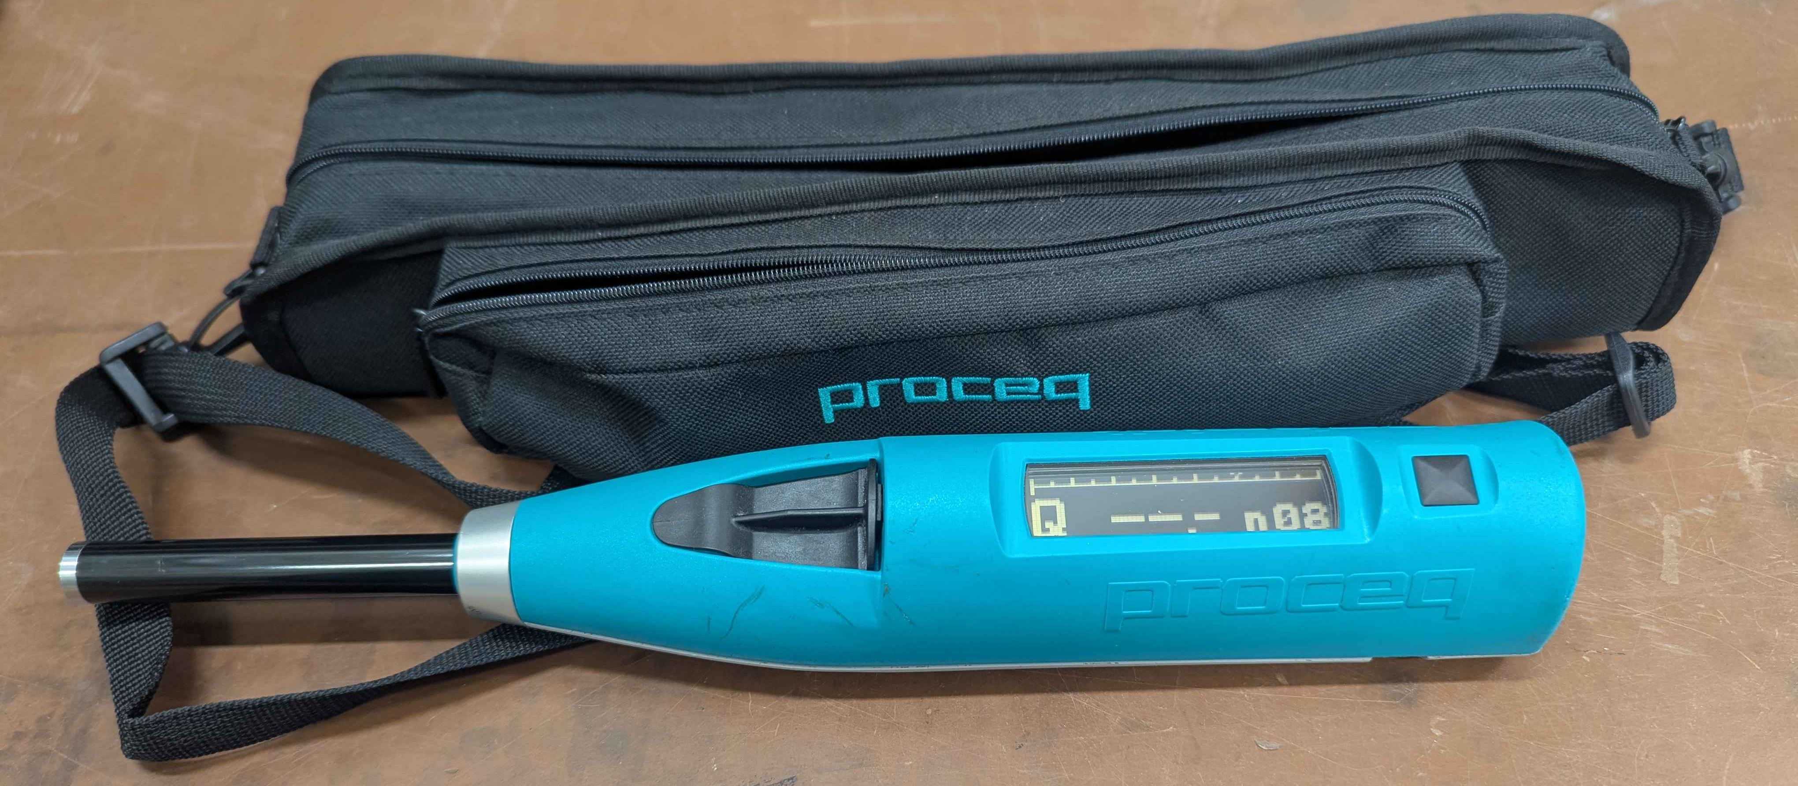

SCOPE
The scope of this Standard Operating Procedure outlines the safe use and operation of:
Name of machinery/equipment | Silver Schmidt Concrete Tester

Campus | Parkville | Other:
Building | 200 – McCoy | Other:
Room No. | 111 – Petrophysics Lab | Other:
Offsite |  | Other:

This item has an inherent risk rating of:
Risk rating | ☐ | Low | ☒ | Medium | ☐ | High

This Standard Operating Procedure considers the intended purpose and use as outlined by the manufacturer.

DESCRIPTION

INTENDED APPLICATION
This device is intended to be used to measure the compressive strength and hardness of a material.

MANUFACTURER’S SPECIFICATIONS
This device is no to be modified in any way, and all maintenance must be performed by the manufacturer. This device is not to be used by peoples under the age of 18 or under the influence of alcohol, drugs or pharmaceuticals.

TRAINING / LICENCING
Relevant local inductions that are required for operators of this machinery/equipment

Petrophysics Laboratory Induction

Relevant TrainME modules or external training required for operators of this machinery/equipment

TrainME modules
☒ Health & Safety Roles & Responsibilities | ☐ Chemical Management | ☐ Hot Work
☐ Manual Handling | ☐ Compressed Gas Safety | ☐ Biorisk – Accredited Persons
☐ Computer Workstation Training | ☐ Safe Radiation Practices - Ionising | ☐ Animal Welfare & Ethics
☒ Personal Protective Equipment | ☐ Safe Radiation Practices - Laser | ☐ Other (please specify):
☒ Laboratory Safety | ☐ Biorisk – Biosafety Induction | ☐
☒ Plant Safety | ☐ Biorisk - Behavioural CF | ☐

Externally Provided Courses
☐Provide First Aid | ☐Working at Heights | ☐Four Wheel Drive
☐Remote First Aid | ☐Tower Rescue | ☐Chainsaw Safety
☐Diving Certificate | ☐Boat Licence | ☐Confined Spaces
☐Quad Bike | ☐Heavy Vehicle Licence | ☐Other (please specify):

List of authorised trainers:

Name | Position (Job Title) | Relevant Qualifications/Experience/Licensing (If Applicable)
Dan Sandiford | Research Fellow
Jesse Ash | Laboratory Support Staff

PERSONAL PROTECTIVE EQUIPMENT (PPE)
Personal protective equipment required that meets relevant Australian Standard.
- Standard PPE: (tick the standard PPE to be worn in the School or work area. See guidelines for more information).

☒ Safety glasses/goggles: safety goggles | ☐ Face shield
☐ Gloves (please specify type): | ☐ Mask/ respirator (please specify type):
☐ Laboratory Coat/Gown (please specify type): | ☐ Apron (please specify type):
☒ Fully enclosed footwear: fully enclosed boots | ☐ Hat (please specify type):
☐ Long pants | ☐ Sunscreen
☐ Long sleeves | ☐ Wet suit
☐ Hearing Protection | ☐ Waders
☐ Other (Please Specify): | ☐ Other (Please Specify):
☐ Other (Please Specify): | ☐ Other (Please Specify):
- Health Monitoring required (HHAQ complete form)
☐ Vaccination/s required | ☐ Spirometry testing
List here: | ☐ Hearing test
☐Other Monitoring (Please Specify): | ☐ Eye test for Laser work
 | ☐ Other (Please specify)

Warnings

SAFETY PRECAUTIONS
- Always wear eye protection as rock shards can fly up due to impact of rebound hammer
- Never use the hammer against a volatile (e.g. highly flammable or explosive) or shatterable (e.g. glass) surface or against yourself or others
- See Risk Assessment.
- Operator must be trained and familiar with the safe operating procedure.
- Operator to wear PPE as listed.
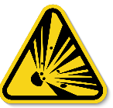

DO’S AND DON’T:
ALWAYS – Isolate and tag out equipment requiring repairs and maintenance.
ALWAYS – Wear appropriate eye protection
NEVER – Use the hammer against a fragile surface
NEVER – Use the hammer against a shatterable surface
NEVER – Use the hammer against a volatile surface
NEVER – Use the hammer against a person

INSTRUMENT CONTROLS
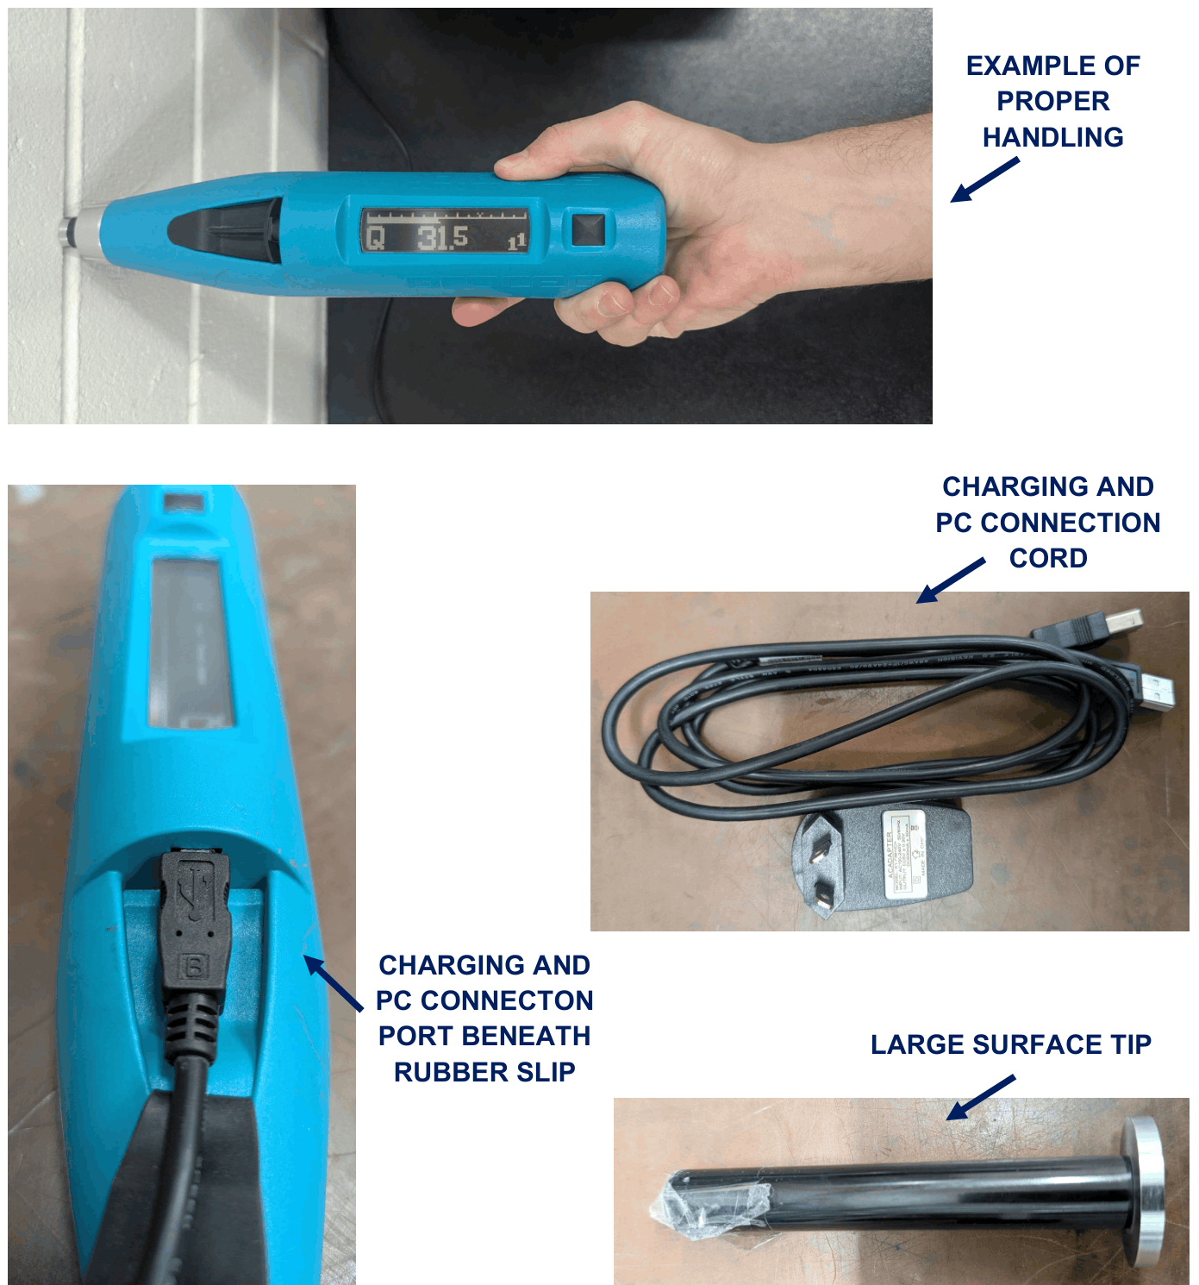

OPERATION

PRE-START UP
Press the black button to turn on. Tilt the device left and right to move the selection left and right. Tilt the device away from you or towards you to move the selection up and down. Note that the controls are inverted.
Navigate to the main menu and select the option with the black button.
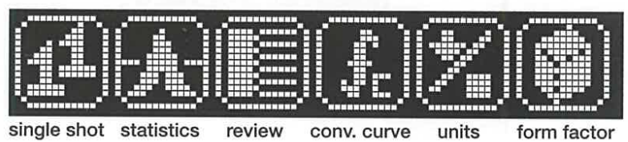
- Single shot allows you to take a single measurement without it being recorded. An 1¹ will appear in the bottom right portion of the screen when a measurement is taken in single shot mode.
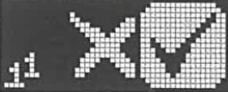
Left to right: cancel, confirm
- Statistics mode allows you to take multiple measurements and record them.
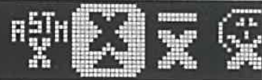
Left to right, how averages will be calculated: regional, median, mean, PC defined.
- Review allows you to record and view recorded measurements. Hover over measurement series and select with button. To return to main menu select one of the static lines (top and bottom).
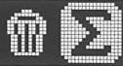
Left to right: delete or view
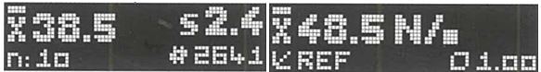
Left: X = Q-value; S = standard deviation; n: number of measurments in series; # = initial value from total impact counter; Right = compressive srength estimate from user settings.
- Conversion curve
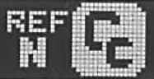
Left: reference curve, Right: PC defined
- Units
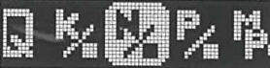
Left to right: Q, kg/cm², N/mm², psi, MPa
- Form factor
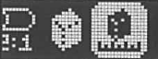
Left to Right: cylinder, cube, custom

To reset to factory default settings, take a measurement whilst holding down the black button.

START UP
To take a measurement press the tip of the device into the sample material and compress until you feel an impact within the device. Allow the tip to fully extend before taking the next measurement.
To reduce risk of repetitive strain injury, ensure: the tip is perpendicular to the material surface, the device is horizontal to the ground, and your wrist is always in line with the tip (your palm should rest against the back of the device).
After each impact the Q value and impact number in series will appear. To delete the last measurement, press the black button and select the bin (left). To save the series select sum (right).
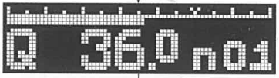
Summary of last impact
To download the saved results, connect the instrument to the laboratory laptop and open hammerlink:

To upload the saved measurements, press green arrow select finish.
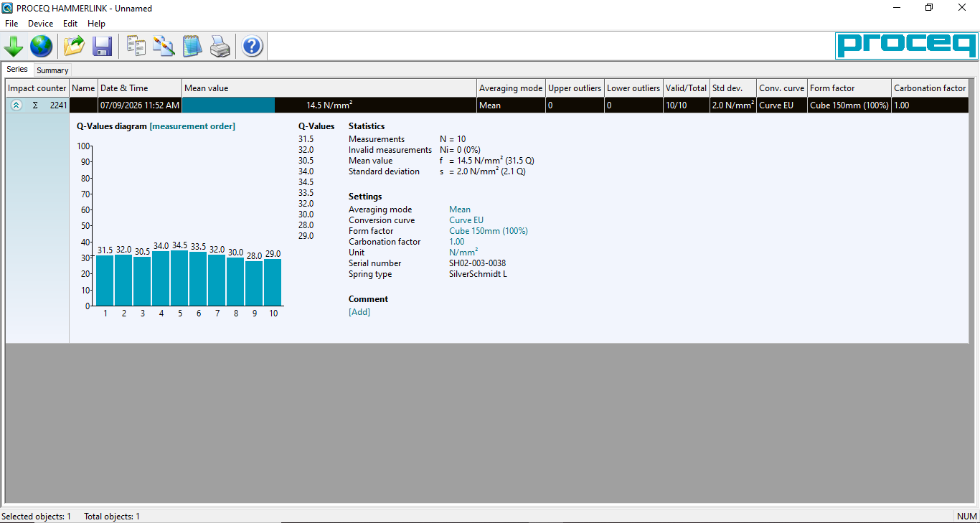

SHUT DOWN
The device will automatically shut down after 5 minutes of inactivity.

TROUBLESHOOTING
If the device is producing erroneous results, the tip may need to be lubricated. Point the tip towards the ground then twist and pull to remove. Apply one or two (no more) drops of light oil onto the plunger. Rotate and contract to evenly distribute.
A calibration should be occasionally performed by Proceq.

MAINTENANCE
To ensure reliable and trouble-free operation, it is the user’s responsibility to maintain the machine in the best possible condition. Such a machine will produce accurate consistent results; problems will be less frequent and less severe.

CLEANING
Do not get wet. Clean with a damp cloth.

MAINTENANCE
Any maintenance should be made by Proceq.

EMERGENCY
Commence emergency procedures in accordance with the local emergency requirements.
UNIVERSITY SECURITY (Parkville 24hr) 834 46666

FIRST AID KITS
There is a first aid kit on the shelf directly above the vacuum chamber.

PORTABLE DEFIBRILLATORS
Portable Defibrillator located at the entrance to Thomas Cherry Building level 2, walk through McCoy foyer. A second Portable Defibrillator is in the Physics podium over the walkway/bridge across Swanston St.

LISTINGS OF FIRST AIDERS
Listings of First Aiders located at First Aid Kits, as well as emergency contact posters on safety notice board.

INCIDENT REPORTING
- Report any incident to your Supervisor immediately.
- Report the incident on ERMS and local OHS contact https://unimelbcloud.sharepoint.com/teams/ScienceOHSResources as soon as possible.
- In the event of a major incident the following reporting steps will also occur:
  - Notify the relevant emergency response department e.g. Fire, Ambulance, Police (000).
  - Notify Security (834 46666) 24/7 support.
  - Notify your supervisor and the local OHS contact as soon as reasonably practicable. https://unimelbcloud.sharepoint.com/teams/ScienceOHSResources

REFERENCES

Reference Material | Location (if physical) or Link (if electronic)
University of Melbourne risk register | https://safety.unimelb.edu.au/__data/assets/pdf_file/0009/4859235/UoM-Health-and-Safety-Risk-Register-v4.pdf
School/Department risk register | https://unimelbcloud.sharepoint.com/teams/SGEASHealthandSafetyResources
Equipment Risk Assessment | N/A
Manufacturer’s / Supplier’s operating manual | https://sgeas.unimelb.edu.au/research/auscope-subsurface-observatory. Physical copy stored with device
Research Group Safety Manual (If applicable) | https://sgeas.unimelb.edu.au/research/auscope-subsurface-observatory. Alternatively scan QR code attached to lid.
University safety website guidelines and requirements | https://safety.unimelb.edu.au/

Relevant Legislation References | Location (web link or physical copy location))
OHS Act, Vic. | https://www.legislation.vic.gov.au/in-force/acts/occupational-health-and-safety-act-2004/043
OHS Regulations, Vic | https://www.legislation.vic.gov.au/in-force/statutory-rules/occupational-health-and-safety-regulations-2017/014
Other relevant Acts and Regulations:
☐ ________________________
☐ ________________________
☐ ________________________
☐ ________________________

Compliance codes and Codes of Practice  ☐ ________________________  ☐ ________________________  ☐ ________________________  ☐ ________________________ | https://www.worksafe.vic.gov.au/laws-and-regulations
Australian Standards: source SAI Global.  ☐ ________________________  ☐ ________________________  ☐ ________________________  ☐ ________________________ | https://research.ebsco.com/c/xppotz/search/details/f7kyfyxrkz

