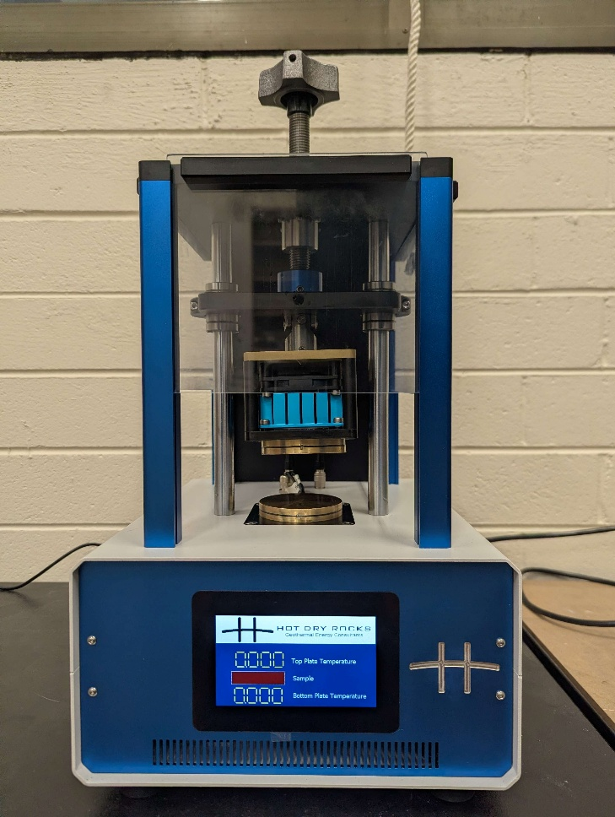

SCOPE
The scope of this Standard Operating Procedure outlines the safe use and operation of:
Name of machinery/equipment | Portable Electronic Divided Bar (PEDB) MKII

Campus | Parkville | Other:
Building | McCoy – 200 | Other:
Room No. | 111 | Other:
Offsite |  | Other:

This item has an inherent risk rating of
Risk rating | ☒ | Low | ☐ | Medium | ☐ | High

This Standard Operating Procedure considers the intended purpose and use as outlined by the manufacturer.

DESCRIPTION

INTENDED APPLICATION
The PEDB is intended to be used to measure the thermal conductivity and specific heat capacity of rock core samples – though other appropriately prepared samples can also be measured.

MANUFACTURER’S SPECIFICATIONS
If at any time the device or software does not respond in the manner described, cease operation and contact Hot Dry Rocks for trouble shooting.

TRAINING / LICENCING
Relevant local inductions that are required for operators of this machinery/equipment

Petrophysics Laboratory Induction

Relevant TrainME modules or external training required for operators of this machinery/equipment

TrainME modules
☐ Health & Safety Roles & Responsibilities | ☐ Chemical Management | ☐ Hot Work
☐ Manual Handling | ☐ Compressed Gas Safety | ☐ Biorisk – Accredited Persons
☐ Computer Workstation Training | ☐ Safe Radiation Practices - Ionising | ☐ Animal Welfare & Ethics
☐ Personal Protective Equipment | ☐ Safe Radiation Practices - Laser | ☐ Other (please specify):
☒ Laboratory Safety | ☐ Biorisk – Biosafety Induction | ☐
☐ Plant Safety | ☐ Biorisk - Behavioural CF | ☐

Externally Provided Courses
☐Provide First Aid | ☐Working at Heights | ☐Four Wheel Drive
☐Remote First Aid | ☐Tower Rescue | ☐Chainsaw Safety
☐Diving Certificate | ☐Boat Licence | ☐Confined Spaces
☐Quad Bike | ☐Heavy Vehicle Licence | ☐Other (please specify):

PERSONAL PROTECTIVE EQUIPMENT (PPE)
Personal protective equipment required that meets relevant Australian Standard.
- Standard PPE:

☐ Safety glasses/goggles (please specify type): | ☐ Face shield
☐ Gloves (please specify type): | ☐ Mask/ respirator (please specify type):
☐ Laboratory Coat/Gown (please specify type): | ☐ Apron (please specify type):
☒ Fully enclosed footwear: fully enclosed shoes | ☐ Hat (please specify type):
☐ Long pants | ☐ Sunscreen
☐ Long sleeves | ☐ Wet suit
☐ Hearing Protection | ☐ Waders
☐ Other (Please Specify): | ☐ Other (Please Specify):
☐ Other (Please Specify): | ☐ Other (Please Specify):
- Health Monitoring required (HHAQ complete form)
☐ Vaccination/s required | ☐ Spirometry testing
List here: | ☐ Hearing test
☐Other Monitoring (Please Specify): | ☐ Eye test for Laser work
 | ☐ Other (Please specify)

Warnings

SAFETY PRECAUTIONS
- Ensure that the cable is free from damage before use.
- Operator must be trained and familiar with the safe operating procedure.
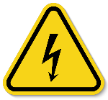
- Operator to wear PPE as listed.

DO’S AND DON’T:
ALWAYS – Isolate and tag out equipment requiring repairs and maintenance.
ALWAYS – Inspect all cables fore damage before plugging them in
ALWAYS – Ensure the material you are testing has been approved for use
ALWAYS – Ensure the sample has two parallel faces that are level and smooth
NEVER – Connect, disconnect or swap a cord whilst the device is powered on
NEVER – Allow the device to get wet or subject it to non-atmospheric heat and temperature conditions
NEVER – Place chemically aggressive materials into the device

INSTRUMENT CONTROLS
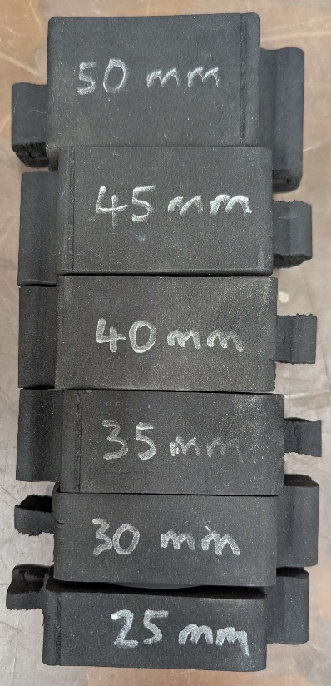
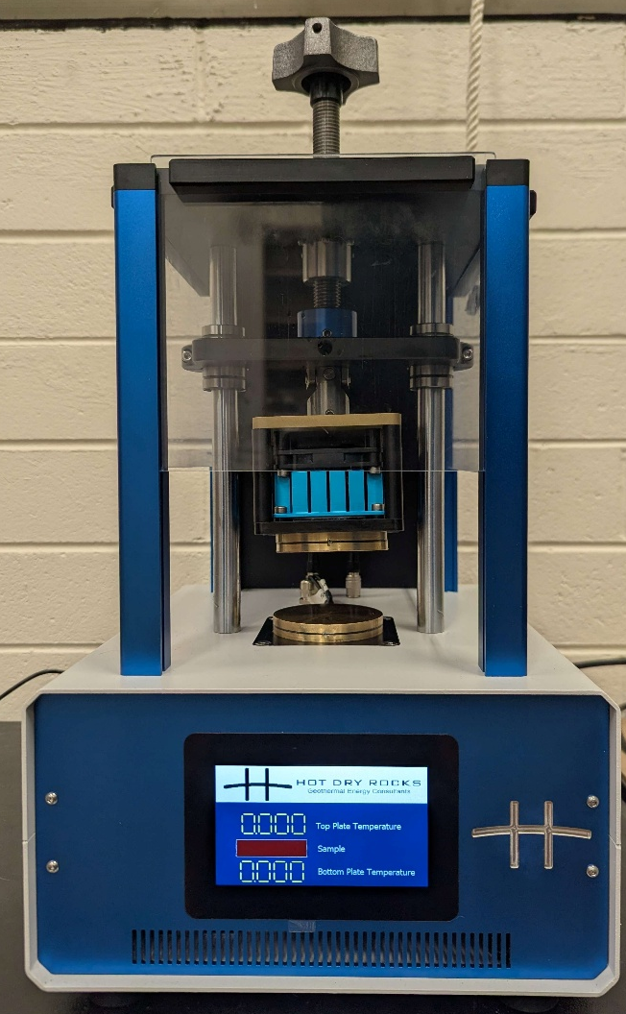
Vice handle
Perspex screen

Insulation foam inserts

Hot plate
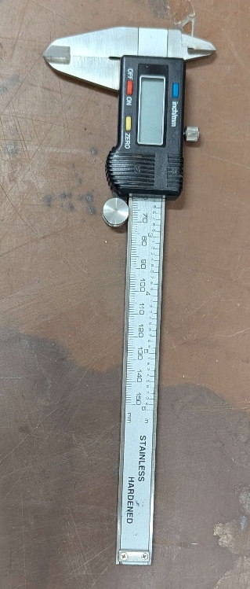
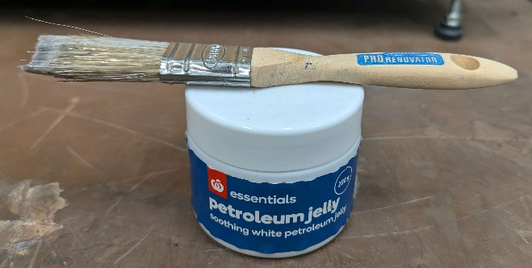
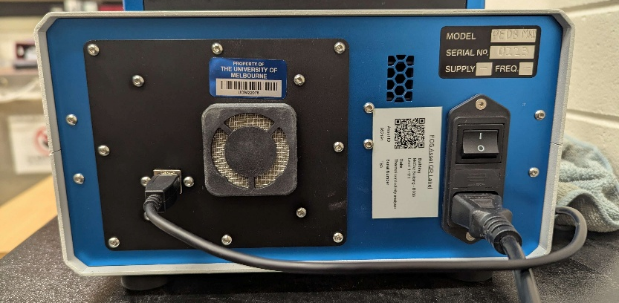
Cold plate
Petroleum Gelly and Brush
Calipers
USB cord port
Power cord port
Power switch
Display

OPERATION

SAMPLE PREPARATION
- The sample must be smooth and flat on two parallel sides.
  - Ideally it should be cylindrical, but a rectangular prism is also acceptable
- The maximum horizontal dimension of the parallel sides is 65mm. The maximum thickness is 50mm.
  - Optimally the thickness of the sample should be ~50φmm where φ is the proportion of the plates (65mm) in contact with the sample. E.g. a sample that covers 50% of the plates should be ~25mm thick.
- Measure the thickness, surface area and mass of the sample.
  - The surface area is the area of the sample in contact with each plate. E.g. if the sample was a 60mm diameter cylinder its area would be 2827. If the faces are unequal take the average.

PRE-START UP
- Plug the power cord into the rear of the device (whilst switched off)
- Connect the device to the laptop marked ‘PEDB’ with the usb cord
- Raise the three Perspex screens and unwind the vice so that there is enough room between the plates for your sample
- Coat both sides of the sample with petroleum jelly and press it into the cold plate to eliminate any air
- Wind the hot plate down onto the sample whilst it centred on the cold plate. Tighten the clamp until it reaches its limit. It is torque limited and will click when fully tightened.
- Select the insulation foam insert that is closest in value to the thickness of your sample + 20mm. Fit the insert securely around your sample such that the cropped teeth are at the rear of the sensor.
- Lower the Perspex screens.

START UP
- Turn on the PEDB power switch and run the PEDB program on the laptop. The display should begin to show real time temperature values. Let it run for 30 minutes to equilibrate.
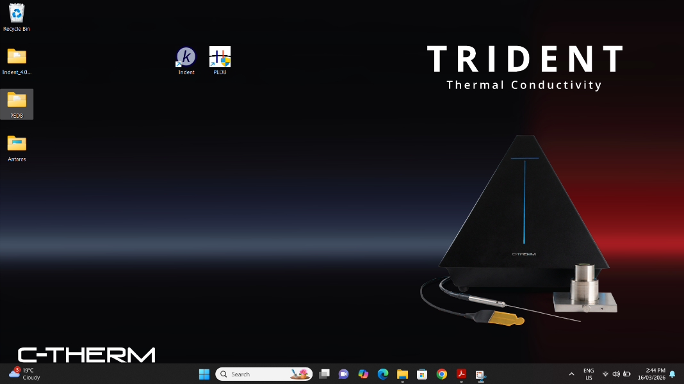
- Once the PEDB has equilibrated, setup the program as follows:
  - Blue arrows: fill out the sample mass, thickness and surface area. Ensure you choose a save directory and filename.
  - Orange arrow: choose the variables you want to monitor. Select ‘Tau’.
  - Green arrow: press ‘start recording’ once the program is setup
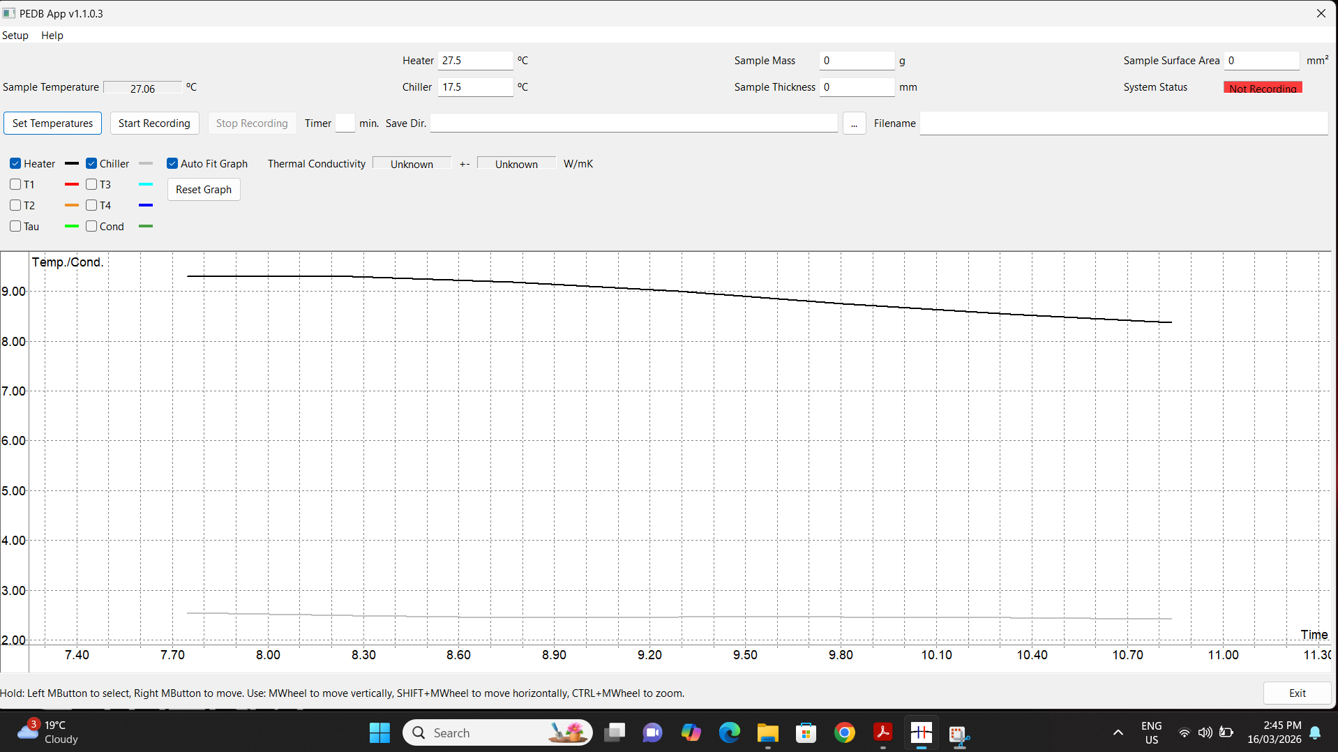
- Once the Tau value has equilibrated, record the thermal conductivity.
- If you also want to measure the specific heat capacity of your sample, then change the heater and cooler values to 32.5 and 27.5 and press set temperature. Ensure you are still recording.
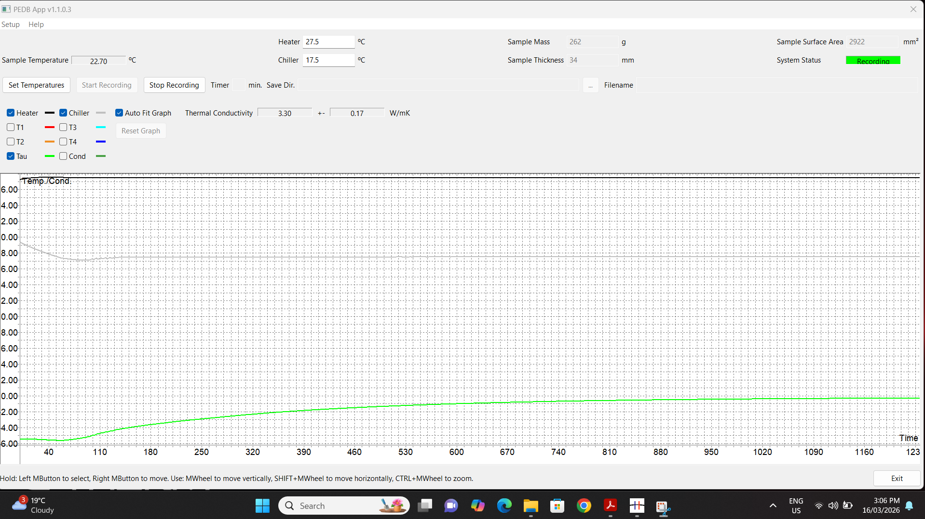
- Once the Tau has re-equilibrated, press ‘stop recording’. Record the thermal conductivity again. The value may be different than after the first equilibration as it is a temperature dependant property. If you want to record another sample, then reset the heater and cooler values to 27.5 and 17.5. Otherwise close the program and shutdown the machine.
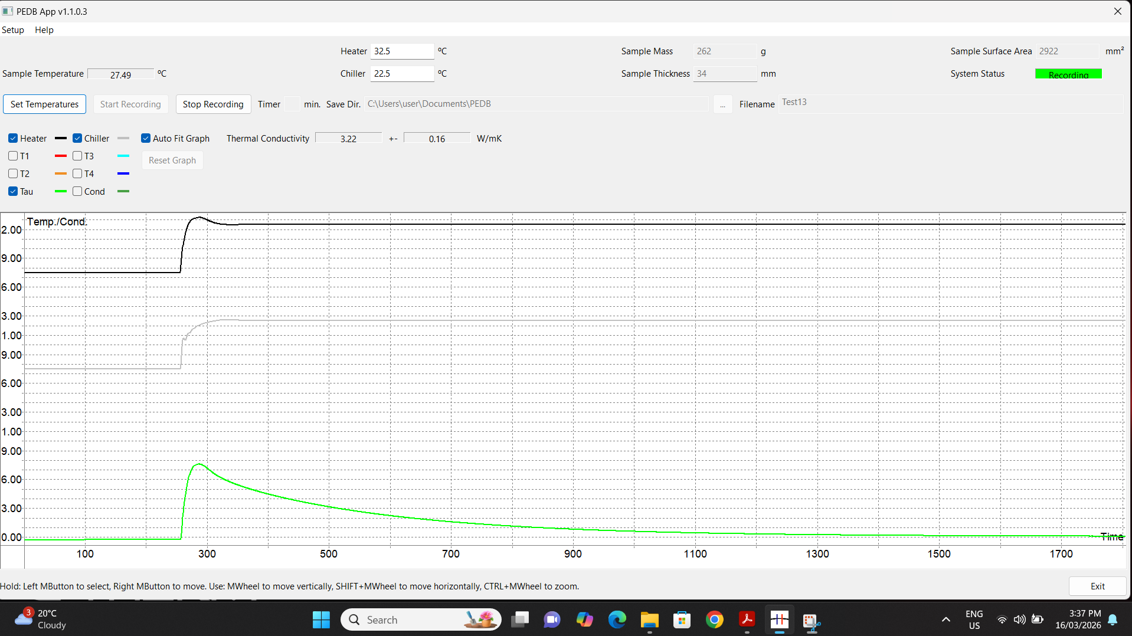

SHUT DOWN
Once the program is closed the PEDB will go into a dormant mode. Turn off the switch at the back. Remove the sample and wipe off the petroleum jelly from the plates. Place the small foam divider between the plates and wind down the vice to clamp it in place.

EMERGENCY SHUT DOWN
If it is unsafe to turn off the machine from the rear switch, then turn off or unplug at the wall socket.

DATA PROCESSING
The following is only relevant for the specific heat capacity:
- There will be two .csv files in the directory specified. One will be time-stamped. Download this one onto your personal device.
- Scan the QR code attached to the device to find a link to ‘PEDB’ google sheet document. Select file make a copy.
Note: there is an excel document available as well. However, the google sheets document runs better on most devices.
- Once you have created your own copy of the file (important), select file import and upload and the timecoded CSV file. Ensure that the import location is set to ‘insert new sheet’
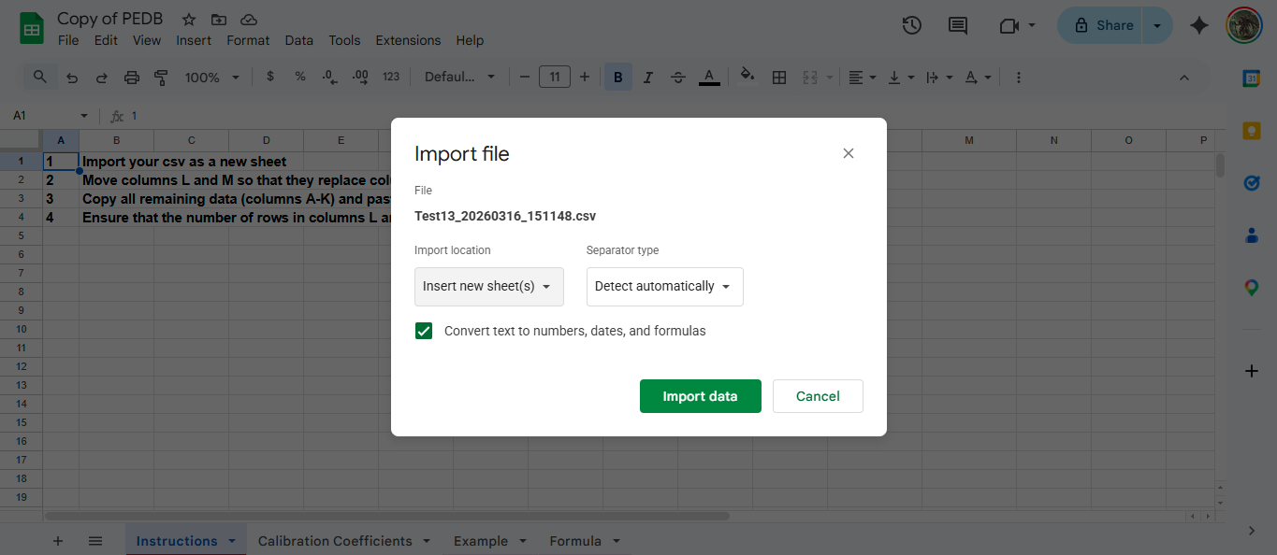
- Select columns L and M and drag the data across to columns J and K so that it replaces the data.
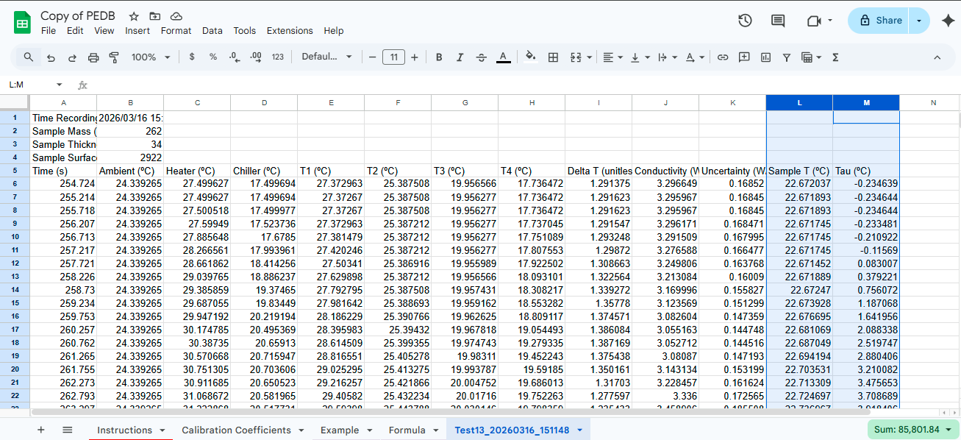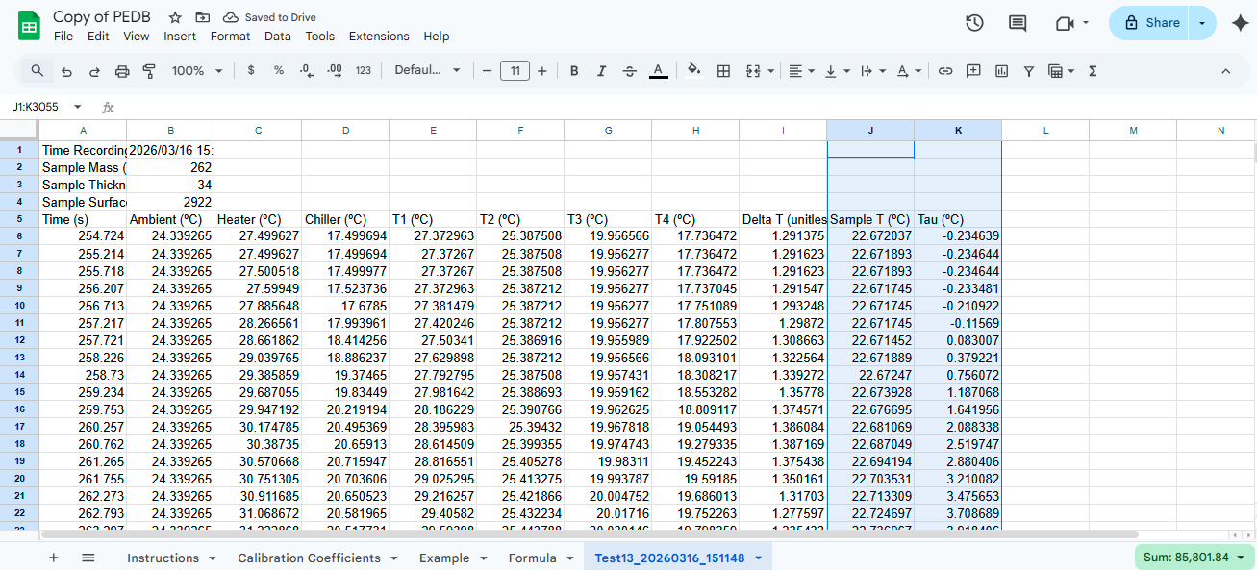
- Copy the remaining data and paste it into the Formula sheet. Ensure that cell A1 is selected when pasting. Ensure that columns L and M are dragged down to match the number of rows of data.
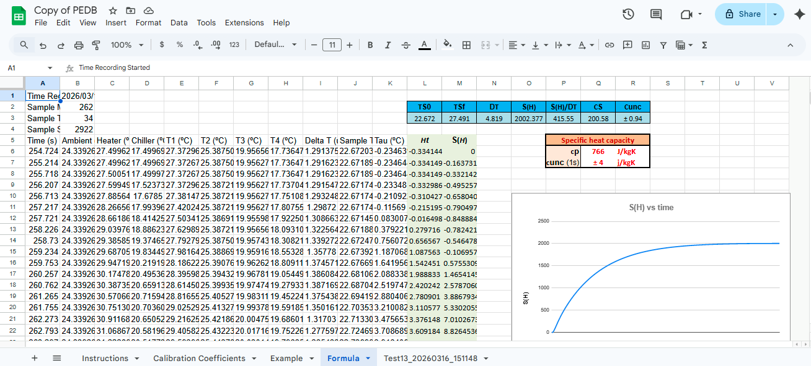

MAINTENANCE
To ensure reliable and trouble-free operation, it is the user’s responsibility to maintain the machine in the best possible condition. Such a machine will produce accurate consistent results; problems will be less frequent and less severe.

CLEANING
Clean the petroleum jelly off of the hot/cold plates with a dry cloth or paper towel. Only clean the device with a damp cloth. Do not use abrasive materials or chemically aggressive cleaning products.

MAINTENANCE
If the machine is not working as intended tag and isolate. All maintenance must be performed by the manufacturer (Hot Dry Rocks).

EMERGENCY
Commence emergency procedures in accordance with the local emergency requirements.
UNIVERSITY SECURITY (Parkville 24hr) 834 46666

FIRST AID KITS
There is a first aid kit on the shelf directly above the vacuum chamber.

PORTABLE DEFIBRILLATORS
Portable Defibrillator located at the entrance to Thomas Cherry Building level 2, walk through McCoy foyer. A second Portable Defibrillator is in the Physics podium over the walkway/bridge across Swanston St.

LISTINGS OF FIRST AIDERS
Listings of First Aiders located at First Aid Kits, as well as emergency contact posters on safety notice board.

INCIDENT REPORTING
- Report any incident to your Supervisor immediately.
- Report the incident on ERMS and local OHS contact https://unimelbcloud.sharepoint.com/teams/ScienceOHSResources as soon as possible.
- In the event of a major incident the following reporting steps will also occur:
  - Notify the relevant emergency response department e.g. Fire, Ambulance, Police (000).
  - Notify Security (834 46666) 24/7 support.
  - Notify your supervisor and the local OHS contact as soon as reasonably practicable. https://unimelbcloud.sharepoint.com/teams/ScienceOHSResources

REFERENCES

Reference Material | Location (if physical) or Link (if electronic)
University of Melbourne risk register | https://safety.unimelb.edu.au/__data/assets/pdf_file/0009/4859235/UoM-Health-and-Safety-Risk-Register-v4.pdf
School/Department risk register | https://unimelbcloud.sharepoint.com/teams/SGEASHealthandSafetyResources
Equipment Risk Assessment | n/a
Manufacturer’s / Supplier’s operating manual | ‘A practical guide to thermal conductivity and specific heat capacity measurement with the PEDB Mk II’ found by scanning QR code on device https://sgeas.unimelb.edu.au/research/auscope-subsurface-observatory.
Research Group Safety Manual (If applicable) | https://sgeas.unimelb.edu.au/research/auscope-subsurface-observatory. Alternatively scan QR code attached to lid.
University safety website guidelines and requirements | https://safety.unimelb.edu.au/
Other (please specify)

Relevant Legislation References | Location (web link or physical copy location))
OHS Act, Vic. | https://www.legislation.vic.gov.au/in-force/acts/occupational-health-and-safety-act-2004/043
OHS Regulations, Vic | https://www.legislation.vic.gov.au/in-force/statutory-rules/occupational-health-and-safety-regulations-2017/014
Other relevant Acts and Regulations:
☐ ________________________
☐ ________________________
☐ ________________________
☐ ________________________

Compliance codes and Codes of Practice  ☐ ________________________  ☐ ________________________  ☐ ________________________  ☐ ________________________ | https://www.worksafe.vic.gov.au/laws-and-regulations
Australian Standards: source SAI Global.  ☐ ________________________  ☐ ________________________  ☐ ________________________  ☐ ________________________ | https://research.ebsco.com/c/xppotz/search/details/f7kyfyxrkz

