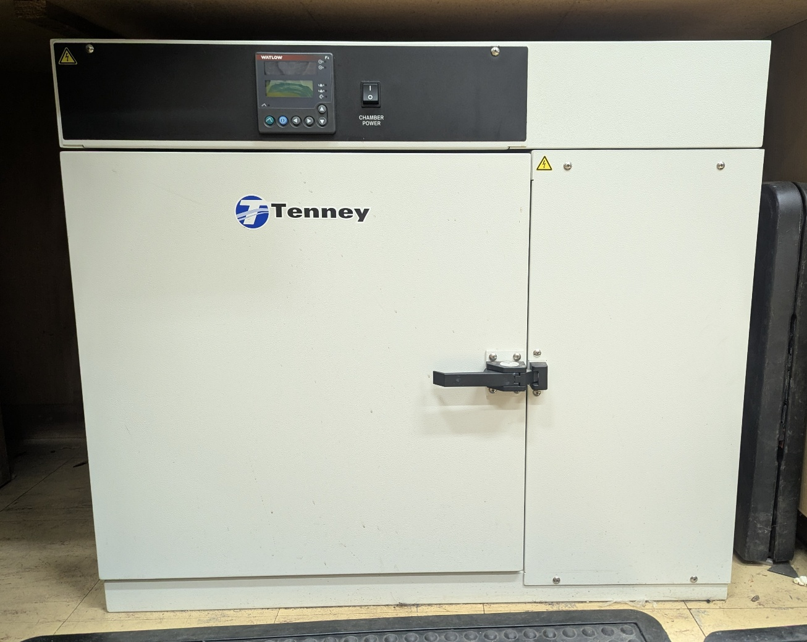

SCOPE
The scope of this Standard Operating Procedure outlines the safe use and operation of:
Name of machinery/equipment | Environmental Chamber

Campus | Parkville | Other:
Building | McCoy – 200 | Other:
Room No. | Petrophysics Lab – 111 | Other:
Offsite |  | Other:

This item has an inherent risk rating of
Risk rating | ☐ | Low | ☒ | Medium | ☐ | High

This Standard Operating Procedure considers the intended purpose and use as outlined by the manufacturer.

DESCRIPTION

INTENDED APPLICATION
The environmental chamber is used to heat/cool rock samples for thermal conductivity measurements at altered ambient temperatures, or to dry saturated rock samples for density measurements.

MANUFACTURER’S SPECIFICATIONS
Environment: The environmental chamber must only be operated in a ventilated indoors environment with temperatures between 5ºC and 30ºC and relative humidity below 90%. Do not place the unit near combustible materials or hazardous fumes or vapours. Do not install in a corrosive environment.
Operation: Ensure that the chamber is level before use. Ensure that the power cord and switch are within easy reach in case the chamber needs to be switched off urgently. Do not open doors until temperatures fall below 93C. Do not overload or load unevenly. Do not stand on the roof of the chamber.
Samples: Do not place any samples inside the chamber that may release explosive or flammable vapours.

TRAINING / LICENCING
Relevant local inductions that are required for operators of this machinery/equipment

Users must be inducted into the petrophysics lab before operating this piece of equipment.

Relevant TrainME modules or external training required for operators of this machinery/equipment

TrainME modules
☒ Health & Safety Roles & Responsibilities | ☐ Chemical Management | ☐ Hot Work
☐ Manual Handling | ☐ Compressed Gas Safety | ☐ Biorisk – Accredited Persons
☐ Computer Workstation Training | ☐ Safe Radiation Practices - Ionising | ☐ Animal Welfare & Ethics
☒ Personal Protective Equipment | ☐ Safe Radiation Practices - Laser | ☐ Other (please specify):
☒ Laboratory Safety | ☐ Biorisk – Biosafety Induction | ☐
☒ Plant Safety | ☐ Biorisk - Behavioural CF | ☐

Externally Provided Courses
☐Provide First Aid | ☐Working at Heights | ☐Four Wheel Drive
☐Remote First Aid | ☐Tower Rescue | ☐Chainsaw Safety
☐Diving Certificate | ☐Boat Licence | ☐Confined Spaces
☐Quad Bike | ☐Heavy Vehicle Licence | ☐Other (please specify):

List of authorised trainers:

Name | Position (Job Title) | Relevant Qualifications/Experience/Licensing (If Applicable)
Dan Sandiford | Research Fellow
Jesse Ash | Laboratory Support Staff

PERSONAL PROTECTIVE EQUIPMENT (PPE)
Personal protective equipment required that meets relevant Australian Standard.
- Standard PPE:

☐ Safety glasses/goggles (please specify type): | ☐ Face shield
☒ Gloves (please specify type): Thermal Gloves | ☐ Mask/ respirator (please specify type):
☐ Laboratory Coat/Gown (please specify type): | ☐ Apron (please specify type):
☒ Fully enclosed footwear (please specify type): Fully enclosed shoes | ☐ Hat (please specify type):
☐ Long pants | ☐ Sunscreen
☐ Long sleeves | ☐ Wet suit
☐ Hearing Protection | ☐ Waders
☐ Other (Please Specify): | ☐ Other (Please Specify):
☐ Other (Please Specify): | ☐ Other (Please Specify):
- Health Monitoring required (HHAQ complete form)
☐ Vaccination/s required | ☐ Spirometry testing
List here: | ☐ Hearing test
☐Other Monitoring (Please Specify): | ☐ Eye test for Laser work
 | ☐ Other (Please specify)

Warnings

SAFETY PRECAUTIONS
- The user could be shocked if the power cord or sensors are damaged and the wiring is exposed
- The chamber can heat/cool samples and internal surfaces to between -75ºC and 200ºC which will produce burns if touched directly.
- If inappropriate materials are selected, they could explode, combust or release toxic fumes
- Operator must be trained and familiar with the safe operating procedure.
- Operator to wear closed toes shoes and thermal gloves when handling cold/hot samples
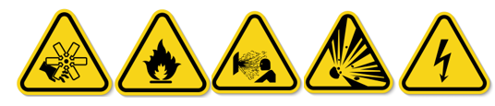

DO’S AND DON’T:
ALWAYS – Isolate and tag out equipment requiring repairs and maintenance.
ALWAYS – Operate the chamber in a well-ventilated indoors environment
ALWAYS – Ensure the power cable and relevant sensor cable(s) are undamaged before powering them on
ALWAYS – Ensure the power switch is within easy reach before turning it on.
ALWAYS – Wait for samples to return to ambient temperatures before removing them and if that is not possible then wear thermal gloves when handling hot/cold samples.
NEVER – Place any sensors that have not been cleared for use into the chamber
NEVER – Place any materials that are volatile, flammable, explosive or corrosive into the chamber.
NEVER – Unload hot/cold samples directly onto an adjacent bench or trolley
NEVER – Handle hot/cold samples with your bare hands.

INSTRUMENT CONTROLS
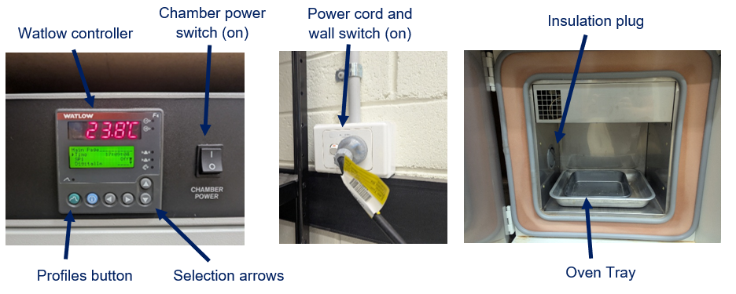

OPERATION

PRE-START UP
- Ensure the chamber is clean, dry and free from debris
- Ensure the insulation plug is securely fastened and both power switches are turned off

To dry saturated rock samples:
- Place rock samples in a single layer onto an oven tray ensuring that the samples are not touching
- Close the door securely

To measure thermal conductivity at altered ambient temperatures
- Remove the insulation plug and feed the sensor cable out the hole
- Setup the sensor on the base of the chamber and then replace the insulation plug
- Setup the rock sample and sensor according to the sensor’s specifications
- Close the door securely

START UP
- Turn on the wall switch
- Press the profiles button
- Using the arrows to navigate: Yes SAMPLEDRY* Step 1 Ramp Time
- Turn on chamber power switch
- Monitor to ensure that the temperature is changing according to the profile selected.
*SAMPLEDRY is used for drying saturated rock samples at ~105ºC for 5.5 hours. If you require a different temperature/time, contact the lab manager or program a new profile according to the Watlow user manual.

SHUT DOWN

The profile should automatically end and return the chamber to ambient temperatures. However, if there is a need to terminate a profile early press the profile button and then select ‘terminate’.

If there is a need to remove the samples before they have returned to ambient temperatures, ensure that you wear thermal gloves and only set them down them upon a heatproof worksurface.
- Turn off both the wall and chamber power switches.

EMERGENCY SHUT DOWN
To turn off the entire system turn off the wall power switch. If safe to do so then turn off the chamber power switch.

TROUBLESHOOTING
If the display shows that the chamber is not heating up please ensure that the insulation plug is secure, the door is fully closed, and the chamber power switch is on.

MAINTENANCE
To ensure reliable and trouble-free operation, it is the user’s responsibility to maintain the machine in the best possible condition. Such a machine will produce accurate consistent results; problems will be less frequent and less severe.

CLEANING
After use ensure that the chamber is clean and dry.

MAINTENANCE
The environmental chamber needs a three-monthly inspection to ensure all electronic components are free from damage.

EMERGENCY
Commence emergency procedures in accordance with the local emergency requirements.
UNIVERSITY SECURITY (Parkville 24hr) 834 46666

FIRST AID KITS
There is a first aid kit on the shelf directly above the vacuum chamber.

PORTABLE DEFIBRILLATORS
Portable Defibrillator located at the entrance to Thomas Cherry Building level 2, walk through McCoy foyer. A second Portable Defibrillator is in the Physics podium over the walkway/bridge across Swanston St.

LISTINGS OF FIRST AIDERS
Listings of First Aiders located at First Aid Kits, as well as emergency contact posters on safety notice board.

INCIDENT REPORTING
- Report any incident to your Supervisor immediately.
- Report the incident on ERMS and local OHS contact https://unimelbcloud.sharepoint.com/teams/ScienceOHSResources as soon as possible.
- In the event of a major incident the following reporting steps will also occur:
  - Notify the relevant emergency response department e.g. Fire, Ambulance, Police (000).
  - Notify Security (834 46666) 24/7 support.
  - Notify your supervisor and the local OHS contact as soon as reasonably practicable. https://unimelbcloud.sharepoint.com/teams/ScienceOHSResources

REFERENCES

Reference Material | Location (if physical) or Link (if electronic)
University of Melbourne risk register | https://safety.unimelb.edu.au/__data/assets/pdf_file/0009/4859235/UoM-Health-and-Safety-Risk-Register-v4.pdf
School/Department risk register | https://unimelbcloud.sharepoint.com/teams/SGEASHealthandSafetyResources
Equipment Risk Assessment | https://sgeas.unimelb.edu.au/research/auscope-subsurface-observatory. Alternatively scan QR code attached to lid.
Manufacturer’s / Supplier’s operating manual | ‘Tenney Junior Environmental Test Chamber Operation & Maintenance Manual’ and ‘Watlow Series F4S/D User’s Manual’ both with lab documentation.
Research Group Safety Manual (If applicable) | https://sgeas.unimelb.edu.au/research/auscope-subsurface-observatory. Alternatively scan QR code attached to lid.
University safety website guidelines and requirements | https://safety.unimelb.edu.au/
Other (please specify)

Relevant Legislation References | Location (web link or physical copy location))
OHS Act, Vic. | https://www.legislation.vic.gov.au/in-force/acts/occupational-health-and-safety-act-2004/043
OHS Regulations, Vic | https://www.legislation.vic.gov.au/in-force/statutory-rules/occupational-health-and-safety-regulations-2017/014
Other relevant Acts and Regulations:
☐ ________________________
☐ ________________________
☐ ________________________
☐ ________________________

Compliance codes and Codes of Practice  ☐ ________________________  ☐ ________________________  ☐ ________________________  ☐ ________________________ | https://www.worksafe.vic.gov.au/laws-and-regulations
Australian Standards: source SAI Global.  ☐ ________________________  ☐ ________________________  ☐ ________________________  ☐ ________________________ | https://research.ebsco.com/c/xppotz/search/details/f7kyfyxrkz

