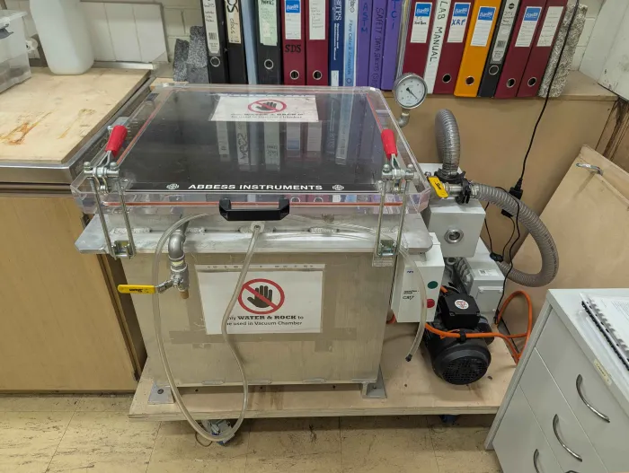

SCOPE
The scope of this Standard Operating Procedure outlines the safe use and operation of:
Name of machinery/equipment | Vacuum Chamber

Campus | Parkville | Other:
Building | 200 – McCoy | Other:
Room No. | 111 – Petrophysics Lab | Other:
Offsite |  | Other:

This item has an inherent risk rating of
Risk rating | ☐ | Low | ☒ | Medium | ☐ | High

This Standard Operating Procedure considers the intended purpose and use as outlined by the manufacturer.

DESCRIPTION

INTENDED APPLICATION
The vacuum chamber is only to be used to introduce water into rock samples so that their pore spaces can be entirely saturated.

MANUFACTURER’S SPECIFICATIONS
Environment: The vacuum chamber must only be used in a ventilated indoors environment with a temperature between 10 ºC and 40ºC and humidity between 20% and 85%.
Operation: Ensure that the valves are sealed and undamaged prior to starting the vacuum. The side mounted inlet valve must be closed prior to shutting off the pump to avoid sucking oil into the system. Slowly admit air using the front mounted inlet. Slowly open the vacuum lid once depressurized.
Samples: Only use water as saturating agent. Only admit water from container outside of vacuum chamber whilst under atmospheric conditions. Only use water as the saturating agent. Do not place a sealed container into the chamber. Do not place volatile, explosive, corrosive, acidic or alkaline materials into the chamber.

TRAINING / LICENCING
Relevant local inductions that are required for operators of this machinery/equipment

Users must be inducted into the petrophysics lab before operating this piece of equipment.

Relevant TrainME modules or external training required for operators of this machinery/equipment

TrainME modules
☒ Health & Safety Roles & Responsibilities | ☐ Chemical Management | ☐ Hot Work
☒ Manual Handling | ☐ Compressed Gas Safety | ☐ Biorisk – Accredited Persons
☐ Computer Workstation Training | ☐ Safe Radiation Practices - Ionising | ☐ Animal Welfare & Ethics
☒ Personal Protective Equipment | ☐ Safe Radiation Practices - Laser | ☐ Other (please specify):
☒ Laboratory Safety | ☐ Biorisk – Biosafety Induction | ☐
☒ Plant Safety | ☐ Biorisk - Behavioural CF | ☐

Externally Provided Courses
☐Provide First Aid | ☐Working at Heights | ☐Four Wheel Drive
☐Remote First Aid | ☐Tower Rescue | ☐Chainsaw Safety
☐Diving Certificate | ☐Boat Licence | ☐Confined Spaces
☐Quad Bike | ☐Heavy Vehicle Licence | ☐Other (please specify):

List of authorised trainers:

Name | Position (Job Title) | Relevant Qualifications/Experience/Licensing (If Applicable)
Dan Sandiford | Research Fellow
Jesse Ash | Laboratory Support Staff

PERSONAL PROTECTIVE EQUIPMENT (PPE)
Personal protective equipment required that meets relevant Australian Standard.
- Standard PPE:
☐ Safety glasses/goggles (please specify type): | ☐ Face shield
☐ Gloves (please specify type): | ☐ Mask/ respirator (please specify type):
☐ Laboratory Coat/Gown (please specify type): | ☐ Apron (please specify type):
☒ Fully enclosed footwear (please specify type): fully enclosed shoes | ☐ Hat (please specify type):
☐ Long pants | ☐ Sunscreen
☐ Long sleeves | ☐ Wet suit
☐ Hearing Protection | ☐ Waders
☐ Other (Please Specify): | ☐ Other (Please Specify):
☐ Other (Please Specify): | ☐ Other (Please Specify):
- Health Monitoring required (HHAQ complete form)
☐ Vaccination/s required (Q fever, Hep B etc.) | ☐ Spirometry testing
List here: | ☐ Hearing test
☐Other Monitoring (Please Specify): | ☐ Eye test for Laser work
 | ☐ Other (Please specify)

Warnings

SAFETY PRECAUTIONS
- Clothes, hands or hair could be entangled by the exhaust fan if the cover is damaged or removed.
- If inappropriate materials are selected, they may explode, release toxic fume or combust.
- The user could be shocked if the wires are damaged or water is sucked into electrical components.
- Operator must be trained and familiar with the safe operating procedure.
- Operator to wear closed toed shoes.
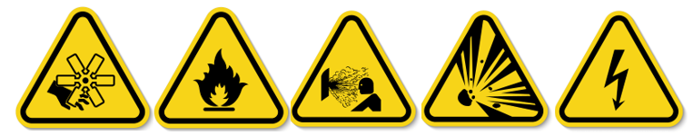

DO’S AND DON’T:
ALWAYS – Isolate and tag out equipment requiring repairs and maintenance.
ALWAYS – Operate vacuum chamber in a well-ventilated indoors environment.
ALWAYS – Ensure the vacuum chamber wheels are locked.
ALWAYS – Close the side mounted vacuum inlet before shutting off the pump to avoid sucking oil through the system.
ALWAYS – Admit air into the chamber slowly using the front mounted vacuum inlet.
ALWAYS – Open the chamber lid slowly only once it has been returned to atmospheric conditions.
ALWAYS – Admit water into the chamber from a filled container using the hose.
NEVER – Connect pressurised water to the vacuum chamber.
NEVER – Place a sealed container into the vacuum chamber.
NEVER – Place any materials that are volatile, flammable, explosive, corrosive, acidic or alkaline into the chamber.
NEVER – Use a saturating liquid that isn’t water.

INSTRUMENT CONTROLS
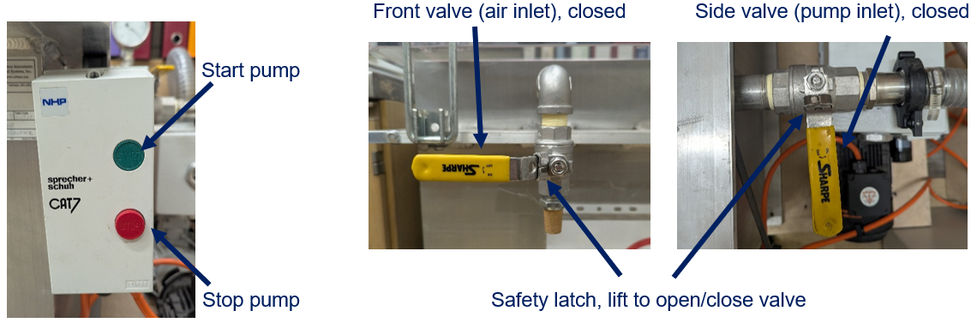

OPERATION

PRE-START UP
- Place rock/core sample in a waterproof tray of appropriate depth (that will ensure the sample is completely immersed once water is admitted).
- Fill a container with water and place the water saturation hose (connected to the vacuum chamber) inside the container.
- Ensure the side valve is open, the front value is closed, and the hose clamp is tight and secure.

START UP
- Turn on power point.
- Start pump. Once the gauge reaches ~ -30 inHg allow it to run for another 2-3 minutes.
- Close side valve.
- Switch pump off.
- Slowly release water hose clamp to allow water to fill the sample container.
- Once the samples are saturated, tighten the hose clamp and restart the pump.
- Open side valve.
- Watch for effervescing bubbles. Once they decrease in size and quantity close the side valve.
- Switch pump off. Leave for 24-48 hours.

SHUT DOWN
- Keep side inlet valve closed.
- Open front valve slightly and wait for gauge to reach 0 inHg, then fully open front valve.
- Open side valve. Wait for air to balance. Then close side valve.
- Unlatch the red handles and slowly open lid.
- Collect samples and container.
- Reattach lid and turn off power point.

EMERGENCY SHUT DOWN
- Press red STOP button.
- Turn off power point.
- Open front valve.

TROUBLESHOOTING
If the pump is rattling without producing any pressure, visually check the direction the fan is turning. If it is turning the wrong direction (opposite to black and orange arrow) then turn off and inform the lab manager. Alternatively, check the oil level glass on the rear of the pump assembly to ensure that there is enough oil and that it isn’t cloudy (water-logged).

MAINTENANCE
To ensure reliable and trouble-free operation, it is the user’s responsibility to maintain the machine in the best possible condition. Such a machine will produce accurate consistent results; problems will be less frequent and less severe.

CLEANING
Wipe down the interior of the chamber with a dry cloth before and after use to ensure it is dry and free from rock fragments.

MAINTENANCE
Before and after use check that the top seals of the chamber are clean and free from cuts or debris. Check that both valves are operating smoothly and that the water hose and clamp are in good condition.

EMERGENCY
Commence emergency procedures in accordance with the local emergency requirements.
UNIVERSITY SECURITY (Parkville 24hr) 834 46666

FIRST AID KITS
There is a first aid kit on the shelf directly above the vacuum chamber.

PORTABLE DEFIBRILLATORS
Portable Defibrillator located at the entrance to Thomas Cherry Building level 2, walk through McCoy foyer. A second Portable Defibrillator is in the Physics podium over the walkway/bridge across Swanston St.

LISTINGS OF FIRST AIDERS
Listings of First Aiders located at First Aid Kits, as well as emergency contact posters on safety notice board.

INCIDENT REPORTING
- Report any incident to your Supervisor immediately.
- Report the incident on ERMS and local OHS contact https://unimelbcloud.sharepoint.com/teams/ScienceOHSResources as soon as possible.
- In the event of a major incident the following reporting steps will also occur:
  - Notify the relevant emergency response department e.g. Fire, Ambulance, Police (000).
  - Notify Security (834 46666) 24/7 support.
  - Notify your supervisor and the local OHS contact as soon as reasonably practicable. https://unimelbcloud.sharepoint.com/teams/ScienceOHSResources

REFERENCES

Reference Material | Location (if physical) or Link (if electronic)
University of Melbourne risk register | https://safety.unimelb.edu.au/__data/assets/pdf_file/0009/4859235/UoM-Health-and-Safety-Risk-Register-v4.pdf
School/Department risk register | https://unimelbcloud.sharepoint.com/teams/SGEASHealthandSafetyResources
Equipment Risk Assessment | https://sgeas.unimelb.edu.au/research/auscope-subsurface-observatory. Alternatively scan QR code attached to lid.
Manufacturer’s / Supplier’s operating manual | ‘ABESS Instruments and Systems Manual’ with lab documentation. Alternatively scan QR code attached to lid.
Research Group Safety Manual (If applicable) | https://sgeas.unimelb.edu.au/research/auscope-subsurface-observatory. Alternatively scan QR code attached to lid.
University safety website guidelines and requirements | https://safety.unimelb.edu.au/

Relevant Legislation References | Location (web link or physical copy location))
OHS Act, Vic. | https://www.legislation.vic.gov.au/in-force/acts/occupational-health-and-safety-act-2004/043
OHS Regulations, Vic | https://www.legislation.vic.gov.au/in-force/statutory-rules/occupational-health-and-safety-regulations-2017/014
Other relevant Acts and Regulations:
☐ ________________________
☐ ________________________
☐ ________________________
☐ ________________________

Compliance codes and Codes of Practice  ☐ ________________________  ☐ ________________________  ☐ ________________________  ☐ ________________________ | https://www.worksafe.vic.gov.au/laws-and-regulations
Australian Standards: source SAI Global.  ☐ ________________________  ☐ ________________________  ☐ ________________________  ☐ ________________________ | https://research.ebsco.com/c/xppotz/search/details/f7kyfyxrkz

