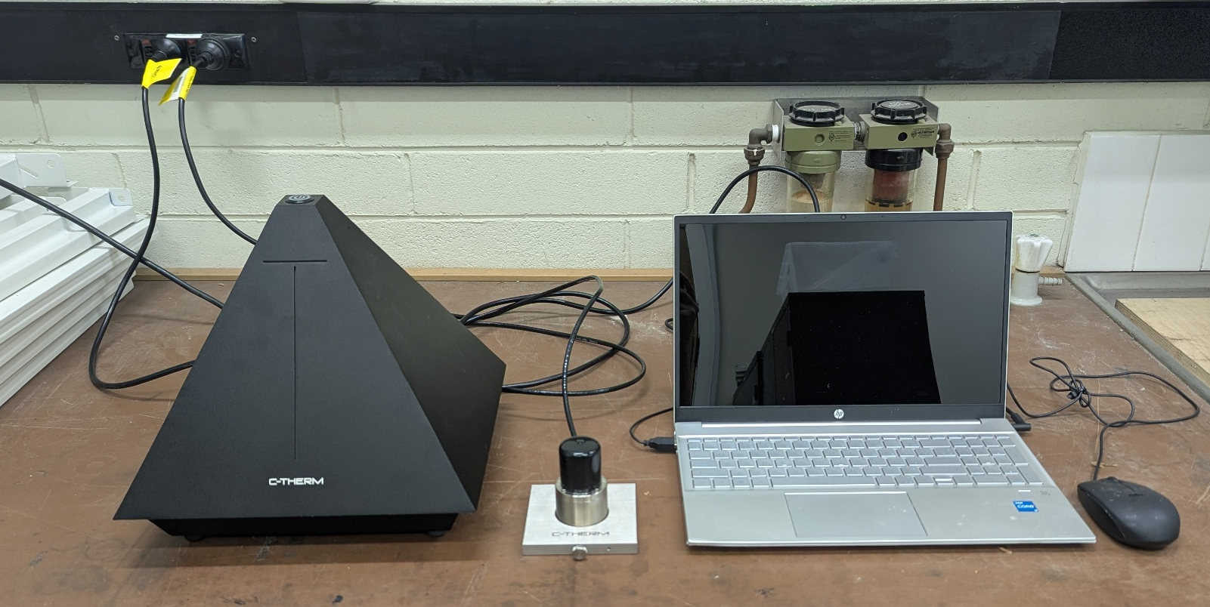

SCOPE
The scope of this Standard Operating Procedure outlines the safe use and operation of:
Name of machinery/equipment | C-Therm Trident Thermal Conductivity Instrument with MTPS Sensor

Campus | Parkville | Other:
Building | 200 – McCoy | Other:
Room No. | 111 – Petrophysics Lab | Other:
Offsite |  | Other:

This item has an inherent risk rating of:
Risk rating | ☒ | Low | ☐ | Medium | ☐ | High

This Standard Operating Procedure considers the intended purpose and use as outlined by the manufacturer.

DESCRIPTION

INTENDED APPLICATION
The Trident Thermal Conductivity Instrument with MTPS sensor is to be used to measure the thermal conductivity and thermal effusivity of various samples, including solids, liquids, powders and pastes in room and modified ambient temperatures. This SOP focuses predominantly on water saturated rock. For other applications please contact the laboratory manager for a modified procedure.

MANUFACTURER’S SPECIFICATIONS
Setup: A grounded power cable is required to prevent damage to the system. Avoid kinks in the cable, minimum bend radius is 7cm. Do not connect, disconnect or swap sensors whilst power is on. Always use on a silicone rubber mat
Sensor: Avoid applying blunt force onto the sensor. Do not put more than 4kg of weight onto the sensor. Only use the 500g weight if the sample is less than 150g. Smooth surfaces may adhere to the sensor when certain contact agents applied - if this is the case remove the sample horizontally instead of vertically.
Heating: The sensor is only to be used between -50ºC and 200ºC. Do not place the sensor into a pre-heated or cooled environment. Heat/cool the sensor no faster than 1C per minute. Once at desired temperature allow time for the sensor and sample to stabilise - the software will confirm when there has been no more than 0.5C variation for 10 minutes. Take care not to allow sample to solidify from liquid whilst on the sensor surface; if this occurs only remove once it has returned to a liquid state
Sample: Do not put chemically aggressive materials on the surface - refer to the safe list if in doubt. Only use samples within 3-10 pH range. Do not use strongly oxidising or reducing agents. Do not test metals - the C-Therm is not calibrated for them.

TRAINING / LICENCING
Relevant local inductions that are required for operators of this machinery/equipment:

Petrophysics Laboratory Induction

Relevant TrainME modules or external training required for operators of this machinery/equipment:
TrainME modules
☒ Health & Safety Roles & Responsibilities | ☐ Chemical Management | ☐ Hot Work
☐ Manual Handling | ☐ Compressed Gas Safety | ☐ Biorisk – Accredited Persons
☐ Computer Workstation Training | ☐ Safe Radiation Practices - Ionising | ☐ Animal Welfare & Ethics
☒ Personal Protective Equipment | ☐ Safe Radiation Practices - Laser | ☐ Other (please specify):
☒ Laboratory Safety | ☐ Biorisk – Biosafety Induction | ☐
☐ Plant Safety | ☐ Biorisk - Behavioural CF | ☐

Externally Provided Courses
☐Provide First Aid | ☐Working at Heights | ☐Four Wheel Drive
☐Remote First Aid | ☐Tower Rescue | ☐Chainsaw Safety
☐Diving Certificate | ☐Boat Licence | ☐Confined Spaces
☐Quad Bike | ☐Heavy Vehicle Licence | ☐Other (please specify):

PERSONAL PROTECTIVE EQUIPMENT (PPE)
Personal protective equipment required that meets relevant Australian Standard.
- Standard PPE:

☐ Safety glasses/goggles (please specify type): | ☐ Face shield
☐ Gloves (please specify type): | ☐ Mask/ respirator (please specify type):
☐ Laboratory Coat/Gown (please specify type): | ☐ Apron (please specify type):
☒ Fully enclosed footwear (please specify type): fully enclosed boots | ☐ Hat (please specify type):
☐ Long pants | ☐ Sunscreen
☐ Long sleeves | ☐ Wet suit
☐ Hearing Protection | ☐ Waders
☐ Other (Please Specify): | ☐ Other (Please Specify):
☐ Other (Please Specify): | ☐ Other (Please Specify):
- Health Monitoring required (HHAQ complete form)
☐ Vaccination/s required | ☐ Spirometry testing
List here: | ☐ Hearing test
☐Other Monitoring (Please Specify): | ☐ Eye test for Laser work
 | ☐ Other (Please specify)

Warnings

SAFETY PRECAUTIONS
- Ensure that the cable is free from damage before use.
- Ensure that you are familiar with the Tenney Environmental Chamber SOP and risk assessment before using it in conjunction with the C-Therm Trident
- Operator must be trained and familiar with the safe operating procedure.
- Operator to wear PPE as listed.
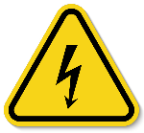

DO’S AND DON’T:
ALWAYS – Isolate and tag out equipment requiring repairs and maintenance.
ALWAYS – Plug in all required cables/cords before turning on the device
ALWAYS – Ensure the material you are testing has been approved for use
ALWAYS – Ensure the sample is smooth and free from sharp points/edges that could scratch or fracture the glass
ALWAYS – Heat/cool the device slowly
ALWAYS – Wait until the sensor has returned to ambient room temperatures before removing the sample
NEVER – Connect, disconnect or swap a cord whilst the device is powered on
NEVER – Place more than 4kg onto the sensor
NEVER – Place chemically aggressive materials onto the sensor
NEVER – Place the device into a preheated environment
NEVER – Subject the device to temperatures beyond the safe -50ºC to 200ºC range.

INSTRUMENT CONTROLS

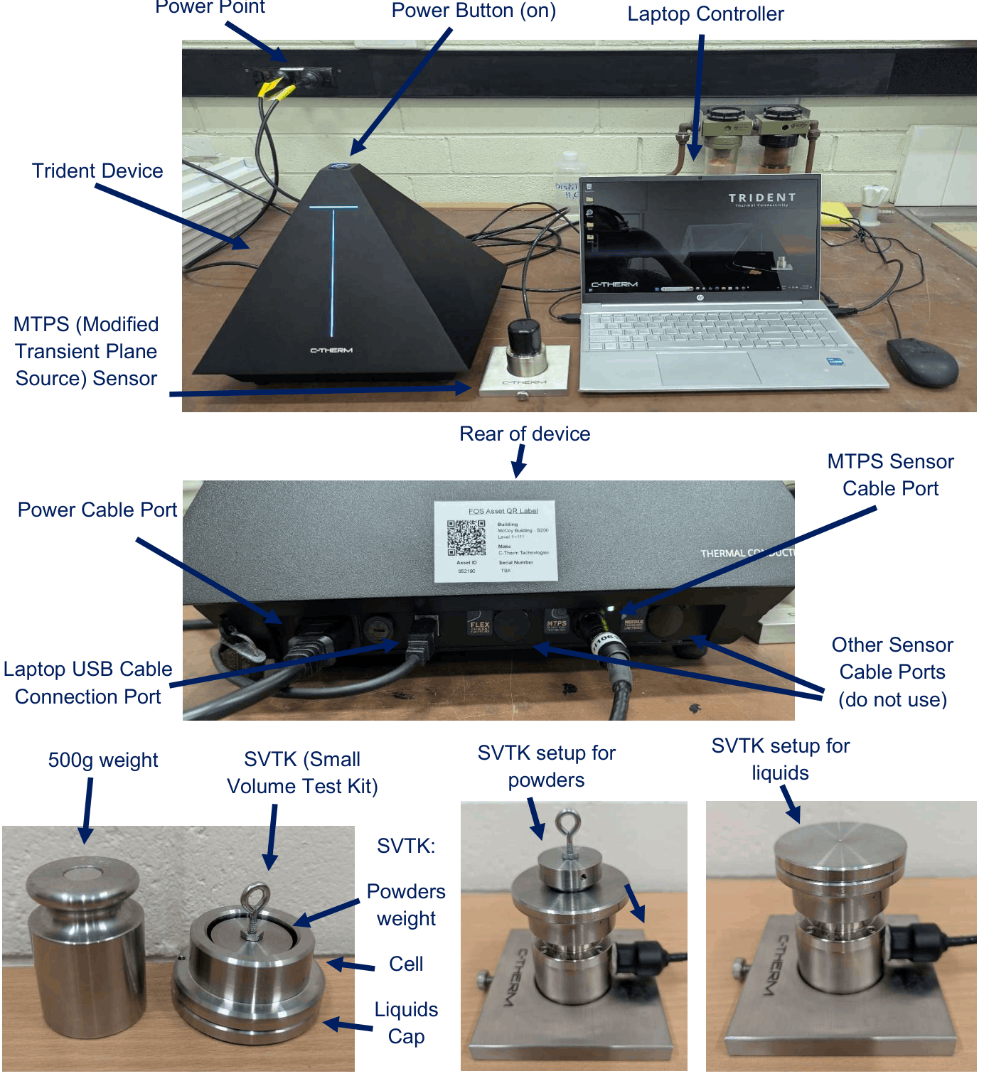
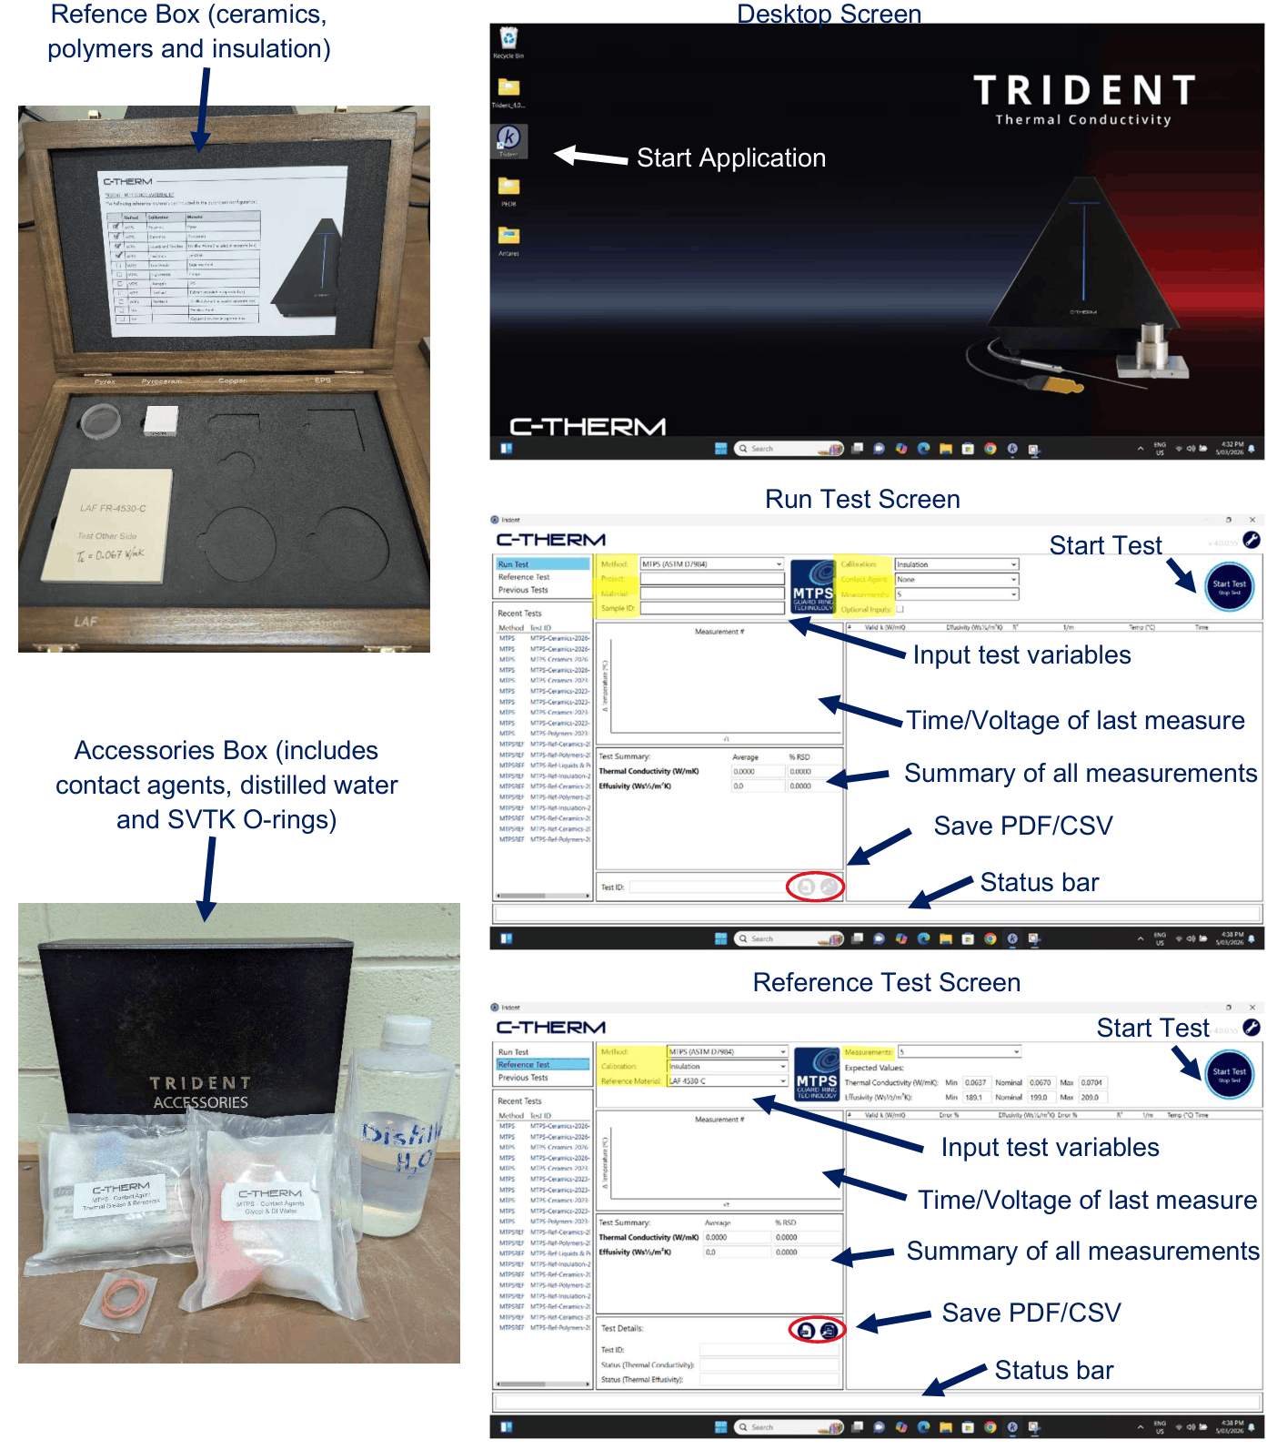

OPERATION
PRE-START UP
- Clear a workspace that is at least 1m x 0.5m; ensure that it is flat, level, dry, clean and adjacent to at least two power ports (ensure they are OFF when plugging the device in).
- Ensure that the workspace is not directly under/beside a source of convective air (AC outlet, window, etc) or a powerful electromagnetic device (Mass Spec, NMR, etc).
- Ensure that the lab will be at a consistent 19-27ºC for the duration of the test
- Place the MTPS sensor onto the rubber mat and connect it to the correct port of the trident
- Connect the USB cable between the laptop and the trident
- Connect the laptop and trident power cables and plug them in (ensure power ports are OFF)
- Ensure that none of the cables are damaged, the surface of the sensor is smooth and free from marks and scratches; and that the sensor pins are connected firmly at both ends of the cable.
- Turn on both power points
- Turn on the trident (top button) and let it run for at least an hour before performing any test
Testing in conjunction with the Tenney Environmental Chamber for altered ambient temperatures:
- Place the sensor and mat into the chamber before it is plugged into the trident. Thread the cord through the insulation hole, replace the plug, then connect the cord into the trident.
- Allow the sensor to calibrate for an hour before starting the temperature profile.
- Place the sample onto the sensor before starting the temperature profile.
- When programming the temperature profile ensure that the ramp speed is set to heat/cool no faster than 1ºC per minute (to a maximum of 50ºC per hour).
- Once the desired temperature has been reached wait for the sensor and sample to stabilise (there has been less than 0.5ºC variation for at least 10 minutes). Use the Trident thermal monitoring function to verify stability.

START UP
Perform a calibration test:
- Only perform a calibration test between 20ºC and 25ºC. If using the environmental chamber, do this test before commencing the profile.
- Find the reference material that closest matches the sample you want to test. Each reference material will have a calibration range. The polymers, ceramics, and insulation materials are found in the wooden box. For liquids and powders use the distilled water. For rock, use ‘ceramics’.
- Prepare the sample for testing as dictated at the end of this section.
- Select reference test. Select the following test variables.
  - Method: MTPS (ASTM D7984)
  - Calibration: the category of reference material
  - Reference Material: automatically populated
  - Measurements: 10
- Start the test. The status bar will indicate if the system is stabilizing or acquiring data.
- The data for each measurement will populate after it is acquired. The most recent Voltage-Time chart will be visible. Click on previous measurements to see their Voltage-Time charts.
- Once the test is over, check to see if any the measurement values are invalid. If so, move to troubleshooting. You can also compare the values in the test summary to the expected reference material values.
- Discard this data and move onto your test.
Perform a test
- Prepare the sample as dictated at the end of this section. Rock should be water saturated.
- Select Run Test. Fill out the following test variables:
  - Method: MTPS (ASTM D7984)
  - Project, Material, Sample ID: Fill out based on your project.
  - Calibration: Select the appropriate calibration for the sample. For rock choose ‘ceramics’.
  - Contact Agent: Select the appropriate contact agent for the sample. For rock this will either be water (if the rock has been saturated) or thermal grease (not preferred)
  - Measurements: 10 is suggested
- Optional Inputs (density and heat capacity) may be inputted to improve accuracy
- Start the test. The status bar will indicate if the system is stabilizing or acquiring data.
- The data for each measurement will populate after it is acquired. The most recent Voltage-Time chart will be visible. Click on previous measurements to see their Voltage-Time charts.
- Once the test is over, check to see if any the measurement values are invalid. If so, move to troubleshooting. Otherwise save the test either as a PDF or CSV.
SAMPLE PREPARATION
Samples must be clean, smooth to the touch and devoid of any sharp points or edges that may damage the sensor. Solid samples must be large enough to fully cover the sensor.
Material | Minimum Thickness/Volume | Instructions
Liquids | 1.2mL (1/4 tsp) | Pour liquid into the SVTK* cell and place cap on top. Ensure the sample is free from air bubbles.
Powders | 1.8mL | Place powder into the SVTK* cell and place powders weight on top.
Pastes | 1.8mL | Load paste into a syringe and eject onto SVTK cell directly onto the sensor. Ensure the sample is free from air bubbles.
Insulators | 2mm | Place the sample on the sensor with the test area in contact with the sensor. Centre the weight on top of the sample (if it is <150g).
Ceramics | 2mm | Place 3 drops of distilled water onto the sensor chip**. Place the sample on the sensor ensuring that it is set down evenly. Centre the weight on top of the sample (if it is <150g).
Polymers | 4mm
*Ensure that the O-ring is firmly secured to the interior of the cell before placing on top of the sensor
**Samples that absorb water (such as rock) may prove difficult to measure. It is recommended to completely saturate them with water first. Alternatively, use Thermal Grease as the contact agent.

REFERNECE MATERIAL EXECTED VALUES
Material | Calibration | Conductivity (W/Mk) | Lower Limit | Upper Limit | RSD Limit (%) | Accuracy (%)
Distilled Water | Liquids and Powders | 0.609 | 0.579 | 0.639 | 1% | 5%
LAF 4530-C | Insulation | 0.067 | 0.0637 | 0.0703 | 1% | 5%
Pyrex | Polymers | 1.143 | 1.086 | 0.0724 | 1% | 5%
Pyroceram | Ceramics | 4.11 | 3.905 | 4.316 | 1% | 5%

CALIBRATION RANGES
Calibration | k Range (W/Mk) | Effusivity Range | RhoCp Range (MJ/m³K) | Preset Sensor Power (W) | Preset Calc. Time (s) | Interval Cooling Time
Liquids/Powders | 0-0.061 | 0-1660 | 1.1-4.5 | 0.35 | 0.5-1 | 60
Insulation | 0.04-0.12 | 50-290 | 0.31-0.69 | 0.18 | 1.2-2.7 | 90
Polymers | 0.13-1.2 | 570-1450 | 1.3-2.0 | 0.35 | 0.5-1 | 60
Ceramics | 1.1-29 | 1400-8600 | 1.8-2.7 | 0.35 | 0.5-1 | 60

TEST VALIDITY
If the measurement result text is:
- Black on a white background: the measurement is valid
- Red on a white background: the measurement is outside of 15% valid range. Remove it from the test (deselect the valid column). The first measurement often should be deselected. Otherwise, only 1 in 10 measurements can be deselected.
- Black on a red background: measurement is too high or low. Try a different calibration or contact agent.
The test R² value should always be >0.0995. Also check the RSD value falls within acceptable ranges. Note that the RSD may be higher if the sample is heterogeneous and/or if thermal grease is used.
TROUBLESHOOTING
In case of invalid rest results (red values in the measurement list) consider the following solutions:
- If there are any noticeable outliers remove them (deselect the checkmark under the ‘valid’ column). The first measurement is often inaccurate. Only 1 in 10 measurements may be removed.
- Ensure the trident controller has been turned on for a full hour.
- Ensure the sensor and cable are both free from visible damage.
- Ensure all components (samples, sensor, controller etc) are thermally stable. There must be less than 0.5ºC variation over 10 minutes, ideally less than 0.1ºC. This may require 2 hours equilibration.
- Ensure the reference materials are free from visible damage and staining.

SHUT DOWN
- Turn off the Trident Controller via the top power button
- Save your work and shut down the trident laptop
- Switch off the power points and unplug

EMERGENCY SHUT DOWN

Only switch the power point off or unplug the power cord if it is not safe to turn off via the top power button.

MAINTENANCE
To ensure reliable and trouble-free operation, it is the user’s responsibility to maintain the machine in the best possible condition. Such a machine will produce accurate consistent results; problems will be less frequent and less severe.

CLEANING
The sensor may be wiped down with soap and water, isopropyl alcohol or arctiClean Thermal Grease Remover. The controller can be wiped down with a damp cloth. Avoid the use of abrasive materials. Do not immerse either in water. The controller is not waterproof. Do not disconnect any cables until completely dry.

MAINTENANCE
Check before and after use for the following signs of damage: fine fracture lines on the sensor chip surface, changes to the sensor chip colour or surface appearance, damage to the sealant around the sensor chip, and wear at the cable connection points. Maintenance and calibration must only be performed by C-Therm.

EMERGENCY
Commence emergency procedures in accordance with the local emergency requirements.
UNIVERSITY SECURITY (Parkville 24hr) 834 46666

FIRST AID KITS
There is a first aid kit on the shelf directly above the vacuum chamber.

PORTABLE DEFIBRILLATORS
Portable Defibrillator located at the entrance to Thomas Cherry Building level 2, walk through McCoy foyer. A second Portable Defibrillator is in the Physics podium over the walkway/bridge across Swanston St.

LISTINGS OF FIRST AIDERS
Listings of First Aiders located at First Aid Kits, as well as emergency contact posters on safety notice board.

INCIDENT REPORTING
- Report any incident to your Supervisor immediately.
- Report the incident on ERMS and local OHS contact https://unimelbcloud.sharepoint.com/teams/ScienceOHSResources as soon as possible.
- In the event of a major incident the following reporting steps will also occur:
  - Notify the relevant emergency response department e.g. Fire, Ambulance, Police (000).
  - Notify Security (834 46666) 24/7 support.
  - Notify your supervisor and the local OHS contact as soon as reasonably practicable. https://unimelbcloud.sharepoint.com/teams/ScienceOHSResources

REFERENCES

Reference Material | Location (if physical) or Link (if electronic)
University of Melbourne risk register | https://safety.unimelb.edu.au/__data/assets/pdf_file/0009/4859235/UoM-Health-and-Safety-Risk-Register-v4.pdf
School/Department risk register | https://unimelbcloud.sharepoint.com/teams/SGEASHealthandSafetyResources
Equipment Risk Assessment | https://sgeas.unimelb.edu.au/research/auscope-subsurface-observatory. Alternatively scan QR code attached to lid.
Manufacturer’s / Supplier’s operating manual | ‘Trident Thermal Conductivity Instrument User Manual’ with lab documentation  https://sgeas.unimelb.edu.au/research/auscope-subsurface-observatory. Alternatively scan QR code attached to device.
Research Group Safety Manual (If applicable) | https://sgeas.unimelb.edu.au/research/auscope-subsurface-observatory. Alternatively scan QR code attached to device.
University safety website guidelines and requirements | https://safety.unimelb.edu.au/
Other (please specify)

Relevant Legislation References | Location (web link or physical copy location))
OHS Act, Vic. | https://www.legislation.vic.gov.au/in-force/acts/occupational-health-and-safety-act-2004/043
OHS Regulations, Vic | https://www.legislation.vic.gov.au/in-force/statutory-rules/occupational-health-and-safety-regulations-2017/014
Other relevant Acts and Regulations:
☐ ________________________
☐ ________________________
☐ ________________________
☐ ________________________

Compliance codes and Codes of Practice  ☐ ________________________  ☐ ________________________  ☐ ________________________  ☐ ________________________ | https://www.worksafe.vic.gov.au/laws-and-regulations
Australian Standards: source SAI Global.  ☐ ________________________  ☐ ________________________  ☐ ________________________  ☐ ________________________ | https://research.ebsco.com/c/xppotz/search/details/f7kyfyxrkz

