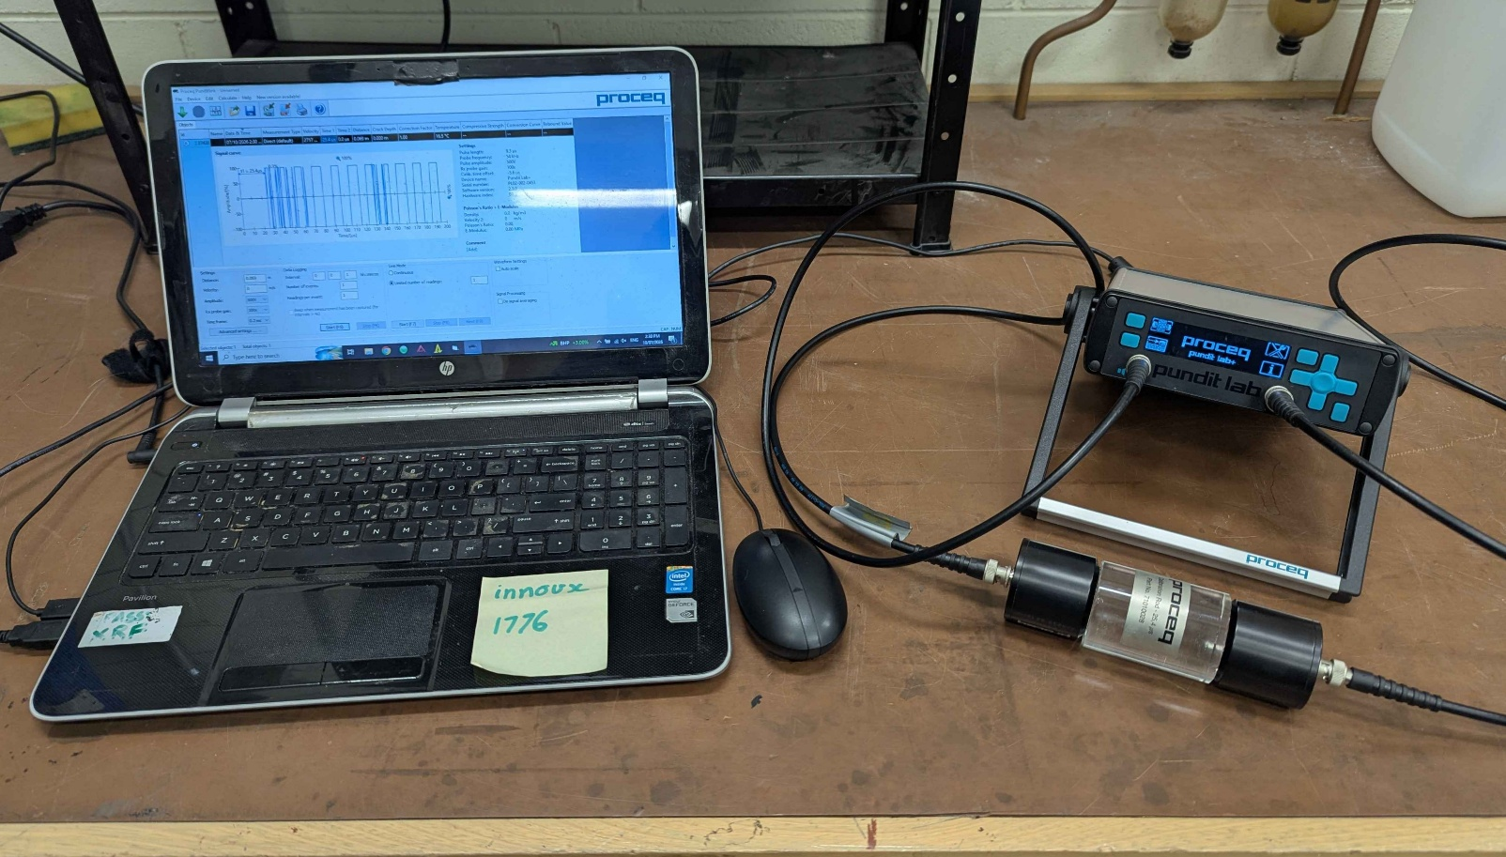

SCOPE
The scope of this Standard Operating Procedure outlines the safe use and operation of:
Name of machinery/equipment | Pundit Lab+ Ultrasonic Instrument  P+S Wave Meter

Campus | Parkville | Other:
Building | 200 – McCoy | Other:
Room No. | 111 – Petrophysics Lab | Other:
Offsite |  | Other:

This item has an inherent risk rating of:
Risk rating | ☒ | Low | ☐ | Medium | ☐ | High

This Standard Operating Procedure considers the intended purpose and use as outlined by the manufacturer.

DESCRIPTION

INTENDED APPLICATION
This instrument measures the P and S wave velocity speeds through rock samples.

MANUFACTURER’S SPECIFICATIONS
This instrument is not to be operated by children or anyone under the influence of alcohol, drugs or pharmaceutical preparations. Faulty components are only to be replaced with original parts from Proceq. Accessories should only be installed if they are expressly authorised by Proceq.

TRAINING / LICENCING
Relevant local inductions that are required for operators of this machinery/equipment

Petrophysics Laboratory Induction

Relevant TrainME modules or external training required for operators of this machinery/equipment

TrainME modules
☒ Health & Safety Roles & Responsibilities | ☐ Chemical Management | ☐ Hot Work
☐ Manual Handling | ☐ Compressed Gas Safety | ☐ Biorisk – Accredited Persons
☐ Computer Workstation Training | ☐ Safe Radiation Practices - Ionising | ☐ Animal Welfare & Ethics
☒ Personal Protective Equipment | ☐ Safe Radiation Practices - Laser | ☐ Other (please specify):
☒ Laboratory Safety | ☐ Biorisk – Biosafety Induction | ☐
☐ Plant Safety | ☐ Biorisk - Behavioural CF | ☐

Externally Provided Courses
☐Provide First Aid | ☐Working at Heights | ☐Four Wheel Drive
☐Remote First Aid | ☐Tower Rescue | ☐Chainsaw Safety
☐Diving Certificate | ☐Boat Licence | ☐Confined Spaces
☐Quad Bike | ☐Heavy Vehicle Licence | ☐Other (please specify):

PERSONAL PROTECTIVE EQUIPMENT (PPE)
Personal protective equipment required that meets relevant Australian Standard.
- Standard PPE:

☐ Safety glasses/goggles (please specify type): | ☐ Face shield
☐ Gloves (please specify type): | ☐ Mask/ respirator (please specify type):
☐ Laboratory Coat/Gown (please specify type): | ☐ Apron (please specify type):
☒ Fully enclosed footwear (please specify type): Fully enclosed boots | ☐ Hat (please specify type):
☐ Long pants | ☐ Sunscreen
☐ Long sleeves | ☐ Wet suit
☐ Hearing Protection | ☐ Waders
☐ Other (Please Specify): | ☐ Other (Please Specify):
☐ Other (Please Specify): | ☐ Other (Please Specify):
- Health Monitoring required (HHAQ complete form)
☐ Vaccination/s required | ☐ Spirometry testing
List here: | ☐ Hearing test
☐Other Monitoring (Please Specify): | ☐ Eye test for Laser work
 | ☐ Other (Please specify)

Warnings

SAFETY PRECAUTIONS
- All cables must be investigated for damage before use.
- Operator must be trained and familiar with the safe operating procedure.
- Operator to wear PPE as listed.


DO’S AND DON’T:
ALWAYS – Isolate and tag out equipment requiring repairs and maintenance.
NEVER – Operate the device if cables are damaged.

INSTRUMENT CONTROLS
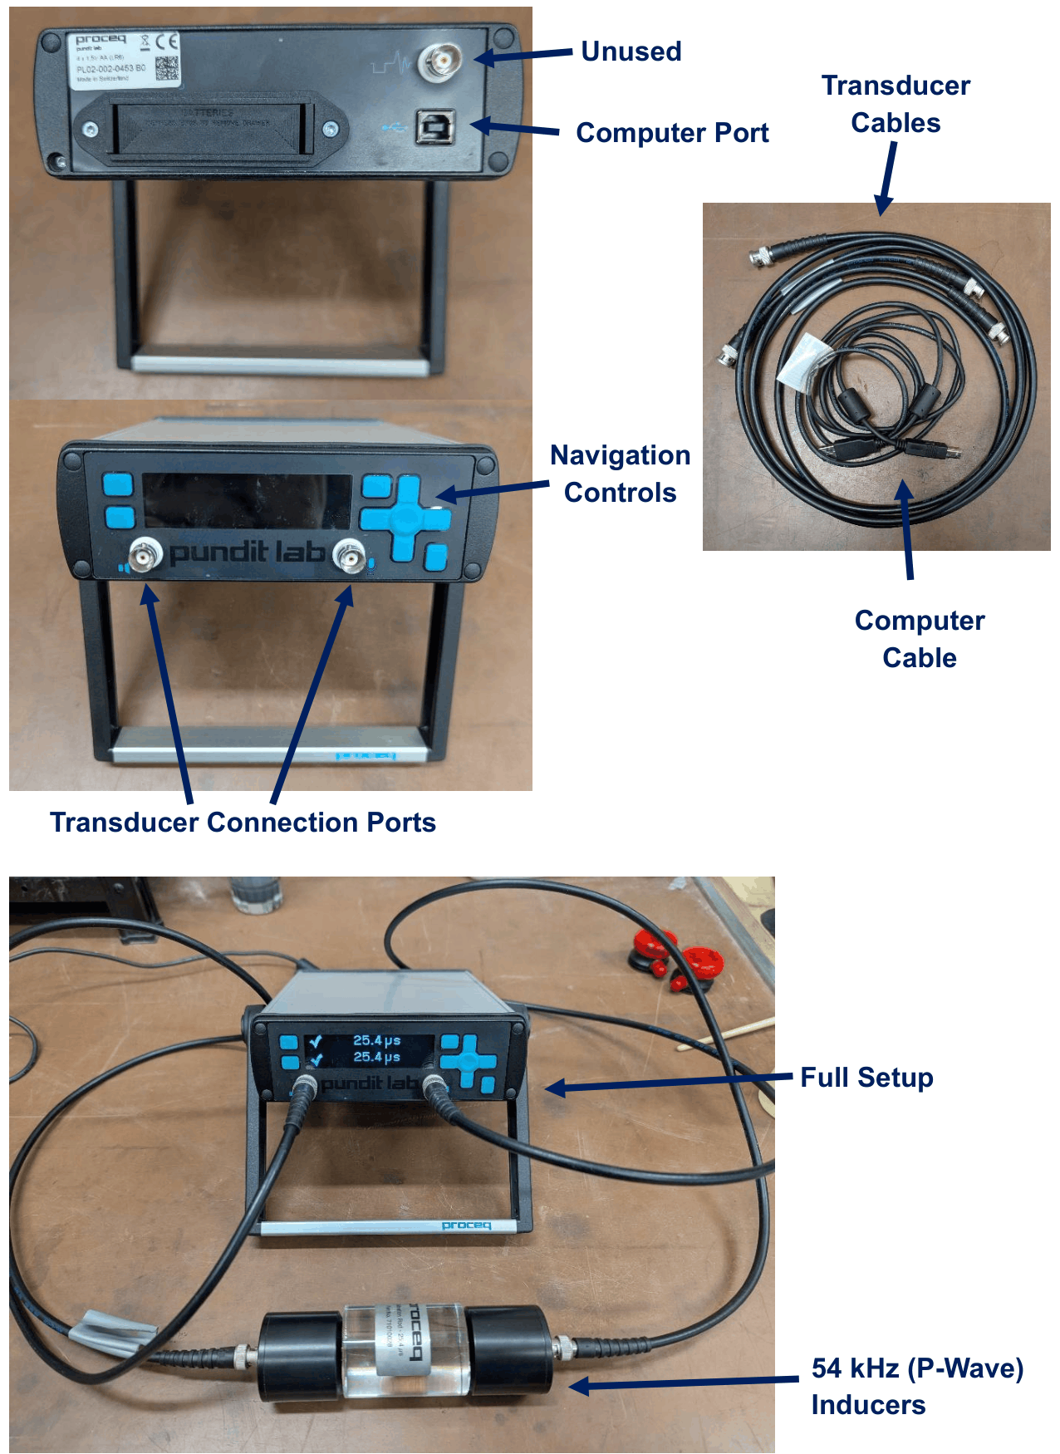
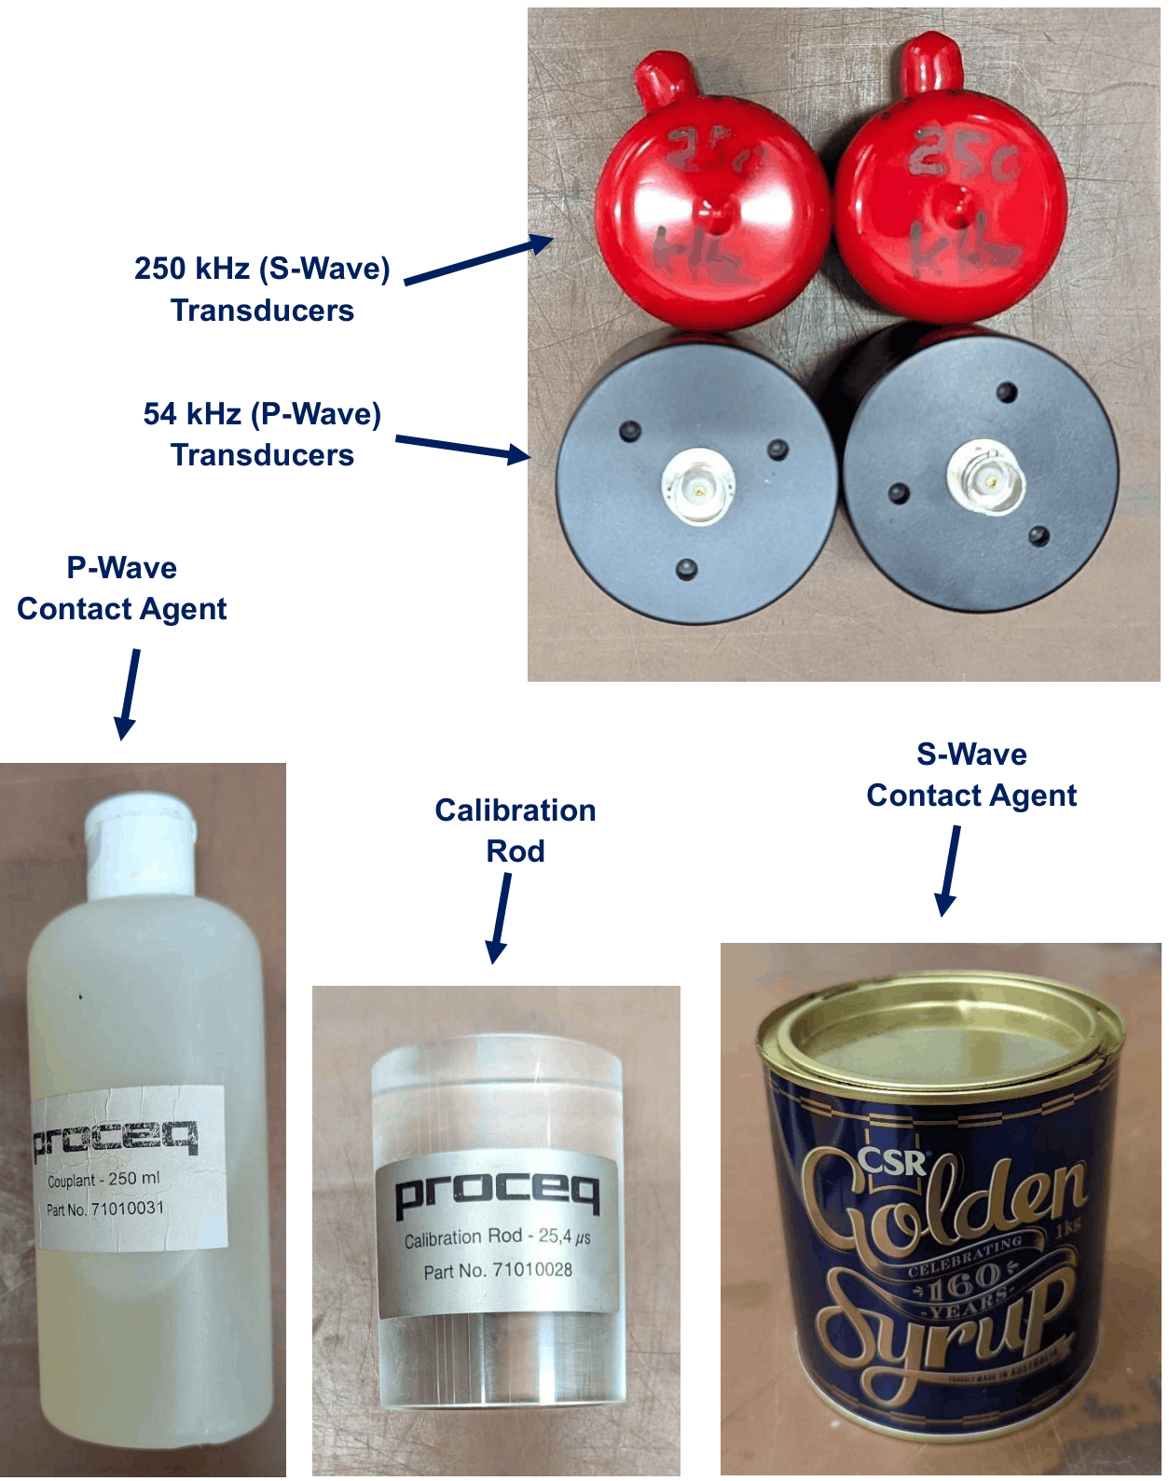

OPERATION

PRE-START UP
- Setup the pundit device forearm so that the screen is angled towards the user
- Attach the transducers to the cables and the cables to the device
- Connect the computer cables to the laboratory laptop (this supplies power and coms)
- Turn on by pressing any button
- Perform a calibration check:
  - Attach the transducers (see below) to the calibration rod (25.4 us travel time)
  - Settings (top right) Calibration check (top left) go (bottom right)
  - Make sure that the correct transducer frequency is selected (settings top left)

START UP
- Apply contact agent to the transducers and firmly press onto either end of the sample
  - For the 54 kHz transducers (P-wave) use the proceq gel.
  - For the 250 kHz transducers (S-wave) microwave a small portion of golden syrup then apply.
The transducers must be oriented in the same way. This is especially important for the S-wave transducers where the outward facing connectors should be aligned. Correct alignment:
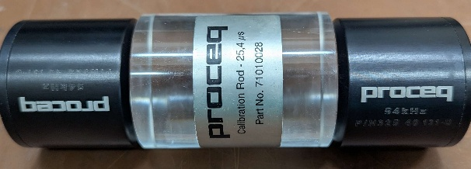
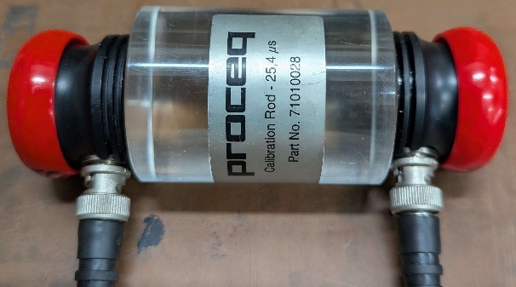
Orient according to desired direction of measurement.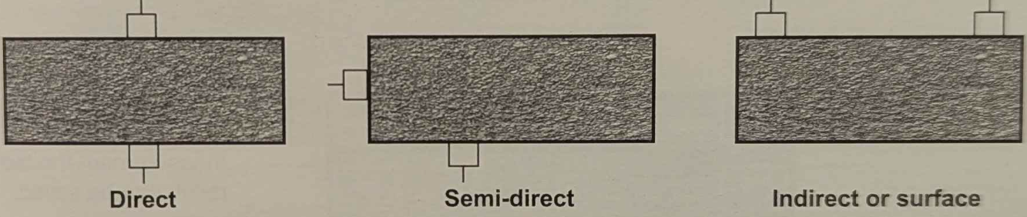

- To perform a measurement, select measure (top left) from the home menu
  - Top left: set path length (distance between transducers) if known, determines velocity
  - Bottom left: set pulse velocity (P-wave velocity) if known, determines path length
  - Top right: single (#) or continuous (∞) measurement.
- Select start (bottom right).
  - Either save (top right) or measure again (bottom right).
  - Voltage (top left) and Rx gain (bottom right) should be automatically set. They can be altered here before the next measurement.
These controls can also be access via Pundlink on the laboratory laptop
- Open punditlink
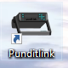
- Select upload (green arrow) and connect via COM port.
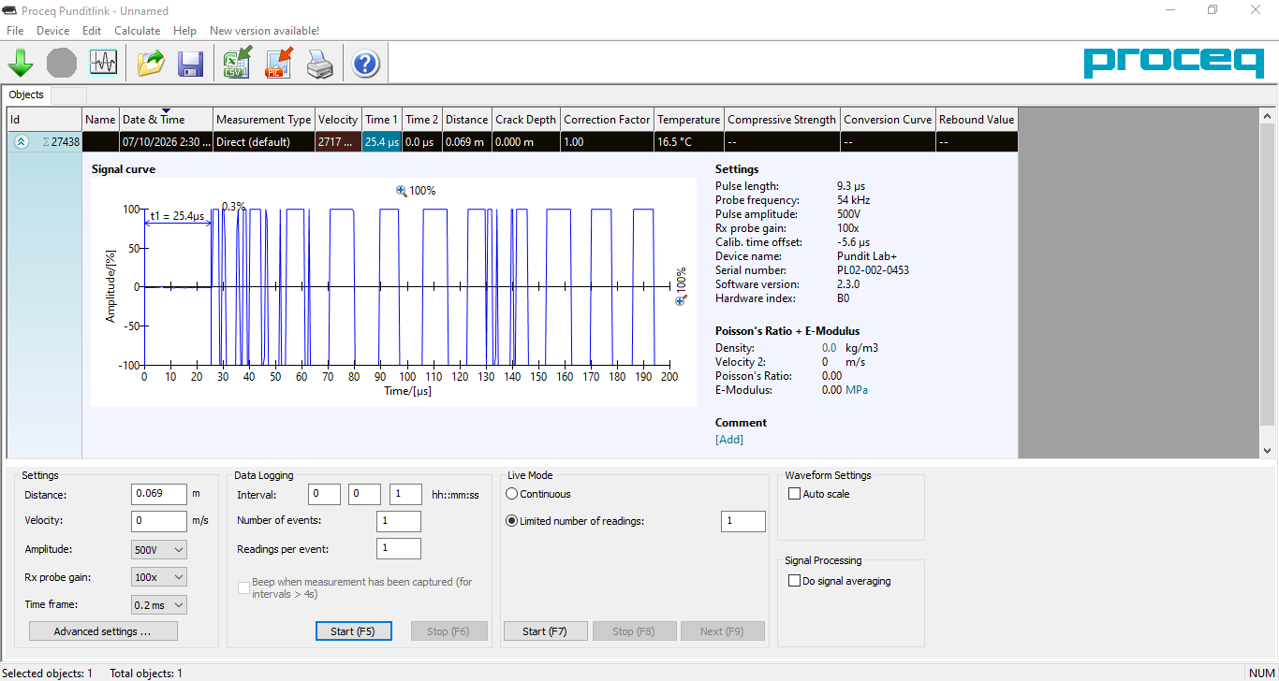

Note: S-wave measurements need to be manually corrected on the laptop
- Look at the continuous reading on the laptop.
  - If setup correctly, there should be a smaller signal at the onset of the P-wave and a larger signal at the onset of the S-wave (~double the time).
  - Rotate the transducers out of correct position to locate the S-wave if needed (it should change independently of the S-wave onset).
  - End the reading and move the line up to the onset of the P-wave to get the exact reading.
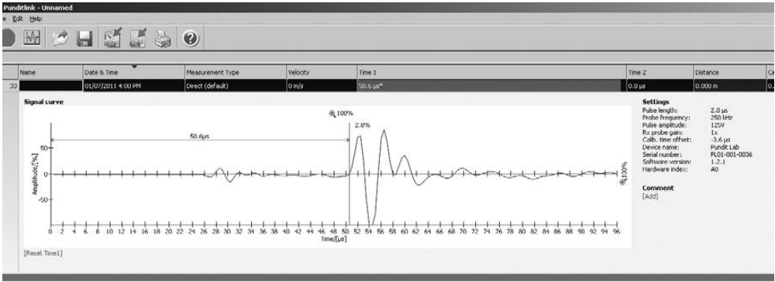

SHUT DOWN
Hold down the ‘back’ button on the device to shut down. Disconnect from the laptop, then disconnect cords and transducers.

EMERGENCY SHUT DOWN
Immediately unplug from the laptop to shut down quickly.

MAINTENANCE
To ensure reliable and trouble-free operation, it is the user’s responsibility to maintain the machine in the best possible condition. Such a machine will produce accurate consistent results; problems will be less frequent and less severe.

CLEANING
Do not get the device wet. Wipe down with a damp cloth.

MAINTENANCE
All maintenance should be performed by Proceq. Cables and connections should be kept undamaged and free from obstruction via regular inspection.

EMERGENCY
Commence emergency procedures in accordance with the local emergency requirements.
UNIVERSITY SECURITY (Parkville 24hr) 834 46666

FIRST AID KITS
There is a first aid kit on the shelf directly above the vacuum chamber.

PORTABLE DEFIBRILLATORS
Portable Defibrillator located at the entrance to Thomas Cherry Building level 2, walk through McCoy foyer. A second Portable Defibrillator is in the Physics podium over the walkway/bridge across Swanston St.

LISTINGS OF FIRST AIDERS
Listings of First Aiders located at First Aid Kits, as well as emergency contact posters on safety notice board.

INCIDENT REPORTING
- Report any incident to your Supervisor immediately.
- Report the incident on ERMS and local OHS contact https://unimelbcloud.sharepoint.com/teams/ScienceOHSResources as soon as possible.
- In the event of a major incident the following reporting steps will also occur:
  - Notify the relevant emergency response department e.g. Fire, Ambulance, Police (000).
  - Notify Security (834 46666) 24/7 support.
  - Notify your supervisor and the local OHS contact as soon as reasonably practicable. https://unimelbcloud.sharepoint.com/teams/ScienceOHSResources

REFERENCES

Reference Material | Location (if physical) or Link (if electronic)
University of Melbourne risk register | https://safety.unimelb.edu.au/__data/assets/pdf_file/0009/4859235/UoM-Health-and-Safety-Risk-Register-v4.pdf
School/Department risk register | https://unimelbcloud.sharepoint.com/teams/SGEASHealthandSafetyResources
Equipment Risk Assessment | N/A
Manufacturer’s / Supplier’s operating manual | https://sgeas.unimelb.edu.au/research/auscope-subsurface-observatory.  Physical copy stored with device.
Research Group Safety Manual (If applicable) | https://sgeas.unimelb.edu.au/research/auscope-subsurface-observatory. Alternatively scan QR code attached to lid.
University safety website guidelines and requirements | https://safety.unimelb.edu.au/

Relevant Legislation References | Location (web link or physical copy location))
OHS Act, Vic. | https://www.legislation.vic.gov.au/in-force/acts/occupational-health-and-safety-act-2004/043
OHS Regulations, Vic | https://www.legislation.vic.gov.au/in-force/statutory-rules/occupational-health-and-safety-regulations-2017/014
Other relevant Acts and Regulations:
☐ ________________________
☐ ________________________
☐ ________________________
☐ ________________________

Compliance codes and Codes of Practice  ☐ ________________________  ☐ ________________________  ☐ ________________________  ☐ ________________________ | https://www.worksafe.vic.gov.au/laws-and-regulations
Australian Standards: source SAI Global.  ☐ ________________________  ☐ ________________________  ☐ ________________________  ☐ ________________________ | https://research.ebsco.com/c/xppotz/search/details/f7kyfyxrkz

